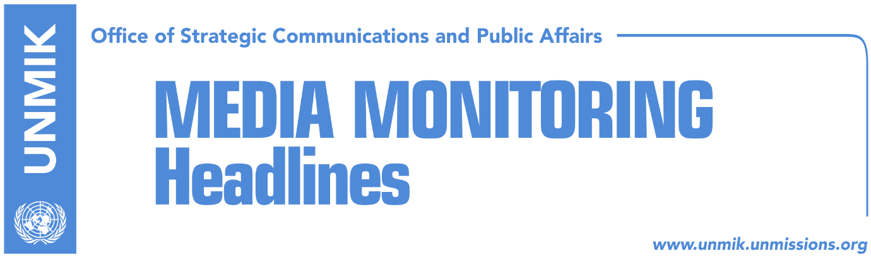

Main Stories 2 August 2018

- Thaci against partition but in favour of ‘border correction’ (Zeri)
- Haradinaj: Partition reports are only speculations (media)
- Kurz: I find it difficult to imagine exchange of territories (Epoka)
- Serbia hopes on Trump’s stance on Kosovo (Kosova Sot)
- Mustafa: Not exchange of territories only unification with Kosovo (Bota Sot)
- UN SG Guterres: Situation in Kosovo stable, there are two concerns (RTK)
- Todosijevic: Association/Community statute based on Brussels Agreement (Koha)
- Environment Minister Reshitaj resigns post (Koha Ditore)
- Ramadani: Region benefits from KSF’s transition (Epoka)

Kosovo Media Highlights

Thaci against partition but in favour of ‘border correction’ (Zeri)
After meeting head of Kosovo’s Academy of Arts and Science Nexhat Daci, President of Kosovo Hashim Thaci said the two agreed that everyone should take its share of responsibility in the dialogue with Serbia: institutions, all political parties, civil society, academia. “Only as united can be achieve our objectives: mutual Kosovo-Serbia recognition, UN seat and membership in all other international organisations. Serbia’s claim over partition of Kosovo will always remain unacceptable but within the border correction issue the right and demand of Presevo Valley to join Kosovo should be raised in the process of dialogue,” Thaci wrote on Facebook after the meeting.

Haradinaj: Partition reports are only speculations (media)
The Prime Minister of Kosovo Ramush Haradinaj, visited yesterday the US army base, Bondsteel Camp, where he met with Commander Nick Ducich. Haradinaj expressed appreciation for the contribution of the United States of America given to Kosovo. “U.S. soldiers have done a great job here and I came to express my appreciation for their contribution,” Haradinaj said. He further added that statements of Serb clergy about plans to divide Kosovo are unsustainable and only speculation. “I think there is no threat of border change,” Haradinaj said. Commander Ducich on the other hand spoke about KFOR’s cooperation with Kosovo’s Security Force. He added that Haradinaj’s visit today is the first one of a Kosovo Prime Minister at the camp.

Kurz: I find it difficult to imagine exchange of territories (Epoka)
Austrian Chancellor, Sebastian Kurz, said he has promised Austria’s support to both presidents Vucic and Thaci and added that he hopes on a speedy progress of the process. Asked by Sarajevo daily Dnevni Avaz if the agreement on Kosovo will be reached by the end of this year and if Austria would support exchange of territories, Kurz said “We support any agreement that would result to a stronger cooperation between the Western Balkans countries and more stability to the region. However, I find it difficult to imagine exchange of territories, because the region would not become more stable if we try to change borders so many years after the war.”

Serbia hopes on Trump’s stance on Kosovo (Kosova Sot)
Serbia’s Prime Minister, Ana Brnabic, said the current U.S. administration is ready to hear Serbia’s position on the solution of Kosovo’s issue. “I very often had the impression that I am facing an interlocutor who is not ready to listen, as if I was talking to a wall. Now we have an interlocutor who is ready to listen,” Brnabic said to the Serbian national broadcaster.

Mustafa: Not exchange of territories only unification with Kosovo (Bota Sot)
Ragmi Mustafa, leader of the Albanian Democratic Party in the Presevo Valley, told Serbian media that unification with Kosovo would be the best solution for normalisation of relations between Kosovo and Serbia. “It is normal we have requested to become part of Kosovo but we are not talking about exchange of territories but a new border demarcation process whereby Kosovo and Serbia, through a new permanent agreement, would resolve their problems in the best possible way,” Mustafa said.

UN SG Guterres: Situation in Kosovo stable, there are two concerns (RTK)
The United Nations Secretary General Antonio Guterres has warned that the building of a road next to Visoki Decani and the lack of results in the investigation into the Ivanovic murder are a cause for concern in Kosovo. However, he welcomed continuation of the dialogue between Belgrade and Pristina with the mediation of the European Union. In his regular report on developments in Kosovo, covering mid-April to mid-July, the UN chief said he was concerned about the intention to build a road in the protected zone around the (Serbian Orthodox) monastery of Visoki (High) Decani - a UNESCO protected site - calling on local authorities to respect laws and decisions according to which construction there is forbidden. "I note with growing concern that the murder of Oliver Ivanovic has not been resolved after six months. I invite the authorities in Kosovo to intensify the investigation and use all available channels that could help them," Guterres said. He welcomed the continuation of the dialogue between Belgrade and Pristina with the mediation of the EU. "Although this meeting did not bring new results, the continuation of the dialogue provides new opportunities to launch the process of resolving long-term differences, which is essential for any viable solution. I encourage the leaders in Belgrade and Pristina to continue their dialogue and fully fulfill the agreements arising from the dialogue which is mediated by the EU," stated Guterres. The UN chief also assessed that the overall situation in Kosovo in the past three months was stable, recalling that members of the Kosovo Assembly from the Serb List have not been taking part in the work of the parliament and the government since the end of March.

Todosijevic: Association/Community statute based on Brussels Agreement (Koha)
Kosovo’s Minister for Local Government and Administration, Ivan Todosijevic, confirmed that the draft statute for the Association/Community of Serb-majority municipalities will be submitted to the government of Kosovo by August 4 but stated that it will be based on the Brussels Agreement and made no mention of the Constitutional Court ruling. “I expect the Management Team to draft statute as set out in the Brussels agreements,” Todosijevic said adding that they have regularly informed the government of Kosovo on the work of the team. Kosovo government meanwhile said it has no information about the work of the Management Team and that it has not yet received the draft statute. “Whenever it is received and its content reviewed, we will come out with an official position,” said government spokesperson Donjeta Gashi.

Environment Minister Reshitaj resigns post (Koha Ditore)
Kosovo’s Minister of Environment and Spatial Planning, Albena Reshitaj, announced through Facebook that she has resigned her post citing ‘personal reasons’. Prime Minister Ramush Haradinaj said he received Reshitaj’s resignation and that he respected her decision. Koha meanwhile reports that Reshitaj has in fact been dismissed because of her disagreements with Haradinaj on the issue of an environment task force. Other sources however said that disagreements within her New Kosovo Alliance (AKR) party led to Reshitaj’s resignation.

Ramadani: Region benefits from KSF’s transition (Epoka)
Burim Ramadani, Deputy Minister of Kosovo Security Force, considers transformation of the Kosovo Security Force into an army through constitutional changes to be challenging. However, he said Kosovo has not given up from continuous engagement in the process. He added that constitutional changes will happen whenever it is possible. He stressed that Kosovo does not aim to replace NATO or KFOR presence and it does not aim KSF’s transition against some other country in Balkans. Furthermore, he added, the region would benefit from this transition, as Kosovo would become a special contributor to the regional security and further.

Disclaimer
This media summary consists of selected local media articles for the information of UN personnel. The public distribution of this media summary is a courtesy service extended by UNMIK on the understanding that the choice of articles translated is exclusive, and the contents do not represent anything other than a selection of articles likely to be of interest to a United Nations readership. The inclusion of articles in this summary does not imply endorsement by UNMIK.

