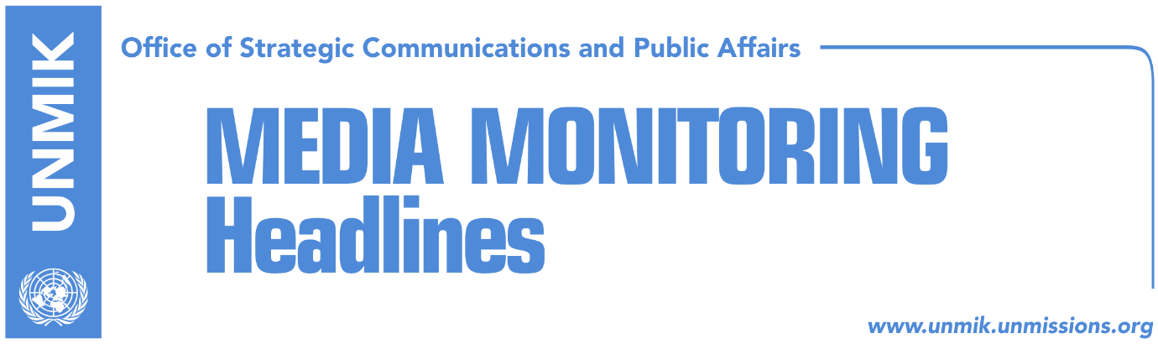

Main Stories 11 August 2018

- Thaci meets with Ali Ahmeti (media)
- Mustafa: Neither Thaci nor Haradinaj are to be trusted (Koha)
- Haziri: It is our historic duty to unite with Valley, we do not exchange Kosovo north (Koha)
- Thaci’s idea for exchange of territories is being assessed as dangerous (Koha)
- Delawie: U.S.-Kosovo friendship will not change (media)
- Kosovo’s partition is a dangerous solution (media)

Kosovo Media Highlights

Thaci meets with Ali Ahmeti (media)
The President of Kosovo Hashim Thaci, met on Friday with the leader of the Democratic Union for Integration (BDI), Albanian political party in the Former Yugoslav Republic of Macedonia (FYROM,) Ali Ahmeti. “We discussed Macedonia’s integration in NATO as soon as possible, as we see it as a strategic interest, as well as about the dialogue between Kosovo and Serbia. It was a joint conclusion that this process should conclude with mutual recognition and Kosovo’s membership at all international organisations,” Thaci wrote.

Mustafa: Neither Thaci nor Haradinaj are to be trusted (Koha)
Isa Mustafa, leader of the Democratic League of Kosovo (LDK,) said the idea of exchange of territories between Kosovo and Serbia is a futile rhetoric, although irresponsible and dangerous. He added that reopening Kosovo issue is the same as reopening the issue of the independence. According to him, no one has the right to do this and stressed that mutual recognition with the borders that Kosovo proclaimed its independence and was recognized internationally, is what is required to be reached in the discussions with Serbia. “Normalisation and good neighborly relations are required,” Mustafa said.
According to Mustafa, neither the President of Kosovo Hashim Thaci nor the Prime Minister Ramush Haradianj are to be trusted. “”One of them promises that we are going to take Presevo Valley and the other that correction of borders would cause war, but they all govern together, they divide roles among themselves, they appear in Brussels together and together they try to deceive the public. Neither of them is to be trusted,” Mustafa said.

Haziri: It is our historic duty to unite with Valley, we do not exchange Kosovo north (Koha)
Deputy leader of the Democratic League of Kosovo (LDK,) Lutfi Haziri, claims that it is Kosovo’s historic and patriotic duty to unite peacefully with Serbia’s southern municipalities of Presevo, Medvedje and Bujanovac. According to Haziri, this does not mean giving the north of Kosovo to Serbia as an exchange, because “Mitrovica is an indivisible part of our country.”
He added that expressions such as territorial division, territorial exchange, internal division, internal political and territorial autonomy, irritated and scare Albanian majority in Kosovo.

Thaci’s idea for exchange of territories is being assessed as dangerous (Koha)
This daily reports that President Hashim Thaci’s announcements that correction of borders means Kosovo’s unification with Presevo Valley and not autonomy for Kosovo Serbs, do not find support in Kosovo. Political analyst Imer Mushkolaj told Kosovapress that all this is done to create the impression that Kosovo is facing a turbulent situation, because Presdent Thaci benefits from it. “I believe that recent statements, of presidents Thaci and Vucic, create an impression that the situation is not calm. This serves the most to Mr. Thaci because he is opening a public debate for correction of borders, proposal for exchange of territories without anybody’s support, and this is a very, very dangerous idea. So, the political situation is calm despite the efforts to create the impression that it is not so. In fact, Thaci with his statements and ideas has remained isolated. We can see that no one is supporting these proposals, not only among opposition political parties but also the governing ones appeared against his idea to exchange territories,” Mushkolaj said.

Delawie: U.S.-Kosovo friendship will not change (media)
The US Ambassador to Kosovo, Greg Delawie, said the friendship between his country and Kosovo will not change. “Friendship between our two countries is very precious and regardless of what you have heard lately, our friendship will not change,” Delawie said on Friday in his remarks before volunteers of the Peace Corps in Kosovo.

Kosovo’s partition is a dangerous solution (media)
Most of the media carry today the opinion peace of David Phillips, Director of the Peace-Building and Rights Program at Columbia University’s Institute for the Study of Human Rights, written for Balkans Insight where he cautions against the idea of Kosovo’s partition and the ‘border adjustment’ saying it could destabilise the region and spark violence. Confirming that the idea of partition of Kosovo is not new, Phillips underlines that it is something that ‘would open wounds from the war’. “Many people died to preserve the ideal of democratic, ethnically diverse states in the Western Balkans. Slobodan Milosevic’s goal was always to unify the Serbian nation and establish ‘Greater Serbia’. Partition of Kosovo would achieve at the negotiating table what Milosevic failed to achieve through ethnic cleansing,” Phillips writes.
More: https://bit.ly/2OWkxV0

Disclaimer
This media summary consists of selected local media articles for the information of UN personnel. The public distribution of this media summary is a courtesy service extended by UNMIK on the understanding that the choice of articles translated is exclusive, and the contents do not represent anything other than a selection of articles likely to be of interest to a United Nations readership. The inclusion of articles in this summary does not imply endorsement by UNMIK.

