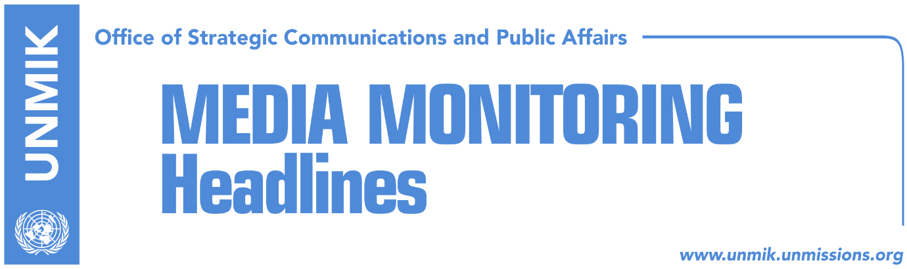

Main Stories 13 August 2018

- Thaci: Dialogue needs to end in mutual recognition (Epoka e Re)
- Halimi: Unification with Kosovo to go through Assembly (Koha Ditore)
- Serwer: Partition or exchange of territories lead to destabilization (Koha)
- Leigh: EU does not support Kosovo’s change of borders (dailies)
- Simic: Kosovo Serbs to agree to partition if they gain more rights (Koha)
- Government denies Association/Community having executive powers (Epoka)
- Man arrested for threatening President Thaci’s family (Kallxo/Zeri)

Kosovo Media Highlights

Thaci: Dialogue needs to end in mutual recognition (Epoka e Re)
President of Kosovo, Hashim Thaci, responded on Twitter to former Swedish prime minister Carl Bildt who said that ‘whoever speaks of [border] correction is embracing a new wave of ethnic cleansing’. Thaci said he was committed to Kosovo’s path to NATO and EU. “We must bring about reciprocal recognition and good neighbourly relations between Kosovo and Serbia,” Thaci wrote adding that a peaceful, agreed border demarcation will guarantee multiethnicity. “Delays will cost us too much,” he underlined. Bildt said he agreed on Kosovo’s and Serbia’s need to further their European integration but noted that this should be done by protecting the joint borders and the multiethnic character of the region. Thaci also engaged in a Twitter debate with the US analyst on Balkans, Daniel Serwer, who asked Thaci whether he wishes to renegotiate agreement with Kosovo’s main allies who have recognised its independence. Thaci reaffirmed position that he is deeply committed to Kosovo’s membership in NATO and the EU but that it was time to close a chapter in Kosovo-Serbia relations which would bring mutual recognition. He also said he was against any partition of Kosovo. “I’m against partition. I’m against swaps. I’m against status quo. I’m against making a Republika Srpska in Kosovo. But I’m in favour of a peaceful demarcation and settling the 400km long border between Kosovo and Serbia. Balanced agreement is in all our interests, incl US & EU,” Thaci wrote.

Halimi: Unification with Kosovo to go through Assembly (Koha Ditore)
In a front-page interview with the paper Riza Halimi, leader of the Party for Democratic Action in the Presevo Valley, said unification with Kosovo would be realization of aspirations of Albanians living in the Valley but questioned the timing of the proposal. He said the proposal of Kosovo President Hashim Thaci for Presevo Valley to join Kosovo was ‘unexpected’. “It would have been better for this initiative to come from the Assembly of Kosovo as it has the direct voter legitimacy,” Halimi said adding however that Thaci’s proposal is not something that ought to be rejected. “The question is how well this proposal is prepared and is there transparency in this process,” Halimi noted.

Serwer: Partition or exchange of territories lead to destabilization (Koha)
Daniel Serwer, Balkans analyst from the Johns Hopkins University, told the paper that the idea of Kosovo’s partition or territorial exchange with Serbia would not be a process free of consequences which would not only affect relations between Albanians and Serbs but the entire region. “I don’t think this is a realistic and wise solution. There will always be people left on the ‘wrong side’ of each ‘corrected border’. An exchange of territories would put the majority of Serbs in Kosovo, who live south of River Iber, in danger. And if not in Presevo, such a solution would put Albanians living elsewhere in Serbia in danger,” Serwer said.

Leigh: EU does not support Kosovo’s change of borders (dailies)
In an interview with Deutsche Welle, Michael Leigh from the German Marshall Fund said the EU has not changed its policies regarding support for Kosovo’s territorial integrity and that it would be ‘almost impossible’ for the EU to reach consensus in favour of changing ‘territorial status quo between Serbia and Kosovo’. “The partition is based on ethnic purity and not the need to live together in a multiethnic society. This way of doing things had a tragic history in the Balkans and is not in line with EU principles,” Leigh said.

Simic: Kosovo Serbs to agree to partition if they gain more rights (Koha)
Igor Simic, deputy leader of the Serbian List, said Kosovo Serbs would agree to partition of Kosovo on condition such an agreement would grant them more freedoms and rights. Simic told Serbia’s broadcaster RTS that Serbs in Kosovo have been living in limbo for decades. “When you consider everything, if there is possibility for economic and political progress, I am convinced such a solution would be supported by Serbs,” Simic said.

Government denies Association/Community having executive powers (Epoka)
The government of Kosovo has denied the possibility of the Association/Community of Serb-majority municipalities having executive powers. National Coordinator for State Reforms, Besnik Tahiri, told the paper that all institutions of Kosovo need to abide by Constitutional Court’s rulings while the government of Kosovo will make sure the Association/Community has no executive responsibilities.

Man arrested for threatening President Thaci’s family (Kallxo/Zeri)
A man from the village of Jabllanica, Klina municipality, was arrested over the weekend for threatening President of Kosovo Hashim Thaci’s family in Buroja, Skenderaj/Srbica municipality. The man is said to have threatened Thaci’s family in connection to an agriculture grant he was refused.

Disclaimer
This media summary consists of selected local media articles for the information of UN personnel. The public distribution of this media summary is a courtesy service extended by UNMIK on the understanding that the choice of articles translated is exclusive, and the contents do not represent anything other than a selection of articles likely to be of interest to a United Nations readership. The inclusion of articles in this summary does not imply endorsement by UNMIK.

