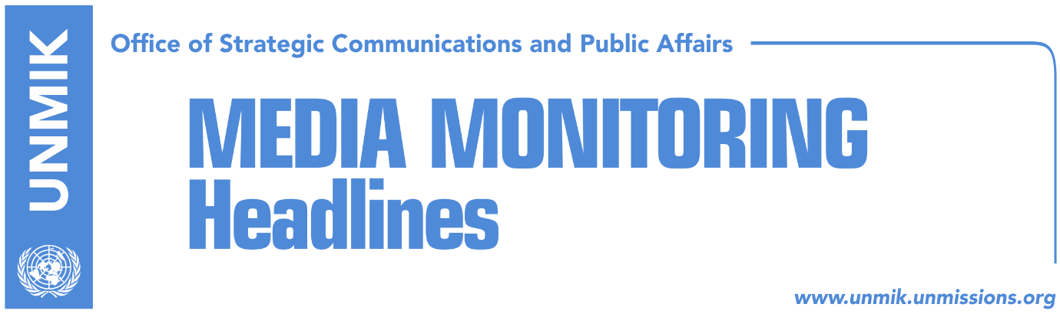

Main Stories 14 August 2018

- Merkel: No change of borders in the Balkans (dailies)
- Thaci continues to promote ‘border adjustment’ idea (media)
- Arifi: Technical dialogue with Serbia ‘clinically dead’ (Telegrafi)
- Kurti: Talk of territory leads closer to war than to peace (VOA/Zeri)
- Ahmeti: Debate on border correction, more imagined than concrete (Epoka)
- Rakic: No one should touch competencies of Serb municipalities (RTK)
- “Mogherini to be dismissed if she participated in partition talks” (RFE/Koha)
- Kosovo’s MFA: Serbia to distance itself from Milosevic’s policies (RTK)

Kosovo Media Highlights

Merkel: No change of borders in the Balkans (dailies)
Several papers carry the statement of the German Chancellor Angela Merkel following meeting with the Chairman of the Council of Ministers of Bosnia and Herzegovina, Denis Zvizdic, that there can be no border changes in the Western Balkans. “Territorial integrity of Western Balkan countries is settled and inviolable,” Merkel said at a joint press conference with Zvizdic. Merkel added that this view needs to be continuously reaffirmed because of tendencies to discuss borders. “There is a European perspective for all countries of the Western Balkans,” Merkel added.

Thaci continues to promote ‘border adjustment’ idea (media)
Kosovo President, Hashim Thaci, thanked yesterday politicians and citizens from Presevo Valley that have supported his idea for “border adjustments”. “I want to thank once again the leaders and citizens of Presevo Valley who are supporting our common objectives for Presevo, Bujanovac and Medvedja joining Kosovo, as part of border adjustments between Kosovo and Serbia. This right should unite us all regardless of party, ideological and other differences, including the ruling parties, civil society and the opposition,” Thaci wrote in a Facebook post.

Arifi: Technical dialogue with Serbia ‘clinically dead’ (Telegrafi)
Avni Arifi, Kosovo’s chief negotiator for technical dialogue with Serbia, said that the process has been ‘clinically dead’ for a while now because of Brussels and Belgrade. He said agreements reached in the course of the technical dialogue are largely not implemented and even those that initially had are now degrading. He mentioned in this respect the agreement for freedom of movement. The Kosovo side, meanwhile, said Arifi has approved the establishment of the Management Team to prepare the draft statute for the Association/Community of Serb-majority municipalities but that according to their information the draft has not yet been submitted to Brussels.

Kurti: Talk of territory leads closer to war than to peace (VOA/Zeri)
Vetevendosje leader, Albin Kurti, told Voice of America that the so-called border correction or exchange of territories with Serbia can have damaging consequences. “I am particularly concerned because based on the most recent bitter history of the Balkans, discussions on exchange of territories lead to displacement of the populations rather than actual change of borders. We know full well that dialogue on territories is closer to war than peace,” Kurti said. He noted that President of Kosovo Hashim Thaci’s introduction of the border change topic at this time is linked to his fear of being indicted by the Specialist Chambers.

Ahmeti: Debate on border correction, more imagined than concrete (Epoka)
Ali Ahmeti, leader of the Democratic Union for Integration (BDI), Albanian political party in the Former Yugoslav Republic of Macedonia (FYROM,) told the paper that recent debate on exchange of territories or division of Kosovo resembles more an imagined debate than something concrete. “I have not seen any discussions or roundtable where concrete matters would be discussed. I consider that demarcation also with Serbia, helps Kosovo become member of all world mechanisms,” Ahmeti said adding that he considers that current problem cannot be resolved without NATO’s, EU’s and Washington’s direct engagement.

Rakic: No one should touch competencies of Serb municipalities (RTK)
Goran Rakic, leader of the Serbian List said that no one should dare touch competencies of the Serb municipalities. Rakic’s statement comes as a response to the recently announced investment plan by the Kosovo Assembly’s President Kadri Veseli, on both sides of River Iber/Ibar. Rakic said Veseli can build towers and cities on the Serbian land “Only over our dead bodies” and warned him not to try such a thing.

“Mogherini to be dismissed if she participated in partition talks” (RFE/Koha)
In a debate for Radio Free Europe, Serbian analyst Dusan Janjic said that if the EU High Representative for Foreign Affairs and Security Policy Federica Mogherini has taken part in discussions between Kosovo and Serbia presidents over partition of Kosovo and exchange of territories, she has clearly overstepped her competencies and would have to be dismissed. Meanwhile, Kosovo MP Ilir Deda, who also participated in the debate, said Thaci’s use of ‘border correction’ notion is a euphemism for partition of Kosovo. Deda said Thaci is giving contradictory statements on daily basis and is politically isolated as “no political party in Kosovo, not even his former party, support change of borders.”

Kosovo’s MFA: Serbia to distance itself from Milosevic’s policies (RTK)
Kosovo’s Ministry for Foreign Affairs confirmed through its Liaison Office in Belgrade another case of arrest of a Kosovo Albanian while crossing the territory of Serbia. According to this office, the individual was arrested under the same charges as other Kosovo citizens, for terrorism during the time of conflict. In its reaction, Kosovo’s Foreign Ministry called continuous arrests ‘witch hunting’ and continuation of Milosevic’s policies. The Ministry called on Serbia to urgently stop mistreating Kosovo citizens and respect human rights of those who are using Serbia as transit during the time of holidays. The Ministry once again called on the EU, Quint states and international community to urgently warn the neighboring country about such behavior and insist on immediate release of the arrested.

Disclaimer
This media summary consists of selected local media articles for the information of UN personnel. The public distribution of this media summary is a courtesy service extended by UNMIK on the understanding that the choice of articles translated is exclusive, and the contents do not represent anything other than a selection of articles likely to be of interest to a United Nations readership. The inclusion of articles in this summary does not imply endorsement by UNMIK.

