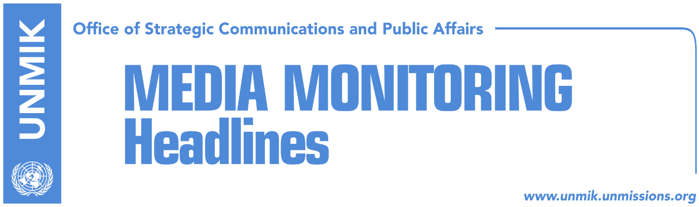

Main Stories 17 August 2018

- Dialogue to resume in September (Zeri)
- US: Kosovo and Serbia to reach agreement which creates stability (Zeri)
- Kosnett: We haven’t changed position (Koha)
- Heldt welcomes Merkel’s statement against border changes (media)
- Kosovo border changes could threaten U.S. geo-strategic interests (Koha)
- Serbian President Vucic to visit Kosovo on September 9 (media)
- Blakaj signed indictment on false war veterans one month before resigning (Koha)
- Lumezi: 19 thousand individuals illegally granted status of veteran (media)
- “Kosovo didn’t take over obligation to form ACSMM, as Serbia’s tool” (Epoka)
- Liberalisation of visas, part of the EU agenda on 28 August (Epoka)
- “Kosovo loses game if it accepts less than complete sovereignty” (Kosova Sot)
- Kosovo to organize march for missing persons on August 30 (media)

Kosovo Media Highlights

Dialogue to resume in September (Zeri)
Carlos Martin, Spokesperson of the European Commision said on Thursday that Pristina and Belgrade will decide on the issues to be discussed at dialogue for normalization of relations. to According him, He said Presidents Vucic and Thaci agreed to intensify dialogue and to meet in September and according to him, they have had an intensive and productive discussion on the framework of an agreement for permanent normalization of relations. “A sustainable solution means a sustainable and realistic solution in accordance with the international right,” Martin said.

US: Kosovo and Serbia to reach agreement which creates stability (Zeri)
Officials from the U.S. Embassy to Kosovo told the paper that the U.S. continue to support Kosovo-Serbia dialogue facilitated by the EU, but not to allow unlimited freedoms of acting in this process. They added that the parties should reach an agreement which does not cause instability in the region. “Content of any agreement for normalization of the relations between Kosovo and Serbia should come from parties themselves. We will continue to support both parties and the EU as facilitator. Kosovo and Serbia should reach an agreement which is implementable, sustainable and which does not create instability in any of the countries or in the region. This will require vision ans flexibility of both parties,” was written in the response of the U.S. Embassy in Kosovo.

Kosnett: We haven’t changed position (Koha)
Philip Kosnett, the U.S. diplomat who is expected to succeed Greg Delawie as the new U.S. Ambassador to Kosovo, said on Thursday that the U.S. administration has not changed its position and that it supports the EU-facilitated dialogue between Kosovo and Serbia. Kosnett told the U.S. Senate’s Foreign Affairs Committee: “We think it is of critical importance for both countries to advance and overcome old tensions. We believe it is critically important for them to be able to discuss new ideas. This is not a code-word to cover up the idea for exchange of territories. We want to see what ideas the two governments will bring. Our long-term strategic objective is to see stability in the region, the resolution of old disagreements between the two countries in ways that strengthen their ties to the West”. Kosnett also said that “the most immediate priority for the U.S. is the normalization of relations between Kosovo and Serbia. This would strengthen regional stability and would pave the way for the integration of both countries in the European Union. The U.S. fully support dialogue between the two countries and the intensification of high-level talks. If my appointment is confirmed, I will encourage Kosovo to work on a solution that improves the lives and guarantees the security of all its citizens”.

Heldt welcomes Merkel’s statement against border changes (media)
The German Ambassador to Kosovo, Christian Heldt, welcomed on Thursday a recent statement by German Chancellor Angela Merkel who said that the borders of the six countries of the Western Balkans are untouchable. Heldt said Kosovo and Serbia should talk about improving the lives of their citizens and not on border changes.

Kosovo border changes could threaten U.S. geo-strategic interests (Koha)
The paper reports in one of its front-page stories that the proposal on border adjustments by Presidents Hashim Thaci and Aleksandar Vucic, will have implications beyond the region. The paper notes that the U.S., Germany, the United Kingdom and France have rejected the idea for border adjustments. Germany’s Ambassador to Kosovo, Christian Heldt, said on Thursday in Pristina that the time of border changes is over. “There will be no border changes,” he was quoted as saying. British Ambassador, Ruairi O’Connell said the idea of exchanging territories could set in motion other precedents in the Balkans. The paper also notes that some EU member states are concerned that the idea could be supported by the Trump administration.

Serbian President Vucic to visit Kosovo on September 9 (media)
Serbian President, Aleksandar Vucic, said on Thursday that he will visit Kosovo on September 9, online media report. He said Belgrade’s objective is to protect the property, state and interests of Serbia and that it is necessary to say the truth and to protect the rights of Serbs living in Kosovo. Vucic also said he was confident that if an agreement is reached with Pristina, “Serbs will have more than they do now”.

Blakaj signed indictment on false war veterans one month before resigning (Koha)
The paper reports on its front page that Elez Blakaj, who recently resigned as special prosecutor with the Special Prosecution of Kosovo, had signed an indictment against false war veterans around one month before submitting his resignation. The paper has secured a copy of the indictment which accuses 12 persons: Agim Ceku, Nuredin Lushtaku, Sadik Halitjaha, Shkumbin Demaliaj, Qele Gashi, Shukri Buja, Ahmet Daku, Rrustem Berisha, Faik Fazliu, Smajl Elezaj, Fadil Shurdhaj and Xhavit Jashari. The indictment notes that all suspects, as members of the government verification committee on war veterans, intentionally surpassed their competencies and failed to meet their official duties. The paper also notes that the state budget must pay €38.8 million for the 19,060 false war veterans every year.

Lumezi: 19 thousand individuals illegally granted status of veteran (media)
According to the Chief Prosecutor of Kosovo Aleksander Lumezi, there are 19 thousand individuals were granted the status of war veteran illegally and they receive benefits from the state. Lumezi told Radio Free Europe that prosecutor Elez Blakaj resigned after drafting an accusation against some individuals involved in this case, which he had submitted to the Special Prosecution for further suggestions. Asked if the prosecution fears politics, Lumezi said “politicians should be afraid of prosecution, not the other way around”. He stressed that Kosovo’s Prosecution has issued 63 arrest warrants for war crimes, while only two prosecutors dealt with them, one being the resigning prosecutor Blakaj. He said he is not aware when would the Special Prosecution based in Hague issue the first indictments, explaining that they are still in the investigation process.

“Kosovo didn’t take over obligation to form ACSMM, as Serbia’s tool” (Epoka)
Avni Arifi, head of the Kosovo delegation for technical discussions with Serbia, said Kosovo has taken international obligation to create the Association/Community of Serb-Majority Municipalities as a form of advancing the position of Serb community in Kosovo. He took to Facebook to write that Kosovo continues to seek solution and there is sufficient consensus in Kosovo society to find a solution, “always by guarding the constitutionality, territorial integrity and functionality of the state. Kosovo has never taken over obligation to establish an association that would serve as Serbia’s instrument to defunctionalize and control Kosovo state,” Arifi wrote adding that such ideas would not pass.

Liberalisation of visas, part of the EU agenda on 28 August (Epoka)
Igor Soltes, European Parliament Rapporteur for Kosovo told Kosovo’s Minister for European Integration Dhurata Hoxha through a telephone conversation that Committee on Civil Liberties, Justice and Home Affairs (LIBE) will meet on 28 August, and that liberalization of visas for Kosovo will be in the agenda. Soltes reportedly said that he was optimistic that this process will gain the green light to move forward.

“Kosovo loses game if it accepts less than complete sovereignty” (Kosova Sot)
David Kanin, former CIA analyst for the region and Europe, and current professor for European Studies at John Hopkins University, said pathology of the West on any exchange of territories truncates discussions of Kosovo and Serbia. He said that Europe’s history is a history of change of borders. However, according to him reopening of the debate is a trivial matter and the most important tissue is Kosovo’s sovereignty, which will remain open as long as Serbia and five EU countries do not recognize it. He said Kosovo loses the game is it accepts less than complete sovereignty in the discussions.

Kosovo to organize march for missing persons on August 30 (media)
Most online media report that Kosovo will organize a march for missing persons on August 30 in Pristina. Over 1,600 persons are still missing from the last conflict in Kosovo and their families are calling for greater commitment by the relevant institutions to resolve the fates of their loved ones. “It is everyone’s responsibility to raise their voice for missing persons and their families. Dignity, truth and justice for missing persons must be established. Kosovo’s society cannot achieve reconciliation and sustainable peace without addressing issues related to the war, including the fate of missing persons,” organizers of the march said.

Disclaimer
This media summary consists of selected local media articles for the information of UN personnel. The public distribution of this media summary is a courtesy service extended by UNMIK on the understanding that the choice of articles translated is exclusive, and the contents do not represent anything other than a selection of articles likely to be of interest to a United Nations readership. The inclusion of articles in this summary does not imply endorsement by UNMIK.

