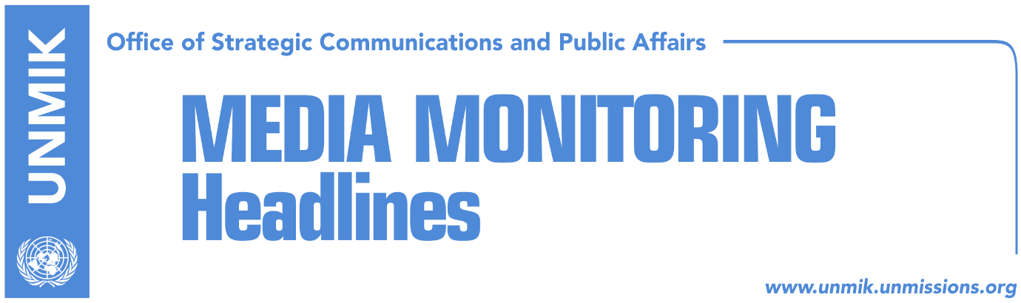

Main Stories 30 August 2018

- Mogherini: Difficult, but possible meetings, for an agreement (media)
- Haradinaj with opposition against Thaci (Koha)
- Thaci does not obey the Assembly (Zeri)
- Former international envoys warn EU about Kosovo’s partition (Kosova Sot)
- Vucic to meet Serb families on 9 September (Zeri)
- Edita Tahiri alarms about the ACSMM (Zeri)
- Gjetaj: Dialogue to be conditioned with shedding light on the missing (Epoka)
- Protest for dismissal of state chief prosecutor goes on (Zeri)

Kosovo Media Highlights

Mogherini: Difficult, but possible meetings, for an agreement (media)
The European Union High Representative, Federica Mogherini, said on Wednesday she expects “difficult but possible” negotiations on a sustainable agreement between Kosovo and Serbia, in Brussels next week. “I will hold a new session of dialogue with the two presidents, Serbian President Aleksandar Vucic, and Kosovo President Hashim Thaci, in Brussels next Friday on September 7. We will continue with the difficult talks, but like I have said they are possible, for reaching a legally binding agreement,” Mogherini was quoted as saying.

Haradinaj with opposition against Thaci (Koha)
The paper reports on its front page that the opposition has received support from Prime Minister Ramush Haradinaj but was slammed by President Hashim Thaci regarding the resolution that aims to stop Thaci and anyone else from negotiating Kosovo’s borders with Serbia. The paper notes that the text of the resolution must be harmonized with AAK and NISMA, two parties from the ruling coalition. The AAK wants one point of the document to express Kosovo’s readiness for dialogue with Serbia. Meanwhile, the Democratic League of Kosovo (LDK) expects the document to be supported by over 2/3 of MPs in the Assembly. Prime Minister Haradinaj said on Wednesday: “I hope we will have clarity and I hope we will all reach an agreement. First, dialogue must happen and a legally-binding agreement on mutual recognition between Kosovo and Serbia must be reached. Second, this agreement must not include the sovereignty, territorial integrity or changing of Kosovo’s borders. I believe we all agree on these two points”.

Thaci does not obey the Assembly (Zeri)
The paper reports on its front page that the Assembly of Kosovo is expected to endorse on next Tuesday a resolution which expresses the position of the representatives of the people against “correction of borders” with Serbia. However, Bekim Collaku, chief of staff at the Office of the President, told the paper that “sovereignty of the Republic of Kosovo is defended only by the constitution of the country and not by some resolution or declaration which can be approved be it from the Assembly or anybody else.”

Former international envoys warn EU about Kosovo’s partition (Kosova Sot)
The paper reports on page two that former international envoys in Bosnia and Herzegovina – Paddy Ashdown, Carl Bildt and Christian Schwartz-Schilling – wrote an open letter to EU High Representative Federica Mogherini and to EU Foreign Ministers calling on them to abandon plans for the exchange of territories between Kosovo and Serbia. They also expressed their concern that border changes in the region would not help solve disputes in the Balkans but would only make them worse.

Vucic to meet Serb families on 9 September (Zeri)
The President of Serbia Aleksandar Vucic will be visiting Kosovo on 9 September. Kosovo’s Minister for Returns, Dalibor Jevtic, informed that he will also meet Serb families. He added 5that Vucic will present the final solution of the Kosovo problem, depending on the flow of the dialogue which will resume on 7 September. “We should take into consideration the factual situation. It is easier to avoid responsibility and push problems under the rug, but these problems will be awaiting us who live in Kosovo sooner or later,” Jevtic said.

Edita Tahiri alarms about the ACSMM (Zeri)
Former chief negotiator of the government of Kosovo at the discussions in Brussels Edita Tahiri, accused the government of Kosovo for neglecting major issues of the Association of Serb-Majority Municipalities, which according to her could leave consequences for Kosovo. According to her the entire process went in a wrong manner. “The government allowed only the representatives of Serb community to be part of the managing team for drafting the statute. This was violation of the Brussels Agreement, because the drafting should commence by a managing team for Serb municiplaities and the government of Kosovo, respectively, the Ministry of Public Administration, as well as the OSCE in Kosovo,” she said.

Gjetaj: Dialogue to be conditioned with shedding light on the missing (Epoka)
Head of the government committee for the missing persons Prenk Gjetaj has requested from Kosovo and international authorities to include the issue of the missing persons in the dialogue between Kosovo and Serbia. He said that resumption of the dialogue should be conditioned with the shedding light on the fate of the missing. He however added that the international community has not shown interest for the issue of the missing to become part of the Brussels discussions. Today, on the International Day of the Missing Persons, a remembrance march is expected to take place in Kosovo to honor the missing persons.

Protest for dismissal of state chief prosecutor goes on (Zeri)
The second protest of the civil society requesting dismissal of the chief prosecutor Aleksander Lumezi, vetting for the judicial system and cleaning the veterans’ lists, took place on Wednesday. Carrying slogans “Lumezi go,” “population against corruption,” and many others, hundreds of protesters marched the Zahir Pajaziti Street.

Disclaimer
This media summary consists of selected local media articles for the information of UN personnel. The public distribution of this media summary is a courtesy service extended by UNMIK on the understanding that the choice of articles translated is exclusive, and the contents do not represent anything other than a selection of articles likely to be of interest to a United Nations readership. The inclusion of articles in this summary does not imply endorsement by UNMIK.

