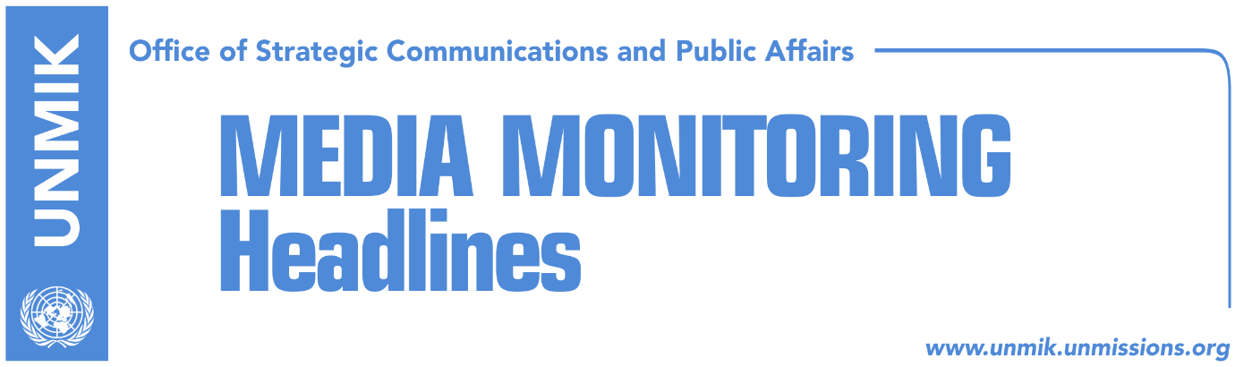

Main Stories 31 August 2018

- President Thaci meets leaders of ruling coalition parties (media)
- Mitchell and Thaci discuss agreement with Serbia (Zeri)
- Mogherini: EU in the Balkans is entering a second phase (media)
- Haziri: Presevo Valley should join Kosovo (RTK)
- Rugova: Assembly must stop initiative that threatens territorial integrity (Epoka)
- Opposition to start with protests after the extraordinary session (Zeri)
- Petrisch: The best solution will be the one coming from Kosovo and Serbia (Zeri)
- Tahiri: Assembly has historic responsibility to say NO to border changes (Epoka)
- UN Security Council will not be discussing Kosovo in September either (Zeri)

Kosovo Media Highlights

President Thaci meets leaders of ruling coalition parties (media)
Under the leading front-page headline Fear from opposition assembles heads of state, Koha Ditore reports that two meetings were held on Thursday in the office of President Hashim Thaci, on dialogue with Serbia. Prime Minister Haradinaj, Assembly President Veseli, and deputy prime ministers Limaj and Gashi, attended the meetings. After the first meeting, Haradinaj told reporters that Thaci said he would not discuss Kosovo’s territory or borders in Brussels. “What is important is that the President has made it clear that Kosovo will not be divided,” Haradinaj said. “He respects the territory and integrity. He respects and works according to the Constitution, so there will be no discussions and he will not accept any discussions for partition. Now it is important to clarify our objectives: the territory and borders will not be the subject of any dialogue. Also important is for the opposition and all stakeholders to be involved in dialogue”. President Thaci said after the meetings that leaders agreed unanimously that dialogue must continue and that he will attend the September 7 meeting with Serbian President Aleksandar Vucic in Brussels. Unlike Haradinaj though, Thaci reiterated his idea on border changes. “What I want to say finally and officially, whether or not someone like this, I will table the request of Albanians from Presevo Valley, for that part to join the territory of Kosovo. I don’t have any nostalgia about the lines that were designated in the most difficult times, when Albanians were expelled in 1956 at the time of the notorious Aleksandar Rankovic. When I talk about correction, this means correcting the injustices that were made against the Albanian people”. Zeri notes in one of its front-page headlines that Thaci does not give up on idea for border correction. Kosova Sot reports on its front page that The adventure continues, Thaci again going to Vucic’s lap. The paper, in its front-page editorial, argues that “Thaci forgot about missing persons, war crimes and damages worth billions!” Epoka e Re says on its front page that “Thaci has reconfirmed his idea on border correction”.

Mitchell and Thaci discuss agreement with Serbia (Zeri)
The President of Kosovo Hashim Thaci took to Facebook to inform that he had a telephone conversation with the U.S. Assistant Secretary of State Wess Mitchell. According to Thaci, they agreed on intensification of the efforts to reach an agreement between Kosovo and Serbia ‘which will once and for all end hostilities between Kosovo and Serbia. An agreement which would open way to mutual recognition and clear perspective of Kosovo for NATO, EU and UN membership as well as other international organisations”. According to him, Mitchell pledged that Kosovo will have the unwavering support of the United States in this process. “Involvement of the U.S. and other strategic partners of Kosovo in the final phase of the dialogue, facilitated by EU, is a guarantee for success and for reaching a historic agreement. Friendship and trust on the U.S. will be eternal,” Thaci wrote.

Mogherini: EU in the Balkans is entering a second phase (media)
EU High Representative, Federica Mogherini, said in the meeting of EU defense ministers in Vienna on Thursday, that the role of the EU in the Balkans has been to create security. “Traditionally, we have viewed the Western Balkans as a region of instability where for many years, decades even, the EU had the role of security provider. We are now entering a phase where we are partners in defense and common security,” she said. “We have talked with NATO and UN, our key partners in the region, on improving cooperation in defense and security as a comprising part of our work in the Western Balkans”.

Haziri: Presevo Valley should join Kosovo (RTK)
Democratic League of Kosovo (LDK) deputy leader, Lutfi Haziri, said in an interview to RTK on Thursday, that “the best solution for an agreement between Kosovo and Serbia, is to designate the 1956 border, whereby Presevo, Bujanovac and Medvedja would join Kosovo”. “If Corridors 8 and 10 are in the territory of Presevo Valley, then they are part of Kosovo and not Serbia,” Haziri said, adding that Serbia in return would get some villages from the northern part of Kosovo.

Rugova: Assembly must stop initiative that threatens territorial integrity (Epoka)
Democratic League of Kosovo (LDK) MP, Naser Rugova, says in a front-page interview to the paper, that the Kosovo Assembly must have the final say on the idea for correcting the border between Kosovo and Serbia. Rugova said at the assembly session on September 4, MPs must adopt the resolution on safeguarding Kosovo’s territorial integrity. He also said he was optimistic that all parties – including the ruling coalition partners – will support the resolution.

Opposition to start with protests after the extraordinary session (Zeri)
Vetevendosje Movement has announced start of protests next week in Pristina “to oppose the initiative of the President Hashim Thaci for correction of the borders with Serbia.” Furthermore, the most voted MP from the Democratic League of Kosovo (LDK) Vjosa Osmani, also called for a protest on 7 September, the day when Presidents Hashim Thaci and Aleksandar Vucic are expected to meet in Brussels. However, officials from this political party denied their participation in a protest organized by Vetevendosje. Kosovo Assembly MP from Alternativa, Ilir Deda also announced massive protests after 4 September. “The red line for Thaci will initially be drawn at the Assembly on 4 September, then with massive civic protests,” Dedaj wrote on his Facebook account.

Petrisch: The best solution will be the one coming from Kosovo and Serbia (Zeri)
Former EU Envoy for Kosovo, Wolfgang Petrisch, said on Thursday that the best solution is the one coming from Belgrade and Pristina. He said he supports the idea of demarcation which caused many reactions and added that no proposal should be rejected. He expressed surprise while interviewed by the Belgrade news agency Tanjug that none sees a problem with demarcation between Slovenia and Croatia while the same problem between Kosovo and Serbia is being challenged. Petrisch claims that if for practical reasons correction of the border is necessary and if it brings more security and peace, then it should happen. “We in EU are continuously with the countries of the region, that need to find a solution to their problems and when we can help on finding difficult compromises… There is no doubt that this is the chance and possibility to find a solution between Belgrade and Pristina,” he said.

Tahiri: Assembly has historic responsibility to say NO to border changes (Epoka)
Kosovo’s former chief negotiator in talks with Serbia, Edita Tahiri, called on members of the Kosovo Assembly on Thursday to oppose ideas for changing Kosovo’s borders. Tahiri argued in a Facebook post that the Assembly has the historic responsibility to say NO to border changes. “We must defend the liberation war against Serbia in 1999 and defeat Serbia’s hegemonistic ambitions and Russian geo-political agendas,” she wrote.

UN Security Council will not be discussing Kosovo in September either (Zeri)
The United States of America which will be presiding with the UN Security Council in September, might follow the example of the United Kingdom, by not including the report of the UN Secretary General Antonio Guterres’ report on the situation Kosovo in the agenda. At least this is what Serbia’s Foreign Minister told the Serbian media. According to him, the report on Kosovo might be discussed during October or November, when Bolivia respectively China will be presiding the UN SC. “We will not give up and we expect for the presider to be someone who is in our favor,” Dacic said.

Disclaimer
This media summary consists of selected local media articles for the information of UN personnel. The public distribution of this media summary is a courtesy service extended by UNMIK on the understanding that the choice of articles translated is exclusive, and the contents do not represent anything other than a selection of articles likely to be of interest to a United Nations readership. The inclusion of articles in this summary does not imply endorsement by UNMIK.

