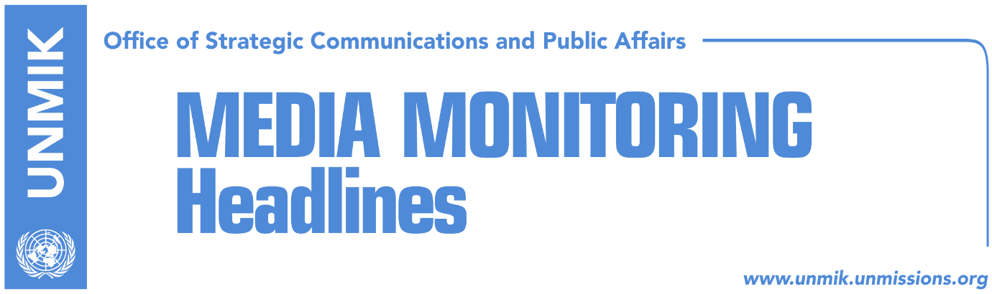

Main Stories 01 September 2018

- Mogherini: Kosovo and Serbia to avoid ethnically pure states (media)
- Veseli: Territorial integrity is inviolable (RTK)
- Hoti: Veseli’s statements, delayed (RTK)
- Thaci at a public debate with civil society on correction of borders (RTK)
- Weber: Germany will impede EU membership if borders change (DW, Kosovo media)
- Alternativa breaches coalition with LDK (media)
- Kouchner supports correction of borders: it is a good idea (RTK)

Kosovo Media Highlights

Mogherini: Kosovo and Serbia to avoid ethnically pure states (media)
EU foreign policy chief Frederica Mogherini said at a press conference in Vienna, after her meeting with EU foreign Ministers and their Balkans counterparts that she would support exchange of territories between Kosovo and Serbia if the two countries avoided any effort to create ethnically pure states.
“Whatever outcome that is mutually agreed would get our support, provided it is as it is being discussed currently, in line with the international law,” Mogherini said.

Veseli: Territorial integrity is inviolable (RTK)
Kadri Veseli, leader of the Democratic Party of Kosovo (PDK,) said the Constitution of Kosovo is the foundation of Kosovo state. “During the last months PDK appealed and undertook concrete initiatives to approximate political and inter-party positions as well as to reach a national consensus. The position of the PDK is consistent and clear: Violation of the sovereignty, territorial integrity of our state and that of the Constitution of the Republic of Kosovo, will not be allowed in any manner.
Kosovo needs national consensus to face Serbia, not divisions among each other for electoral benefits.
The extraordinary session for division called by the opposition can cause serious damage to Kosovo, as an independent and sovereign state as well as to the partnership with the international community.
Legitimizing the issue of the division at the institution of the Assembly without facts, arguments and with clear Constitution is reenactment of the unacceptable game for division, which is a scenario outside Kosovo, the U.S. and the EU.
Democratic Party of Kosovo considers that raising this issue is dangerous for the internal political discourse and will harm the process of the dialogue, creating arguments in favor of anti-Kosovo exponents who want division of Kosovo,” Veseli said.

Hoti: Veseli’s statements, delayed (RTK)
Caucus of the Democratic League of Kosovo (LDK) Avdullah Hoti said further consolidation of Kosovo state has been seriously damaged by anti-constitutional actions of the President Hashim Thaci for exchange of territories with Serbia.
He said Veseli is accomplice on this damage to Kosovo state, as he never raised his voice against these actions against Kosovo state by President Thaci.

Thaci at a public debate with civil society on correction of borders (RTK)
Kosovo Democratic Institute (KDI) is expected to organize on 5 September a public discussion between the President of Kosovo Hashim Thaci, civil society and media. The subject of the discussion will be “What does correction of border between Kosovo and Serbia mean?”

Weber: Germany will impede EU membership if borders change (DW, Kosovo media)
Bodo Weber, German political expert, siad that official Berlin insists on its earlier position on change of the borders in Balkans and stressed that Germany will impede integration of Serbia and Kosovo in EU, if this happens.
He further blamed the EU High Representative Frederica Mogherini for bringing the dialogue to this level. According to him, in 2013 the dialogue was a success and Serbia was in a position to accept that Kosovo is not its part. He also criticized policies of the U.S. President Donald Trump.

Alternativa breaches coalition with LDK (media)
Alternative for Kosovo has breached coalition with the Democratic League of Kosovo (LDK). The news was confirmed by the leader of this political party, Mimoza Kusari-Lila. “From now on, me and Ilir will be independent MPs at the Assembly of Kosovo, representing Alternative,” she said and added that their political party need more focus on its promotion and more space.

Kouchner supports correction of borders: it is a good idea (RTK)
Former UN Special Representative of the Secretary General Bernard Kouchner supports the idea of correction of the borders between Kosovo and Serbia. According to him, this option was mentioned even earlier and that it would have been a good idea if both parties agreed. He told the BBC that this agreement would mean “the end of the war.”

Disclaimer
This media summary consists of selected local media articles for the information of UN personnel. The public distribution of this media summary is a courtesy service extended by UNMIK on the understanding that the choice of articles translated is exclusive, and the contents do not represent anything other than a selection of articles likely to be of interest to a United Nations readership. The inclusion of articles in this summary does not imply endorsement by UNMIK.

