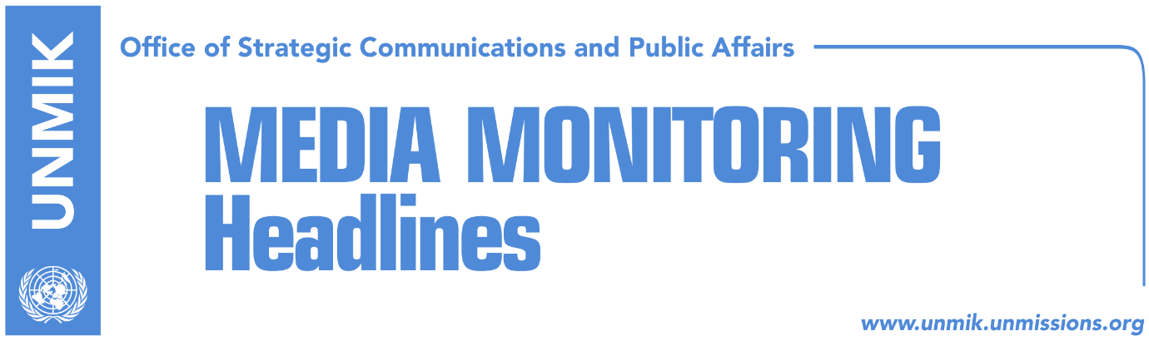

Main Stories 7 September 2018

- Thaci will negotiate borders in Brussels (Koha Ditore)
- Thaci: Kosovo has no meaning without Mitrovica and Gazivoda (media)
- Vucic annuls visit to Kosovo? (Epoka e Re)
- No way out of parliamentary blockade (Koha Ditore)
- IFIMES: Vucic-Thaci agreement for two million new refugees (Koha)
- Serwer and Philips: Change of borders would be dangerous (Epoka)
- Vetevendosje invites LDK to organize protests against Thaci (Epoka)
- LDK: We don’t support protests (Telegrafi)
- Ymeri: Negotiating team should be mandated (RTK)
- Haradinaj: Interpol membership helps fight against transnational crime (RTK)

Kosovo Media Highlights

Thaci will negotiate borders in Brussels (Koha Ditore)
The paper reports on the front page that Kosovo borders will be discussed today in Brussels when President of Kosovo Hashim Thaci is to meet Serbian President Aleksandar Vucic. The paper notes that overwhelming opposition in Kosovo to the idea of border changes has not changed Thaci’s mind and that he will be raising the issue today. Ahead of the meeting, Thaci said that “border adjustment” with Serbia and Presevo Valley’s unification with Kosovo are two separate matters and that meanwhile, EU foreign policy spokesperson Maja Kocijancic only confirmed the meeting will take place Friday but did not specify what issues will be discussed. She said the EU High Representative for Foreign Affairs and Security Policy Federica Mogherini will first meet presidents separately and then they will all have a joint meeting.

Thaci: Kosovo has no meaning without Mitrovica and Gazivoda (media)
Kosovo President, Hashim Thaci, said at the 5th conference of Kosovo’s ambassadors on the EU-brokered dialogue with Serbia that the “border adjustment” with Serbia includes Presevo Valley joining Kosovo but noted that Kosovo would have no meaning without Mitrovica and Gazivoda. “We must use this momentum and resolve our problems. It is not going to be easy, but it is the only way forward … We will coordinate every step with Brussels and the U.S. We will sign an agreement with Serbia only if it is acceptable for the U.S. and Brussels. The conclusion of dialogue will pave a new way for Kosovo’s diplomacy,” he said. “At the London Summit it was said that Western Balkans countries can join the EU only after they resolve their problems. This was a clear message to all Western Balkans countries. We want to build good relations with Serbia too”. Thaci also said, “now is the time to address the topic of Presevo, Bujanovac and Medvedja joining Kosovo. As President, I have accepted the request of Presevo Valley leaders and I have agreed to table it in Brussels. At the end of this process, we see Kosovo recognized by Serbia. Let me reiterate that an agreement with Serbia makes sense only if Serbia recognizes Kosovo”.

Vucic annuls visit to Kosovo? (Epoka e Re)
There are chances that the visit of the Serbian President Aleksandar Vucic to Kosovo, will be annulled. The paper reports based on Belgrade media that Vucic is close to this decision and he has ordered interruption of all contacts with Pristina, and there are chances that the meeting in Brussels scheduled for Friday might be annulled as well. Belgrade daily Vecernje Novosti reported that Kosovo institutions have informed Belgrade that President of Serbia will be banned to visit Gazivoda lake, “which is a provocation that Vucic does not want and cannot stand.” The paper further reports that Vucic might address the nation today (Friday.) The meeting between Presidents Hashim Thaci and Aleksandar Vucic in Brussels is scheduled for today.

No way out of parliamentary blockade (Koha Ditore)
Kosovo Assembly has failed to hold a session where the opposition hoped to push through a resolution preventing President Hashim Thaci from negotiating Kosovo borders in the dialogue with Serbia. The parliamentary crisis, according to Koha, was evident on Thursday when both the ruling and opposition parties struggled to secure quorum to discuss the negotiating team and resolution against Thaci leading the dialogue. In addition, the meeting of the Assembly chairmanship that took place yesterday afternoon ended in deadlock as the opposition did not agree to options presented by the Assembly Speaker Kadri Veseli.

IFIMES: Vucic-Thaci agreement for two million new refugees (Koha)
Koha Ditore publishes a report by the Ljubljana-based International Institute for Middle East and Balkan Studies (IFIMES) which states that so far dialogue between Belgrade and Pristina has shown only modest results “due to obstructions caused by the participating parties in their attempts to achieve certain goals”. The report says Serbian President Aleksandar Vucic and Kosovo’s Hashim Thaci took over leadership of dialogue through ‘arbitrary action’ which should have been at the level of prime ministers and “took the initiative to correct and redefine state borders”. The exchange of territories between Kosovo and Serbia, notes IFIMES, would lead to massive resettlement of people on both sides of the border and would also create ethnic borders. “Analysts warn that this would not solve the problem but instead cause new conflicts, victims, tragedies and at least two million new refugees,” the report says.

More: http://www.ifimes.org/en/9567

Serwer and Philips: Change of borders would be dangerous (Epoka)
David Philips, Director of the Institute for Peace at Columbia University, New York, told Voice of America that the two presidents of Kosovo and Serbia should think deeply about what they are doing, as change of borders means destabilization of the region. Daniel Serwer, U.S. expert on Balkans said even though Kosovo and Serbia can legally do this, exchange of territories is bad if the intention is to exchange populations, which would proceed with homogenization of the countries.

Vetevendosje invites LDK to organize protests against Thaci (Epoka)
The leadership of Vetevenodsje Movement held on Thursday an extraordinary meeting to discuss the current situation in Kosovo. They decided to invite the Democratic League of Kosovo (LDK) for joint protests. “It is necessary to at latest tomorrow set the date of the protest,” informs a press release issued by this political party. According to Vetevendosje Movement, the President of Kosovo Hashim Thaci, is heading towards negotiations with Serbia without being mandates by the Assembly of Kosovo, and without any principles. “The Assembly is blocked. Serbia’s President will come to Kosovo this weekend, but Kosovo government and opposition will not arrest him. “Association” Thaci-Vucic is evident. President of Serbia should not be allowed to enter Kosovo,” is written in their press release.

LDK: We don’t support protests (Telegrafi)
Deputy leader of the Democratic League of Kosovo (LDK), Haki Rugova responded to Vetevendosje’s invitation to join protests to prevent President Hashim Thaci from discussing change of borders saying that the party, in principle, is against the idea of organising protests. “We try to resolve problems within institutions,” Rugova said adding that LDK’s leadership will decide on the future course of actions.

Ymeri: Negotiating team should be mandated (RTK)
Kosovo Assembly MP from the Social-Democratic Party (PSD) Visar Ymeri said on Thursday that it is urgent for the Kosovo Assembly to re-establish decision-making. “It is vital and quite urgent for the Assembly of Kosovo to take over its defense. Otherwise, Thaci’s heading for the dialogue without any kind of mandate, violates the democratic character of the Republic, is bargaining with Vucic endangers territorial integrity,” Ymeri said.

Haradinaj: Interpol membership helps fight against transnational crime (RTK)
Prime Minister of Kosovo Ramush Haradinaj said at the 19th anniversary of the Kosovo Police’s establishment that transnational crime can be fought more efficiently if Kosovo were to become member of Interpol. Haradinaj said Serbia is wrong to object to Kosovo’s membership and “it is a mistake for world countries not to invite Kosovo to become member of Interpol.”

Disclaimer
This media summary consists of selected local media articles for the information of UN personnel. The public distribution of this media summary is a courtesy service extended by UNMIK on the understanding that the choice of articles translated is exclusive, and the contents do not represent anything other than a selection of articles likely to be of interest to a United Nations readership. The inclusion of articles in this summary does not imply endorsement by UNMIK.

