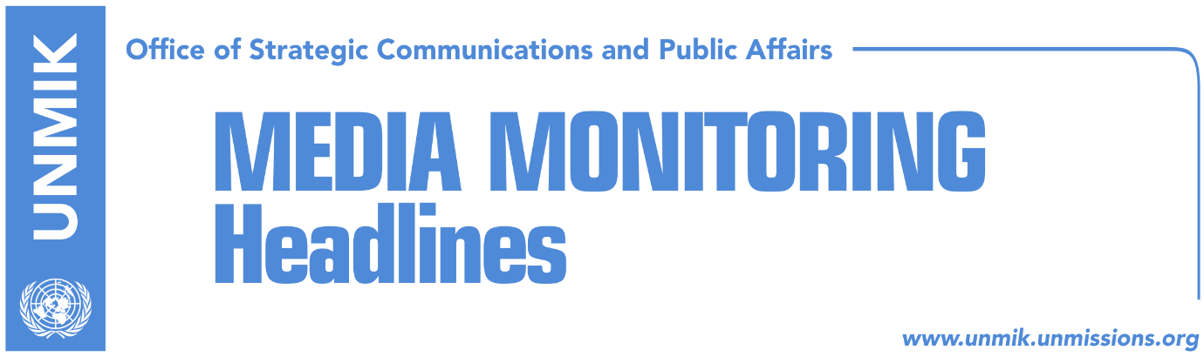

Main Stories 12 September 2018

- “Resolution for Presevo Valley in conflict with Constitution of Kosovo” (Zeri)
- Haradinaj: Border games, dangerous experiment (dailies)
- Montenegro supports dialogue between Kosovo and Serbia (Epoka e Re)
- Hoxhaj: The U.S. support at final phase of dialogue is important (Epoka)
- Commissioner Hahn to visit Kosovo in November (Zeri)
- Soltes hopes Kosovo-Serbia agreement will be reached in coming months (Koha)
- European institutions encouraged to lift visa regime for Kosovo (Zeri)
- Mustafa meets Ambassador Delawie, discuss current issues (Epoka)
- Rubin does not think change of borders would bring Kosovo a UN seat (Kallxo)
- Mayor Jashari meets KFOR commander, discuss current situation (Bota Sot)
- New Specialist Prosecutor signs solemn declaration (Kosova Sot)

Kosovo Media Highlights

“Resolution for Presevo Valley in conflict with Constitution of Kosovo” (Zeri)
The paper on the front page writes that Kosovo Assembly will not be able to pass a resolution in support of Presevo Valley joining Kosovo as this would be in conflict to the Constitution of Kosovo. Prime Minister of Kosovo Ramush Haradinaj said yesterday that his duty is to uphold Constitution of Kosovo which, the paper adds, states that “the Republic of Kosovo shall have no territorial claims against, and shall seek no union with, any State or part of any State.”

Haradinaj: Border games, dangerous experiment (dailies)
Prime Minister of Kosovo, Ramush Haradinaj, said after the meeting of the government today that opening of the border change issue is a ‘dangerous experiment’ and that he opposes such moves. “We are all aware of how dangerous border games are in the Balkans. We know from the past that any time they were open it was not clear where they would end and on whose benefit,” Haradinaj said. “Kosovo does not have the luxury to speak about exchange of territories,” he added. Asked to comment on the proposal of Presevo Valley leaders for the Assembly of Kosovo to approve a resolution expressing support for it joining Kosovo, Haradinaj said his duty is to implement Constitution of Kosovo but that “we will maintain interest for Albanians in the Presevo Valley.”

Montenegro supports dialogue between Kosovo and Serbia (Epoka e Re)
The President of Kosovo Hashim Thaci and his counterpart Milo Djukanovic, met on Tuesday in Podgorica and discussed regional developments. Both presidents informed about their meeting through their Facebook accounts. “It is encouraging to see the support of President Djukanovic for the efforts of Kosovo and Serbia to completely normalize inter-sate relations, with mediation of the European Union, through negotiations and in a peaceful manner reach an agreement acceptable for both parties. Inter-state agreement between Kosovo and Serbia will be an additional contribution for peace and stability in Balkans, as well as for the joint European perspective,” Thaci wrote.

Hoxhaj: The U.S. support at final phase of dialogue is important (Epoka)
Kosovo’s Deputy Prime Minister Enver Hoxhaj, is participating at Bled Strategic Forum in Slovenia. He met with the U.S. Deputy Assistant Secretary of State Mattew Palmer, Montenegro’s Foreign Minister Srdjan Darmanovic, Deputy Foreign Minister of Greece, Terens Quick as well as many other significant personalities participating at this event. During his meeting with Palmer, Hoxhaj stressed the role and importance of the U.S. support in the final phase of the dialogue between Kosovo and Serbia. He said the final agreement should have guarantees of the European Union and of the United States.

Commissioner Hahn to visit Kosovo in November (Zeri)
European Commissioner for Neighbourhood Policy and Enlargement Negotiations, Johannes Hahn, is set to visit Kosovo in November to launch the second part of the European Reform Agenda, announced Prime Minister of Kosovo Ramush Haradinaj. He said Kosovo needs to assure international partners that Kosovo has not been distracted from EU integration aspirations despite current situation.

Soltes hopes Kosovo-Serbia agreement will be reached in coming months (Koha)
European Parliament Rapporteur for Kosovo, Igor Soltes, said it is in the interest of the EU, Serbia and Kosovo for a comprehensive peace agreement be reached between Pristina and Belgrade within a short period of time. He said he regretted the failed meeting between Kosovo and Serbia presidents last week in Brussels but that he hoped an agreement will be reached in the coming months.

European institutions encouraged to lift visa regime for Kosovo (Zeri)
In a written reply to the paper, European Commission said it was encouraging the European Parliament and the Council of Ministers to move forward in line with proposal for visa liberalisation for Kosovo. “Kosovo has made significant progress in the last two years and it is important for implementation of all standards to continue,” European Commission stated. At the same time, Minister of European Integration, Dhurata Hoxha, said she was hopeful that the people of Kosovo will be able to travel freely to Europe by the end of the year. She said Kosovo has given enough evidence to be granted visa liberalisation while Prime Minister Ramush Haradinaj said that the visa liberalisation issue should remain a priority for Kosovo despite other debates going on at present.

Mustafa meets Ambassador Delawie, discuss current issues (Epoka)
Isa Mustafa, leader of the Democratic League of Kosovo (LDK), had on Tuesday a farewell meeting with the U.S. Ambassador Greg Delawie. Mustafa expressed appreciation for Delawie’s contribution and irreplaceable support of the U.S. for Kosovo’s state-building. They also discussed the current important issues for Kosovo and the U.S. role. LDK’s deputy leaders Lutfi Haziri and Agim Veliu also participated at the meeting.

Rubin does not think change of borders would bring Kosovo a UN seat (Kallxo)
Former U.S. Assistant Secretary of State, James Rubin, does not believe that change of borders between Kosovo and Serbia could bring Kosovo’s membership at the United Nations. “We had the best possible Russians in 1999. They became worse each year. It is clear that Russians do not want an independent Kosovo because they think that this is bad for them, they consider that whatever is good for America is bad for them even though Russia does not have any national interest on Kosovo. They block it just because of the grudges with America,” Rubin told Kallxo.com. Asked if Russia would allow Kosovo’s seat at the U.N. if recognized by Serbia. Rubin said “I would in no case trust Serbia. Never. This only way I could trust them, and this does not mean that I would ever trust them, is if I had all the guarantees that Russia would recognize the interdependence of Kosovo. But I would not do anything based on speculations,” Rubin said.

Mayor Jashari meets KFOR commander, discuss current situation (Bota Sot)
Mayor of Skenderaj/Srbica, Bekim Jashari, and his deputy, Nuredin Lushtaku, met yesterday KFOR Commander, Major General Salvatore Cuoci, and discussed the recent developments in the municipality in light of Sunday’s protest of local residents against the visit of Serbian President Aleksandar Vucic. Jashari said the protest came as a result of residents considering Vucic’s visit an insult without him first apologizing for crimes committed by Serbian forces in Kosovo. Jashari said it was positive the protest ended peacefully but he also said there was no cooperation and coordination with central-level institutions which failed to inform him of Vucic’s visit. Jashari also said that Sunday’s protest was by no means directed against local Serb residents but only against Vucic’s planned visit.

New Specialist Prosecutor signs solemn declaration (Kosova Sot)
Specialist Prosecutor Jack Smith signed a solemn declaration that he would exercise his functions independently, impartially and conscientiously, a press release issued by the Specialist Chambers announced. Smith succeeds David Schwendiman who stepped down at the end of March when his term as a US Foreign Service Officer expired.

Disclaimer
This media summary consists of selected local media articles for the information of UN personnel. The public distribution of this media summary is a courtesy service extended by UNMIK on the understanding that the choice of articles translated is exclusive, and the contents do not represent anything other than a selection of articles likely to be of interest to a United Nations readership. The inclusion of articles in this summary does not imply endorsement by UNMIK.

