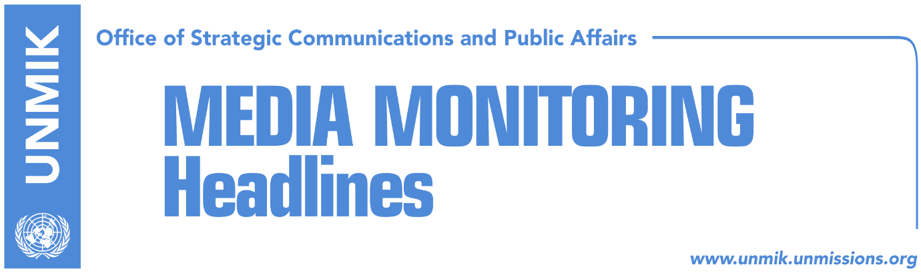

Main Stories 13 September 2018

- New York could be dialogue’s next stop (Koha Ditore)
- Kosovo opposition writes letter to HR Mogherini (dailies)
- Haradinaj: Agreement with Serbia not reached through exchange of land (Zeri)
- Thaci to hold a press conference today (media)
- Thaci receives Ali Ahmeti’s support for agreement with Serbia (Epoka)
- Veseli: Kosovo does not have territorial claims towards any country (RTK)
- Kurti warns of possible incidents incited by Thaci (dailies)
- Collaku: Idea for correction of borders brings long-term peace (RTK)
- Shala: Unification with the Valley does not violate the Constitution (T7)
- EP to vote on visa liberalisation recommendation today (dailies)
- Women network slam Haziri’s remarks towards party fellow Osmani (Bota Sot)

Kosovo Media Highlights

New York could be dialogue’s next stop (Koha Ditore)
The paper quotes unnamed diplomatic sources in Brussels saying that chances are slim for a meeting between Kosovo President Hashim Thaci and Serbian President Aleksandar Vucic taking place in the near future in Brussels and that it is possible for the presidents to meet in New York where the European Commissioner Johannes Hahn is set to meet Western Balkans leaders. Sources said that a special meeting on Kosovo could also take place in New York during this occasion which would also include other international representatives, most likely from the US, Russia and perhaps even China. EU officials in Brussels are not sure this would be a good idea as involvement of other actors in the dialogue for normalisation of relations between Belgrade and Pristina could put the EU in a bad light in the sense that it is not capable unaided to secure agreement between the parties.

Kosovo opposition writes letter to HR Mogherini (dailies)
Kosovo opposition parties – the Democratic League of Kosovo (LDK), Vetevendosje, Social Democratic Party (PSD), Alternativa – have written a letter to the EU High Representative for Foreign Affairs and Security Policy Federica Mogherini expressing their views on the dialogue for normalisation of relations with Serbia. The opposition parties said they were concerned over discussion of territorial exchange and border changes ideas. These ideas, said the opposition, do not have support and any agreement that rests on these theories will not be supported. The parties said the final stage of the dialogue needs to be based on clear principles and that the Assembly of Kosovo is responsible for approving a platform for dialogue with two-thirds of votes. “Any other type of dialogue is destined to fail,” opposition parties underlined in their letter.

Haradinaj: Agreement with Serbia not reached through exchange of land (Zeri)
Prime Minister of Kosovo, Ramush Haradinaj, said that an agreement with Serbia cannot be reached through exchange of territories but through readiness for peace and reconciliation. “Despite the great pain and suffering, Kosovo finds the strength to move towards Europe,” Haradinaj said after meeting leader of the Albanian Democratic Party from the former Yugoslav Republic of Macedonia (FYROM), Menduh Thaci.

Thaci to hold a press conference today (media)
The Office of the President of Kosovo announced that President Hashim Thaci will hold a press conference today (Thursday) at 10:00 hours. Thaci traveled for official visits to Albania, Montenegro and FYROM during this week, and held several meetings with institutional and political leaders to inform them about the final phase of the dialogue with Serbia.

Thaci receives Ali Ahmeti’s support for agreement with Serbia (Epoka)
The President of Kosovo Hashim Thaci met during his visit to the former Yugoslav Republic of Macedonia (FYROM) with the leader of the Democratic Union for Integration (BDI), Ali Ahmeti. “I assured President Thaci that we will be strong supporters of any solution that the institutions of Kosovo would reach on demarcation lines with the Serbian party. These are important and historic moments for Kosovo to close this problem as well, because the region is in need of progress,” Ahmeti said.

Veseli: Kosovo does not have territorial claims towards any country (RTK)
Kadri Veseli, President of the Assembly of Kosovo met on Wednesday in Albania with the leader of the Democratic Party of Albania, Lulezim Basha. He said after the meeting that what Kosovo needs is a consensus for a joint national platform for the final facing with Serbia. According to him, that platform would have only one result: final agreement that would ensure Kosovo’s membership at international organisations. Kosovo has nothing to give or take from the others. Kosovo is a sovereign state and it has its own territory. The standards that we have built for Serb citizens should be respected also for our brothers at Presevo Valley. We do not have claims toward any country, but we will look after our citizens. We do not have division among us, and we should not carry problems that concern ego for power,” Veseli said.

Kurti warns of possible incidents incited by Thaci (dailies)
Vetevendosje leader Albin Kurti said in a meeting with German Ambassador Christian Heldt that after international rejection he had encountered and the recent speech of Serbian President Aleksandar Vucic in Mitrovica, President of Kosovo Hashim Thaci’s initiative for “border correction” needs new tensions and incidents to destabilise the situation. “We hold President of Kosovo Hashim Thaci responsible for the potential violence,” Kurti said. He also thanked Ambassador Heldt for the firm position of German Chancellor Angela Merkel in support of Kosovo’s statehood and integrity. In a separate meeting with French Ambassador Didier Chabert, Vetevendosje leader Kurti said that Thaci has no support for his “dangerous game” in negotiating without a platform and mandate.

Collaku: Idea for correction of borders brings long-term peace (RTK)
Bekim Collaku, chief of staff to President of Kosovo Hashim Thaci, told the national broadcaster that President’s idea for correction of borders will offer to Kosovo de facto and de jure recognition from Serbia and Albanians from Presevo Valley would unite with Kosovo. Responding on whether correction of the border would be unconstitutional, Collaku said “if the agreement is reached, it has to be endorsed by the Assembly of Kosovo, by the two thirds of the MPs. The Constitution is not a Bible or a Coran, it is the highest judicial document of Kosovo. It has changed several times, and it will change dozens and hundreds of times. Kosovo Assembly MPs are those who change the Constitution of Kosovo.” Collaku added further that scenario for the change of the border is better than establishment of the Association of Serb-majority Municipalities with the competencies requested by Serbia.

Shala: Unification with the Valley does not violate the Constitution (T7)
Blerim Shala, political adviser to the President of Kosovo, that a resolution endorsed by the Assembly of Kosovo would have been just political position, that according to him, would strengthen Kosovo’s position at the dialogue. “Unification with the Valley does not contradict the Constitution of Kosovo. It will not bring any troubles,” Shala said.

EP to vote on visa liberalisation recommendation today (dailies)
European Parliament is expected to vote today on the European Commission’s recommendation for visa liberalisation for Kosovo, announced European Parliament’s Committee on Civil Liberties, Justice and Home Affairs (LIBE). The voting paves way for the start of negotiations with EU member states on lifting visa regime for Kosovo. Talks on behalf of European Parliament will be led by MEP Tanja Fajon, rapporteur on visa liberalisation for Kosovo. Prime Minister of Kosovo, Ramush Haradinaj, said he expects good news today.

Women network slam Haziri’s remarks towards party fellow Osmani (Bota Sot)
Kosovo Women Network has reacted against remarks made by the Democratic League of Kosovo (LDK) deputy leader Lutfi Haziri towards his party colleague Vjosa Osmani in referring to her not by her name but by the “Presevo bride” term. Women network state that this way of communication is sexist and undermines the role of women in politics.

Disclaimer
This media summary consists of selected local media articles for the information of UN personnel. The public distribution of this media summary is a courtesy service extended by UNMIK on the understanding that the choice of articles translated is exclusive, and the contents do not represent anything other than a selection of articles likely to be of interest to a United Nations readership. The inclusion of articles in this summary does not imply endorsement by UNMIK.

