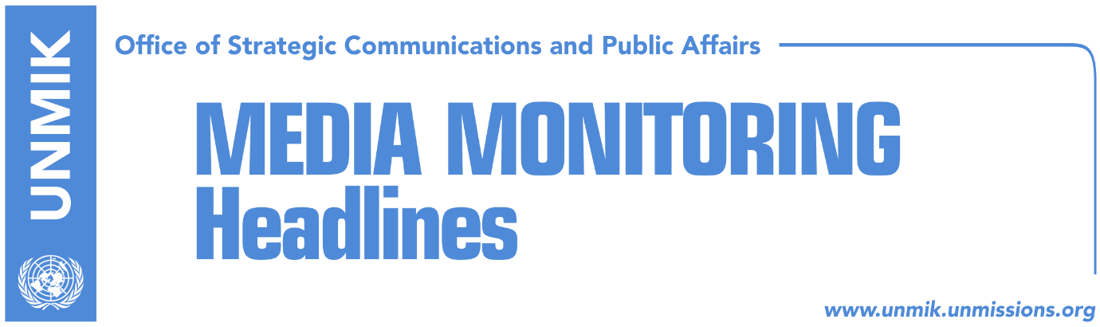

Main Stories 17 September 2018

- Thaci: Peaceful border correction between Kosovo and Serbia (media)
- Vucic: Agreement would resolve problems of both countries (RTK)
- German minister: Border change concept not liked in the Balkans either (Zeri)
- Germany skeptical about change of borders (RTK)
- Albanian leaders on possible Kosovo-Serbia agreement (Koha Ditore)
- Hoxhaj: This year, dialogue not new elections (Epoka)
- Ethnic definition of borders would undo Ahtisaari’s package (Koha Ditore)
- Kosovo institutions going against international community (Zeri)
- Mitrovica bridge not expected to open this year (Zeri)
- Economists propose imposing trade measures against Serbia (Koha Ditore)

Kosovo Media Highlights

Thaci: Peaceful border correction between Kosovo and Serbia (media)
President of Kosovo, Hashim Thaci, has penned a letter stating that Kosovo’s aspirations of joining the UN, NATO and EU cannot be achieved if an agreement with Serbia is not reached in the coming months. “The agreement can only be achieved if the parties compromise,” he wrote. He said that he has made the proposal of border correction with Serbia as a way of securing Kosovo’s recognition from Serbia. “I have argued that eventual agreement on peaceful border correction with Serbia ensures Serbia’s recognition of Kosovo as well as the union of Presheva, Bujanoc and Medvegja with our country. I have expected rational counter arguments but all I have heard to date is lots of noise and in worst cases, hatred. Kosovo is too small a country to produce so much hate, which divides our society,” Thaci writes.

See the full letter: https://bit.ly/2D1ZKxe

Vucic: Agreement would resolve problems of both countries (RTK)
President of Serbia, Aleksandar Vucic spoke once again about reconciliation between Albanians and Serbs as well as reach of an agreement that would resolve the problems of both sides. In an editorial text for Belgrade daily Blic, Vucic emphasizes that the policy which he leads is oriented against myths which according to him come from the region, and blame Serbia as always being responsible and wanting to expand at the expense of others. He said that during his visit to Kosovo, his criticizers did not deal with parts that di not suit them. According to Vucic a new era has started for Serbia and the entire Balkans, where the past should be forgotten. “Therefore, the best solution for Serbia would have been if Serbs and Albanians, whenever, reach an agreement and resolve their problems with Albanians,” Vucic wrote.

German minister: Border change concept not liked in the Balkans either (Zeri)
Germany’s Minister for Europe, Michael Roth, said he considers that the idea of border change between Kosovo and Serbia is not something that is being backed in the Western Balkans either. “The opening of the Pandora’s Box would have grave consequences,” Roth said adding that he believed that with good will and courage, a “creative” solution between Kosovo and Serbia can be achieved.

Germany skeptical about change of borders (RTK)
Recently appointed Ambassador of Germany to Serbia, Thomas Schieb told Serbian daily Danas that normalization of all relations between Kosovo and Serbia is determinant and will contribute the stability of the region. “The European Union has made it clear: Serbia can join EU only after resolving relations with Kosovo. We are very skeptical about change of the borders according to ethnic lines. German Chancellor Angel Merkel has made several announcements on the issue these days,” he said.

Albanian leaders on possible Kosovo-Serbia agreement (Koha Ditore)
President of Albania, Ilir Meta, said in an interview for an Italian paper that Kosovo and Serbia should normalise their relations without changing their borders. The paper says that while Albanian president has taken on a firm position on the idea of “border correction”, Prime Minister Edi Rama is less so clear saying it is up to Kosovo authorities to determine own platform for talks with Serbia. “A very complex issue is being discussed, an issue that is far more important than what Albanian politicians are stating and it is not right for me to comment on it,” Rama said recently.

Hoxhaj: This year, dialogue not new elections (Epoka)
Enver Hoxhaj, Deputy Prime Minister at Kosovo government, told the paper that things in Kosovo are not moving on the right path and he held accountable both the government and the opposition for this. He said both coalition partners and the opposition should conclude the state-building process and complete Kosovo’s sovereignty. He said it is prime time for reach of a political consensus on the dialogue with Serbia. He said dialogue should be priority this year, not new elections. He also said during this interview that the Association/Community of Serb-majority Municipalities will not be allowed to have executive competencies.

Ethnic definition of borders would undo Ahtisaari’s package (Koha Ditore)
International law experts told the paper that definition of borders based on the ethnic concept would undo the Ahtisaari’s status package which served as foundation for Kosovo’s declaration of independence in 2008. Legal expert, Vigan Qorrolli, said no one in Kosovo, except perhaps President Hashim Thaci, knows the principles on which the so-called border correction would take place. “If borders do change, and this happed based on the ethnic dimension – Kosovo’s constitutional character should also change automatically. Ahtisaari’s package would fall and Kosovo could become a state of Albanians and other nationalities,” Qorrolli said.

Kosovo institutions going against international community (Zeri)
The paper on the front page writes that Kosovo institutions have recently taken several steps which are considered to be against the positions of the international community including government approving draft law on Kosovo Security Force transformation and President Hashim Thaci’s idea of the so-called border adjustment. Analysts fear these unilateral steps risk damaging international support for Kosovo. “It is not okay to ignore our friends who have provided important support to Kosovo,” said political analyst Mazllum Baraliu. He said Kosovo needs to exercise caution and not take hasty steps.

Mitrovica bridge not expected to open this year (Zeri)
The paper reports that the main Mitrovica bridge is not expected to open for traffic this year for the fact that Mitrovica North Mayor Goran Rakic has requested municipal boundaries with the southern part of the city be defined before the bridge is reopened. At the same time, Adriana Hodzic, head of the Kosovo government’s municipal administration in Mitrovica North, said that the project for revitalization of the bridge will be concluded by the end of the year.

Economists propose imposing trade measures against Serbia (Koha Ditore)
Head of the Kosovo Chamber of Commerce, Berat Rukiqi, said Kosovo suffers yearly losses of around €30 million mainly because of Serbia’s failure to implement agreements reached in Brussels. Rukiqi said he believed that imposing a so-called energy tax on Serbia would make it implement agreements. This tax would be imposed on Serb products and he estimates it would bring Kosovo around €45 million a year which would be sufficient to cover losses. Economy professor Naim Gashi agrees with Rukiqi. He says Serbia already employs numerous barriers on Kosovo produce while Kosovo stands idly. “When Kosovo is blocked by Serbia, there is never talk of violation of the CEFTA agreement but whenever Kosovo applies such measures, as the trade measures on agricultural produce, international mechanisms immediately react,” Gashi said.

Disclaimer
This media summary consists of selected local media articles for the information of UN personnel. The public distribution of this media summary is a courtesy service extended by UNMIK on the understanding that the choice of articles translated is exclusive, and the contents do not represent anything other than a selection of articles likely to be of interest to a United Nations readership. The inclusion of articles in this summary does not imply endorsement by UNMIK.

