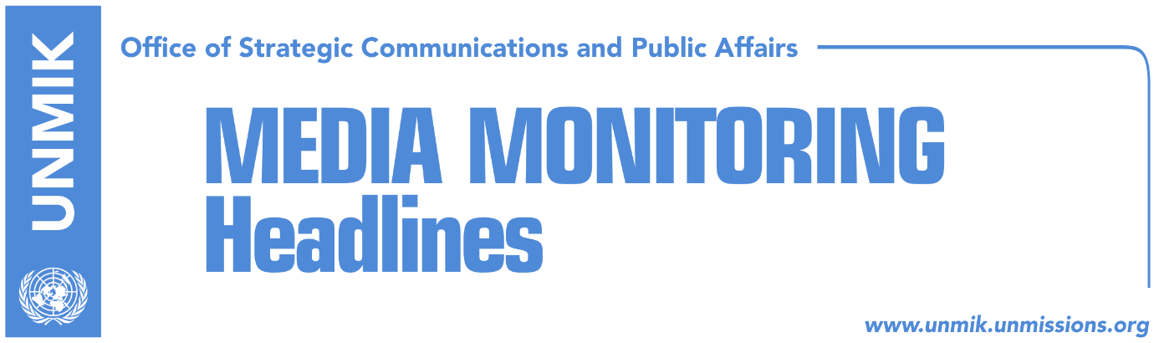

Main Stories 20 September 2018

- Haradinaj: Kosovo borders settled by ‘boots’ not negotiations (Telegrafi)
- President’s Office: Presevo Valley will be discussed in Brussels (Zeri)
- Germany skeptical over border change idea (dailies)
- Kurti: Serbia’s claims on Kosovo are being encouraged (Zeri)
- Kosovo, Serbia talking about redrawing their borders. A terrible idea (media)
- Haradinaj meets director of technical dialogue, Cooper (Epoka)
- “Initiative for the army should not turn back” (Epoka)
- Army with no extra budget (Koha)
- KCSS: Serbia made pressure on KSF Serb members (Epoka)
- US Department of State: Kosovo fighting growing threat of terrorism (media)
- KLA associations call for reassessment of verification process (Koha)

Kosovo Media Highlights

Haradinaj: Kosovo borders settled by ‘boots’ not negotiations (Telegrafi)
In an interview with Tirana-based Klan TV, Prime Minister of Kosovo Ramush Haradinaj said he would not accept any agreement with Serbia which encourages change of borders and that he didn’t consider such a plan to be serious. “After everything that’s happened, I cannot believe President Thaci considered this a serious project. I think this is part of his political tactics,” Haradinaj said. “Opening of the border issue, opening of such an agreement, even just discussing it is dangerous for the stability of the region. Borders of Kosovo were settled by boots not in tables and talks… if they are moved, many boots of soldiers from both sides will be required once again,” Haradinaj said.

President’s Office: Presevo Valley will be discussed in Brussels (Zeri)
Although a date for the next meeting of the final phase of dialogue in Brussels has yet to be set, it has been confirmed that the request of Albanians from Presevo Valley to join Kosovo will be discussed at the next meeting, the paper reports on page four. The Office of Kosovo President Hashim Thaci told the paper in a reply on Wednesday that the meeting will also discuss the modalities for reaching a legally-binding agreement between the two countries.

Germany skeptical over border change idea (dailies)
Germany’s Foreign Minister Heiko Maas told Deutsche Welle that he was skeptical of the idea of border changes between Kosovo and Serbia saying attempts to shift borders have been source of endless suffering in the past. “Germany has recognised Kosovo as a multiethnic country on the basis of Ahtisaari Plan,” Maas said adding that part of European perspective is also the fact of peaceful coexistence between people regardless of their ethnic and cultural background. “Attempts to move borders to eliminate precisely this diversity was, in the past, source of endless sufferings. Therefore, I consider such ideas not only unpromising but they also risk reopening many old wounds in the region,” Maas said ahead of his visit to Albania.

Kurti: Serbia’s claims on Kosovo are being encouraged (Zeri)
Vetevendosje leader Albin Kurti tweeted on Wednesday that “the use of phrases such as ‘land swap’, ‘border adjustment’, ‘territorial exchange’ and ‘painful compromise’ has only encouraged Serbia’s claims on Kosovo”. Kurti also tweeted that it is no wonder that Serbian President “Vucic is once again considering Milosevic a great leader”.

Kosovo, Serbia talking about redrawing their borders. A terrible idea (media)
Several local news websites carry an article published in The Washington Post according to which talks between Kosovo and Serbia to redraw their borders is a terrible idea. The article notes that the leaders of Serbia and Kosovo are planning to swap territory. They say it will ease ethnic tensions and contribute to stability in the western Balkans. Some commentators and politicians think it is a great idea. Don’t bet on it. The proposals present enormous risks — not only for the countries themselves but also for the broader region. Indeed, they could set an ominous precedent for leaders who harbor separatist ambitions. What Kosovo President Hashim Thaci refers to as a ‘border adjustment’ could easily prompt nationalists in this part of Europe to demand similar changes. It could offer destructive inspiration to Croatia, Albania, Bosnia and Macedonia, where nationalist movements and some of the leaders yearn to have their own ethnically homogeneous countries. German Chancellor Angela Merkel has come out strongly against the plan, citing the need to safeguard ‘the territorial integrity’ of states in the region. She is right. As one of the few European leaders who has consistently taken a close interest in the Western Balkans, she knows stability is fragile. Astonishingly, the United States disagrees with Merkel’s view. “The U.S. policy is that if the two parties can work it out between themselves and reach agreement, we don’t exclude territorial adjustments,” said national security adviser John Bolton. “We would not stand in the way, and I don’t think anybody in Europe would stand in the way if the two parties to the dispute reached a mutually satisfactory settlement,” he added. https://www.washingtonpost.com/news/global-opinions/wp/2018/09/19/kosovo-and-serbia-are-talking-about-redrawing-their-borders-its-a-terrible-idea/?noredirect=on&utm_term=.f0f94245260c

Haradinaj meets director of technical dialogue, Cooper (Epoka)
The Prime Minister of Kosovo Ramuish Haradinaj hosted on Wednesday a meeting with a delegation of the European Council for Foreign Affairs, lead by Robert Cooper. Haradinaj valued Cooper’s role in the technical dialogue between Pristina and Belgrade while he was engaged at senior EU positions. He added that the role of the European Council for Foreign Affairs is important to find the best solutions for the final agreement between Kosovo and Serbia. Cooper on the other hand valued the progress reached in Kosovo and expressed commitment on support to Kosovo in its European path.

“Initiative for the army should not turn back” (Epoka)
Head of the Assembly Committee for internal affairs, aecurity and aupervision of Kosovo Security Force Haxhi Shala assessed the initiative for transformation of KSF into an army through law, was undertaken at the right time. He told the paper that this action was undertaken in coordination with the international factor. He added that KSF transformation is a necessity of time and it is not being undertaken to gain political and electoral points. He stressed that as KSF cannot currently transform through constitutional changes, then it will be given competencies through law. According to him, this initiative should endorse by the Assembly as soon as possible and it should not turn back as it happened in the past.

Army with no extra budget (Koha Ditore)
The paper reports on the front page that even if the Assembly does approve three draft laws relating to the Kosovo Security Force (KSF), there will be no sufficient budget for their implementation. According to the bills, the average annual budget for the KSF will be €57 million which the paper says does not include purchase of weaponry or payment for extra members of the KSF. According to the Ministry of Finance which has prepared financial implications of the bill, there will be no need for allocating extra budget as the activities set out in the laws can be covered by Medium-Term Expenditures Framework for 2019-2021.

KCSS: Serbia made pressure on KSF Serb members (Epoka)
Kosovo Center for Security Studies (KCSS) has issued a report which notes that Serbia “has committed aggression” towards the Kosovo Security Force (KSF), “by exercising violence” to withdraw almost fifty percent of the Serb members from the KSF. According to this report, the number might increase during the following months, if Kosovo institutions and international partners do not undertake required measures. “Threats for interruption of salaries/pensions of their close or distant family members of these KSF members were used as means of pressure. KCSS’s research found out that psychological threats and special methods were also used, by telling these members that there will be a war between Kosovo and Serbia soon, and they would end up fighting against their own Serbian brothers,” the report emphasizes.

US Department of State: Kosovo fighting growing threat of terrorism (media)
The US Department of State has released annual report on terrorism which also includes Kosovo. The report, published by VOA, says Kosovo continued to fight growing threat of terrorism in 2017 and that the government continued to implement strategy for countering violent extremism. The report states that around 403 Kosovo citizens have travelled to Syria and Iraq to fight or join ISI or al-Nusrah Front, of which 74 have been killed. The report also notes that the security and political situation in the northern Kosovo continued to limit the government’s ability to exercise authority in the region despite the successful integration of Serb judicial staff into Kosovo institutions.

KLA associations call for reassessment of verification process (Koha)
In a press conference yesterday, representatives of Kosovo Liberation Army (KLA) war veterans’ associations called on the government of Kosovo to launch another process for verification of KLA members. Head of the association, Hysni Gucati, said prosecution of Kosovo has committed legal violations by publishing the list of “false” KLA veterans which is said to contain names of persons who truly were members of KLA.

Disclaimer
This media summary consists of selected local media articles for the information of UN personnel. The public distribution of this media summary is a courtesy service extended by UNMIK on the understanding that the choice of articles translated is exclusive, and the contents do not represent anything other than a selection of articles likely to be of interest to a United Nations readership. The inclusion of articles in this summary does not imply endorsement by UNMIK.

