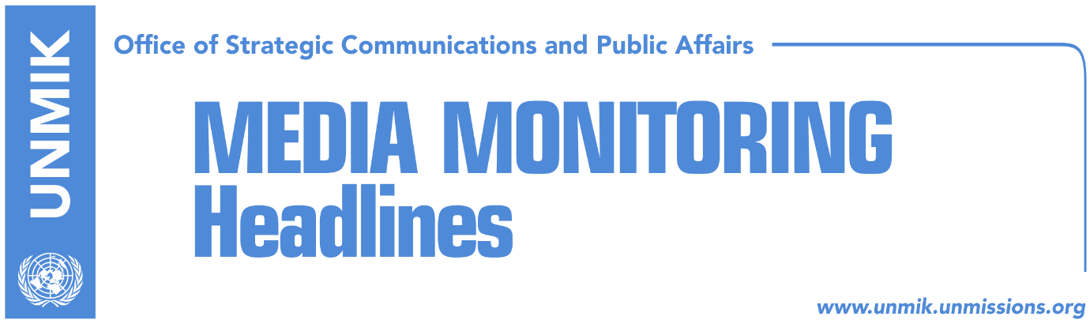

Main Stories 21 September 2018

- President Thaci wants free hands for agreement with Serbia (Koha)
- Thaci: Border correction. Trepca, Gazivoda and north won’t be touched (media)
- LDK considers Thaci’s border change proposal unacceptable (Zeri)
- Haley: U.S. speaks in unison – Kosovo is a friendly country (Koha)
- Assembly ratifies agreements with EU (dailies)
- Apostolova hails Assembly’s pro vote on EU assistance projects (Zeri)
- Hoxhaj and Apostolova discuss visa liberalisation (RTK)
- Feith: Let us explore Kosovo-Serbia land swap idea (Zeri)

Kosovo Media Highlights

President Thaci wants free hands for agreement with Serbia (Koha)
The paper reports on its front page that Kosovo President Hashim Thaci is determined to close on his own a final agreement with Serbia. After his idea for border changes was rejected even by some of the ruling parties, Thaci has decided to address the Constitutional Court to interpret Article 18 of the Constitution on the ratification of international agreements. Thaci has namely asked the Court if international agreements, signed by the President and without the approval of MPs, are considered ratified. He used the example of extending the mandate of the EU Rule of Law Mission in Kosovo, which was done only through a letter exchange between the President and the EU High Representative. Following Thaci’s request, the Constitutional Court has sent a notification to MPs asking them to submit their comments by September 28.

Thaci: Border correction – Trepca, Gazivoda and north won’t be touched (media)
Kosovo President Hashim Thaci told Vision Plus on Thursday that there is a slim chance that the border correction between Kosovo and Serbia will take place. “I see slim theoretical chances that the border correction will take place, because Serbia will not agree but I hope that they will reflect on the matter … What is important is that I have visited German Chancellor Angela Merkel in her office and she strongly supports dialogue, negotiations and the possibility of reaching an agreement,” Thaci was quoted as saying. “I understand the skepticism and I respect it but the moment that Kosovo and Serbia reach an agreement on border correction, I am confident that everyone will support the agreement, including the U.S. and the European Union”. Thaci categorically denied that the idea for border correction implies the exchange of territories. “There has been talk about division and the exchange of territories, but these are not my ideas, they are Serbian ideas. I totally against these ideas. Those who send messages of division and exchange of territories are wrong and I will stand against them,” he added. “My idea is [border] correction, for Presevo, Medvedja and Bujanovac to join Kosovo. No asset of Kosovo – neither Gazivoda, nor northern Kosovo, or Trepca, will be part of Serbia … It is also true that Tito and Rankovic, at the time of mass expulsion of Albanians from Kosovo in 1956 – 1959, in order to reach some demographical balance, gave part of Leposavic, Lesak and Zubin Potok to Kosovo. Now should we remain victims of Tito? It is the historical right of Presevo, Medvedja and Bujanovac to join Kosovo. I fully support this, and I am glad that the international community is reflecting on this”. Thaci further argued that “90 percent of members of the Kosovo government and 80 percent of Kosovo citizens support border correction with Serbia and for Presevo Valley to join Kosovo”. He also said there will be a referendum on the matter. “If the people approve, a miracle will happen. If they don’t, we will remain at the same position”.

LDK considers Thaci’s border change proposal unacceptable (Zeri)
The Democratic League of Kosovo (LDK) has reaffirmed its position against border changes saying it considers such a proposal to be unacceptable. LDK’s secretary, Ismet Beqiri, said after the meeting of the party’s chairmanship that the dialogue with Serbia is not an urgent matter but said they consider the time is not yet right to organise street protests. He said not all institutional possibilities have been exhausted to prevent President of Kosovo Hashim Thaci from discussing border correction in Brussels.

Haley: U.S. speaks in unison – Kosovo is a friendly country (Koha)
Asked to comment on the U.S. position on border changes, United States Ambassador to the United Nations, Nikki Haley, said on Thursday that despite individual voices, the U.S. administration speaks in unison and that Kosovo is a friendly country of the U.S. “Our positions have not changed. What you are hearing is what we have always said. We have always appreciated Kosovo and we see it as a friendly country and this is how it will be in the future. There may be individual voices in the administration, but when we speak as an administration, we will speak in unison and this is how it will be,” Haley added.

Assembly ratifies agreements with EU (dailies)
Kosovo Assembly voted yesterday in favour of international agreements relating to cooperation with European Union, namely the Instrument for Pre-Accession Assistance agreement, participation in Erasmus+ and Creative Europe and Europe for Citizens programmes. Minister of European Integration Dhurata Hoxha thanked MPs for the vote saying the agreements bring Kosovo a step forward towards European integration.

Apostolova hails Assembly’s pro vote on EU assistance projects (Zeri)
Head of the EU Office in Kosovo and Special Representative, Nataliya Apostolova, hailed Kosovo Assembly’s ratification of three agreements with EU. “The vote confirms Kosovo’s European belonging and ability to unite around issues of national interest,” Apostolova said.

Hoxhaj and Apostolova discuss visa liberalisation (RTK)
Kosovo’s Deputy Prime Minister, Enver Hoxhaj, met yesterday head of EU Office in Kosovo, Nataliya Apostolova, and discussed the upcoming visit of the Working Party on the Western Balkans Region (COWEB) related to visa liberalisation. Hoxhaj wrote on Twitter that the meeting was fruitful. “Looking forward to meeting representatives of EU member states and briefing them on Kosovo’s progress of the EU agenda and visa free travel for our citizens,” he said.

Feith: Let us explore Kosovo-Serbia land swap idea (Zeri)
Former EU Special Representative to Kosovo, Pieter Feith, has come out in support of the territorial exchange proposal between Kosovo and Serbia. “It is time to be pragmatic. This history lasted far too long and there is still no reconciliation,” Feith said in an interview for a Dutch radio. He said however that the territorial exchange option could take place only if there is support from the society. “Let us explore the idea,” he stated.

Disclaimer
This media summary consists of selected local media articles for the information of UN personnel. The public distribution of this media summary is a courtesy service extended by UNMIK on the understanding that the choice of articles translated is exclusive, and the contents do not represent anything other than a selection of articles likely to be of interest to a United Nations readership. The inclusion of articles in this summary does not imply endorsement by UNMIK.

