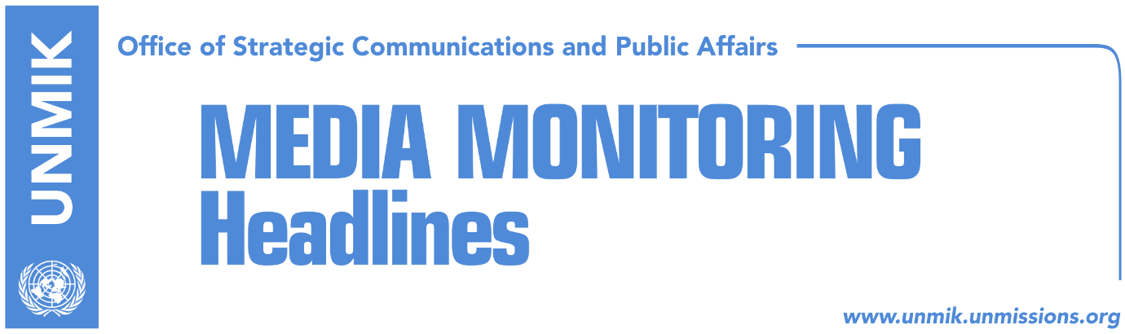

Main Stories 1 October 2018

- Thaci calls on political parties to build joint platform on dialogue (Epoka)
- Haradinaj says he received US support for Kosovo army (dailies)
- WSJ: EU-US in support of Kosovo-Serbia land swap (Koha Ditore)
- The north quiets down (Zeri)
- Cafeteria in the north that served Thaci comes under fire (Insajderi)
- Mustafa: Correction of borders, damger for Balkans (Epoka)
- Majko: Correction of borders intended to raise tensions in the region (Kosova)
- Veseli in Great Britain invited by PM May’s political party (Epoka)
- FYROM between the West and failure (Koha)

Kosovo Media Highlights

Thaci calls on political parties to build joint platform on dialogue (Epoka)
The President of Kosovo Hashim Thaci said on Sunday that he will not ask for anyone’s permission to visit the north of Kosovo. He said his visit should not be seen as a competition, but as how to work more to functionalize the state on that part. Thaci called on the political spectre to unite for the final phase of the dialogue with Serbia. He said he does not see any realistic obstacle for the political spectre not to unite in the following days around a comprehensive platform for the process of the dialogue. “We should all together work against division, exchange and Association,” Thaci said.

Haradinaj says he received US support for Kosovo army (dailies)
In a press conference following his return from the US, Prime Minister of Kosovo Ramush Haradinaj said he has received the support for transformation of the Kosovo Security Force (KSF) into a Kosovo army. He said the main topics of discussions the Kosovo delegation had during its visit to the US for the UN General Assembly session included membership in Interpol and creation of Kosovo army. Haradinaj also said that in meetings with different world officials he made it clear that he supports an agreement with Serbia but that this should not include redrawing of borders or exchange of territories. “I can say that Kosovo has the blessing of the US and the Defense Department over Kosovo Army. This is perhaps the best piece of news that we bring from the US this time,” Haradinaj said.

WSJ: EU-US in support of Kosovo-Serbia land swap (Koha Ditore)
The paper carries a report from the Wall Street Journal saying that the US and the EU are supporting redrawing of borders between Kosovo and Serbia, a plan which is being opposed by Germany. A confidential document WSJ has obtained notes that the EU has adopted Washington’s view on Kosovo-Serbia land swap option and rejected Germany’s.

See more: https://on.wsj.com/2OnC6Qg

The north quiets down (Zeri)
The paper reports soon after the unannounced visit of the President of Kosovo Hashim Thaci to the north and the Ujman/Gazivoda Lake, local Serb residents in Zubin Potok set up a roadblock at the entrance of the town but that the road was reopened following an appeal from the Serbian President Aleksandar Vucic. As a result of the roadblock customs and police officers had to travel to their postings through alternative roads but the paper reports that on Sunday the situation went back to normal.

Cafeteria in the north that served Thaci comes under fire (Insajderi)
The cafeteria owned by a local Serb man in the village of Banje, Zubin Potok, csme under gun attack a day after it served President of Kosovo Hashim Thaci. The owner of the cafeteria said his shop and the adjacent house came under a burst of fire at 3 a.m. on Sunday. No one was injured in the attack. Kosovo Police confirmed the attack and said it has opened an investigation into it.

Mustafa: Correction of borders, damger for Balkans (Epoka)
Isa Mustafa, leader of the Democratic League of Kosovo (LDK) has conveyed through a letter the message to the German Chancellor Angela Merkel as well as to the Foreign Ministers of 28 EU countries, that LDK opposes correction of borders or exchange of territories based on ethnic lines. “This solution would have been dangerous not only for Kosovo, but also for the Balkans in general,” Mustafa wrote.

Majko: Correction of borders intended to raise tensions in the region (Kosova)
Albania’s Minister for Diaspora Pandeli Majko said correction of borders is Belgrade’s will to raise tensions in the region as well as a verifying diplomacy supported by Russia. He wrote on his Facebook account that ‘it is Serbia’s profession to cause destabilization by referring to history. “Serbs are exposing the diplomacy of ‘power’ due to Moscow’s support. In 1999 a group of intervening Russian parachutists took the airport of Pristina. If Russian uniforms would come from Nis and settle at Mitrovica bridge ‘to defend peace’ it would be a real crisis. But no one should seek protagonism behind this. Russian policy does not make business, it prefers chez,” Majko wrote.

Veseli in Great Britain invited by PM May’s political party (Epoka)
The President of the Assembly of Kosovo Kadri Veseli has travelled to the Great Britain, invited by the Conservatory Party of the Prime Minister Theresa May. Veseli will meet with several leaders of this party who are also senior officials in the United Kingdom. He is also invited to participate at works of the convention of the political party in Birmingham.

FYROM between the West and failure (Koha)
Most of the media report on referendum held in the Former Yugoslav Republic of Macedonia on Sunday. However, low turnout makes it unclear on how to proceed on implementing the agreement between prime Ministers Zoran Zaev and Alexis Tsipras on the new FYROM name. Representatives of the governing coalition said the burden now belongs to the Assembly, while insisting that FYROM is oriented towards the West.

Disclaimer
This media summary consists of selected local media articles for the information of UN personnel. The public distribution of this media summary is a courtesy service extended by UNMIK on the understanding that the choice of articles translated is exclusive, and the contents do not represent anything other than a selection of articles likely to be of interest to a United Nations readership. The inclusion of articles in this summary does not imply endorsement by UNMIK.

