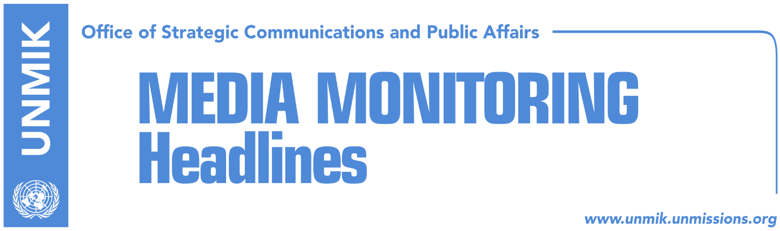

Main Stories 2 October 2018

- Thaci discusses recent developments with Quint ambassadors (dailies)
- Veseli disagrees with timing of Thaci’s visit to the north of Kosovo (Zeri)
- Veseli cuts short UK visit (Indeksonline)
- Reports claim Justice Minister Tahiri’s resignation imminent (media)
- Haradinaj: Kosovo borders will not change (RTK)
- Endrit Shala appointed new Minister of Trade and Industry (dailies)
- UNMIK was not notified of Thaci’s visit to the north (Koha)
- Hoxhaj: EU to lift visa regime for Kosovo (Zeri)
- Referendum on border requires constitutional amendments (RFE/Koha)
- Haliti: We are trying to solve our problems (Indeksonline)
- O’Connel criticizes justice system in Kosovo (RTK)

Kosovo Media Highlights

Thaci discusses recent developments with Quint ambassadors (dailies)
President of Kosovo Hashim Thaci met yesterday ambassadors of Quint countries and the head of the EU Office and discussed recent developments, in particular dialogue with Serbia, Kosovo’s Interpol membership, transformation of the Kosovo Security Force (KSF) and visa liberalisation. According to a press release issued by the President’s Office after the meeting, Thaci “welcomed the unified support of the international community to the dialogue and negotiations between Kosovo and Serbia, without prejudice or conditioning of its epilogue.” He also said Kosovo is finalising its Interpol membership bid while with regards to visa liberalisation Thaci pointed out that it is important there are no delays in the process. As for the KSF transformation, Thaci said this was ‘unstoppable’ and ‘irreversible’ and that it was being conducted with utmost caution and in full coordination with Kosovo’s international partners.

See the statement: https://bit.ly/2NXG3fc

Veseli disagrees with timing of Thaci’s visit to the north of Kosovo (Zeri)
Kosovo Assembly Speaker and leader of the Democratic Party of Kosovo (PDK), Kadri Veseli, said the timing of President of Kosovo Hashim Thaci’s visit to the north of Kosovo and the Ujman/Gazivoda Lake was off. “I would have gladly supported the visit to Ujman had it been on some other day,” said Veseli adding that the visit should not have come as a response to ‘provocation’ from Vetevendosje leader Albin Kurti.

Veseli cuts short UK visit (Indeksonline)
Kosovo Assembly Speaker and leader of the Democratic Party of Kosovo (PDK) Kadri Veseli returned to Kosovo after cutting short his visit to the United Kingdom, Indeksonline reports. Sources said Veseli’s move was triggered by latest political developments in Kosovo amid reports that two of his party’s ministers, Abelard Tahiri Justice Minister and Bedri Hamza Finance Minister, have handed over their resignations.

Reports claim Justice Minister Tahiri’s resignation imminent (media)
Several media outlets yesterday reported about the imminent resignation of Justice Minister Abelard Tahiri. RTV Dukagjini said Tahiri already presented his resignation to Prime Minister Ramush Haradinaj as a sign of discontent with the functioning of the justice system, in particular political interference in it. Klan Kosova also confirmed Tahiri’s resignation and while it said it is not known what reasons prompted him to take such a step it recalled an earlier statement made by Tahiri where he called on politicians not to put pressure on justice institutions. Prime Minister of Kosovo Ramush Haradinaj in an interview with T7 confirmed Tahiri offering his resignation but he said he asked the Minister to put it on hold pending “general consultations”. Haradinaj said leader of the Democratic Party of Kosovo (PDK) Kadri Veseli asked him not to accept Tahiri’s resignation.

Haradinaj: Kosovo borders will not change (RTK)
The Prime Minister of Kosovo Ramush Haradinaj told T7 that Kosovo borders will not change. He added that he would not sit at a table where exchange of territories would be discussed. “I believe in 17 February Kosovo and its borders. I do not accept from anyone to open any discussions for any kind of integrity of the borders. No one will have my support on the change of borders,” he said. “Serbia’s interest does not stand on Gazivoda or Stari Trg, Serbia’s concern is about a range of mountains with minerals, from Jarinje toward Lesak and Leposavic,” he said adding that Serbia is interested to trade minerals while it does not need water.

Endrit Shala appointed new Minister of Trade and Industry (dailies)
Prime Minister of Kosovo Ramush Haradinaj has appointed Endrit Shala from the Social Democratic Initiative (NISMA) Minister of Trade and Industry. Shala, close associate to party leader Fatmir Limaj, was involved in the so-called ‘happy fire’ case along with Diaspora Minister Dardan Gashi and former Skenderaj/Srbica Mayor Sami Lushtaku and was charged by the prosecution for unauthorised weapon possession. Meanwhile Koha Ditore comments on Shala’s appointment calling it “another black record” for the government of Kosovo.

UNMIK was not notified of Thaci’s visit to the north (Koha)
Koha carries a statement attributed to UNMIK spokesperson Sanam Dolatshahi saying that the mission was neither notified nor involved in the visit of Kosovo President Hashim Thaci to the north. “UNMIK staff and vehicles in the area were present only fulfilling monitoring responsibilities, which include ascertaining and assessing developing situations on the ground, under the Mission mandate,” Dolatshahi told Serbian news agency Tanjug.

Hoxhaj: EU to lift visa regime for Kosovo (Zeri)
Kosovo’s Deputy Prime Minister Enver Hoxhaj said at the 14th Conference of European Regions and cities underway in Salzburg, Austria that the Council of European Union should recognise and acknowledge Kosovo’s implementation of all visa liberalisation criteria and “give green light for free movement to the citizens of Kosovo.”

Referendum on border requires constitutional amendments (RFE/Koha)
The news agency quotes legal and constitutional experts in Pristina as saying that Kosovo needs to amend its constitution if it plans to go to a referendum on the correction of the border with Serbia. Constitutional amendments require a double two, namely 2/3 of votes of majority MPs and 2/3 of votes from minority communities. Kosovo President Hashim Thaci said referendum could be held to ask the people of Kosovo if they favor the border correction, namely for Presevo, Medvedja and Bujanovac to join Kosovo.

Haliti: We are trying to solve our problems (Indeksonline)
Democratic Party of Kosovo (PDK) deputy leader, Xhavit Haliti, said in an interview to the news website, that if the Haradinaj-led government falls, “we need to look into new elections and new coalitions”. “As far as we’re concerned, there is no need for new elections. We are not working for new elections; we are trying to solve the problems we face … If the government falls, then we need to see if we have to go to new elections or if we will form a new coalition that will continue to govern,” Haliti was quoted as saying.

O’Connel criticizes justice system in Kosovo (RTK)
Ruairi O’Connell, Ambassador of the United Kingdom to Kosovo, has criticized the justice system in Kosovo, requesting from the prosecutors and judges to expose their well-known Albanian courage. “It would have been better is politicians in Kosovo felt more responsible about the developments in the country,” he said. “I sometimes have the impression that people prefer to rather leave responsibility to the internationals, than to keep it themselves, and this does not function in democracy. So, they should take over responsibility and citizens should request for their politicians to feel entirely responsible about the developments in the country,’ Ambassador O’Connell said.

Disclaimer
This media summary consists of selected local media articles for the information of UN personnel. The public distribution of this media summary is a courtesy service extended by UNMIK on the understanding that the choice of articles translated is exclusive, and the contents do not represent anything other than a selection of articles likely to be of interest to a United Nations readership. The inclusion of articles in this summary does not imply endorsement by UNMIK.

