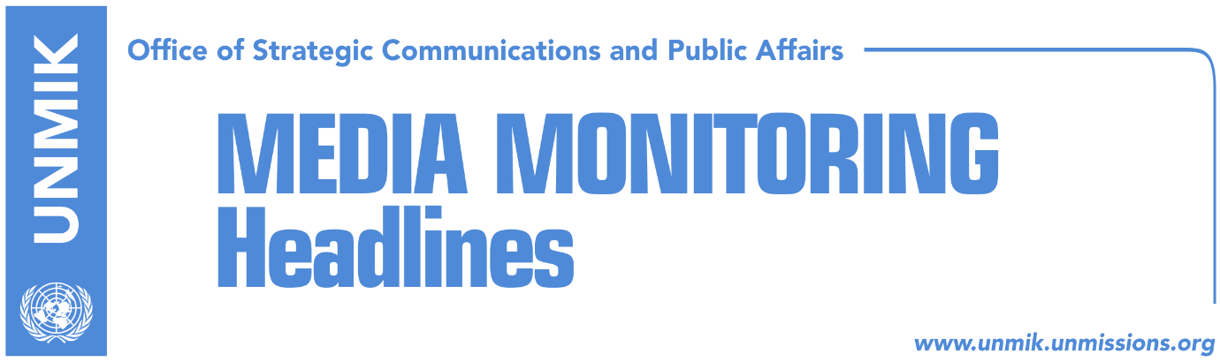

Main Stories 06 October 2018

- Thaci meets David McAllister (Facebook, RTK)
- Juncker speaks about a new “specter” of war in Balkans (RTK)
- Vucic: I never spoke about ethnic division of Kosovo (Russia Today, Gazeta Express)
- Shala: Army to be voted by over 100 MPs in November (Zeri)
- KFOR responds to Dacic’s statements on the North (Gazeta Express)
- Mustafa: LDK will not be part of the dialogue with Serbia (Facebook, RTK)
- Haradianj: We owe it to martyrs to preserve territory of Kosovo (media)

Kosovo Media Highlights

Thaci meets David McAllister (Facebook, RTK)
The President of Kosovo Hashim Thaci met with Chair of the European Parliament Foreign Affairs Committee David McAllister to discuss Kosovo’s path towards the European Union. “We are already united in values and principals. Our real power is unity and persistence to make our Euro-Atlantic aspiration become true,” Thaci wrote on his Facebook account.

Juncker speaks about a new “specter” of war in Balkans (RTK)
President of the European Commission Jean-Claude Juncker warned on Friday that there is a danger of new military conflicts in the Balkans, if the countries of the region are left without European perspective.

“If such a complex European region gets an impression that we are not serious with the European perspective, we will experience, sooner rather than later, what we had in the Balkans during the 1990s”, stressed Juncker in a speech titled “For Europe as a Foreign Policy Actor” delivered in front of the Austrian Parliament.

Juncker emphasised that the history of the 1990s still has not been overcome in the Balkans. “The history of the 1990s was made possible because the past decades and centuries had not been dealt with”, he stated.

He nevertheless pointed out that the road of Western Balkan countries towards the full EU membership is still long. According to him, a progress can be seen, but it does not stand out enough.

Juncker proposed that the Western Balkan countries should be offered some kind of an economic area in which they could partially act the way they would when they become full members.

Vucic: I never spoke about ethnic division of Kosovo (Russia Today, Gazeta Express)
The President of Serbia Alaksandar Vucic told Russia Today that he has never mention partition of Kosovo based on ethnic lines. “We need to find a compromised solution between Serbs and Albanians, which means that it cannot be the case that Albanians get everything and Serbs get nothing.”
“That was Serbia’s first and the only position that we have never left. Then we faced response from different sides. Russia was saying OK if Serbia agrees on something because we consider Serbia as a sovereign state, if Serbia agrees on something, we support it, which was absolutely in accordance with the international public law, and that is why we respect and appreciate the political attitude of President Putin and Russia very much; On the other hand we got a very clear response from several countries that were totally against it. They were saying that if that happens, Serbia will open Pandora’s Box,” Vucic said.
“Who opened Pandora’s Box in 2008, accepting, acknowledging and recognizing independence of Kosovo?” he further asked.

https://www.rt.com/shows/sophieco/440384-vucic-kosovo-serbia-tensions/

Shala: Army to be voted by over 100 MPs in November (Zeri)
Haxhi Shala, Chair of the Assembly Committee for Supervision of Kosovo Security Force, told the paper that the Law for the army of Kosovo will be voted in November by the Assembly of Kosovo. According to him, more than 100 MPs will support the law. He also expressed conviction that international partners of Kosovo will support formation of the army based on the Law. “The Serbian List cannot delay formation of the army of Kosovo because this process can be voted with the simple majority,” Shala said.

KFOR responds to Dacic’s statements on the North (Gazeta Express)
KFOR Spokesperson Vincenzo Grasso, said on Friday that the Force would not attack itself in northern Kosovo.

Grasso responded to Serbia’s Foreign Minister Ivica Dacic’s statement that there was a danger that Kosovo, helped by Western countries, could attack the Serbs in the north as a part of the process of establishing the border between the Serbs and the Albanians.

“Should we prepare to attack ourselves,” Grasso told Gazeta Experss adding that the KFOR members were deployed in four municipalities in the northern Kosovo. He added that KFOR had been operating in the whole of Kosovo for 19 years without any limitations.
“KFOR is always present in northern Kosovo and has units patrolling at all four Serb-dominated municipalities,” Grasso said.

Mustafa: LDK will not be part of the dialogue with Serbia (Facebook, RTK)
Isa Mustafa, leader of the Democratic League of Kosovo (LDK,) took to Facebook to inform that the political party he leads is preparing to take over governing of Kosovo. He also wrote that LDK will never be part of the dialogue with Serbia, neither as part of President’s nor government’s team.
“Starting from this month we started to intensify our work with local LDK organizations. We are discussing the priorities that we need to stick to as the LDK in municipalities and at central level, for the changes that must take place, so that Kosovo is governed well and without corruption.
We are exchanging views with LDK structures and membership on topics of particular importance to Kosovo. We are about to rethink the country's government by providing European solutions to the processes that await us ....” Mustafa wrote further.

Haradianj: We owe it to martyrs to preserve territory of Kosovo (media)
The Prime Minister of Kosovo Ramush Haradinaj, the President of Kosovo Hashim Thaci and the Assembly President Kadri Veseli, participated on Friday at a commemoration ceremony for martyrs in the village of Marine. Haradinaj said during his speech that the fight for freedom is sacred and preserving territory is a debt Kosovo has towards its martyrs. He added that Kosovo owes to its martyrs to strengthen freedom, state, economy and “preserve territory of Kosovo by making it untouchable by anyone, be that person here with us or somewhere else.” “We all like to expand but something that has been won by blood cannot be touched,” Haradinaj said.

Disclaimer
This media summary consists of selected local media articles for the information of UN personnel. The public distribution of this media summary is a courtesy service extended by UNMIK on the understanding that the choice of articles translated is exclusive, and the contents do not represent anything other than a selection of articles likely to be of interest to a United Nations readership. The inclusion of articles in this summary does not imply endorsement by UNMIK.

