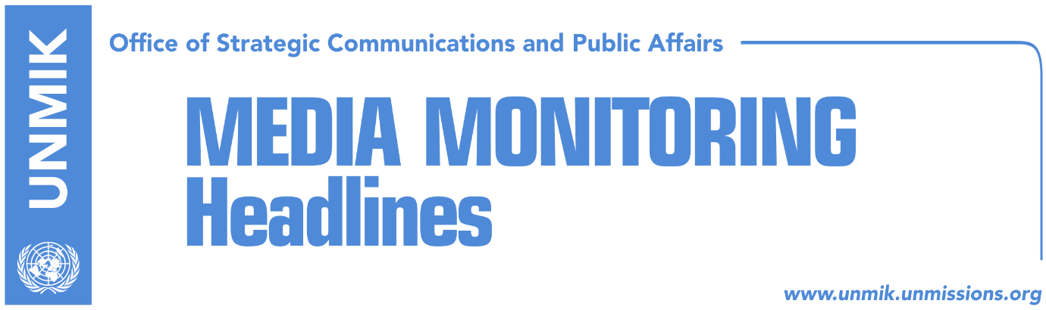

Main Stories 12 October 2018

- Thaci: Macron strongly supports dialogue, possible border correction (TVSH)
- Pacolli: Macron said there can be no open conflict in the Balkans (Klan Kosova)
- No consensus on platform for dialogue (Koha)
- Assembly Speaker Veseli meets Quint ambassadors (social media)
- Veseli: We request recognition from the agreement with Serbia (Klan)
- Phillips: Border correction undermines Kosovo sovereignty (Zeri)
- David Philips resigns, doesn’t want to be part of Kosovo’s partition (Koha)
- Hoxhaj discusses visa liberalisation with Dutch officials (Bota S./social media)
- Kosovo becomes associated member of OIF (dailies)
- “World Bank statements, no impact on Kosova e Re project” (Koha)

Kosovo Media Highlights

Thaci: Macron strongly supports dialogue, possible border correction (TVSH)
Kosovo President Hashim Thaci said in an interview to TVSH on Thursday that he received the support of French President, Emmanuel Macron, for a binding agreement between Kosovo and Serbia, and with a real possibility for border correction. “President Macron strongly supports the Kosovo – Serbia dialogue, the possibility of reaching an agreement within a short period of time, and with a real possibility of border correction, which implies Presevo, Medvedja and Bujanovac joining Kosovo’s territory. This would pave way to Kosovo’s certain Euro-Atlantic perspective, but not with borders along ethnic lines, but always safeguarding multiethnicity in Kosovo and building a civic democracy in our country. President Macron strongly supports dialogue and the possible border correction,” Thaci was quoted as saying.

Pacolli: Macron said there can be no open conflict in the Balkans (Klan Kosova)
Kosovo Foreign Minister Behgjet Pacolli spoke to Klan Kosova about the meeting Kosovo President Hashim Thaci and Albanian Prime Minister Edi Rama had with the French President Emmanuel Macron on the sidelines of the Organisation of the Francophonie conference in Yerevan, Armenia. According to Pacolli, in the several-minute long meeting with Thaci and Rama, Macron said dialogue with Serbia needs to come to a close and that there can be no open conflicts in the Balkans. “The result of the dialogue depends entirely on the subjects you address,” Macron said according to Pacolli.

No consensus on platform for dialogue (Koha)
The paper reports on its front page that another attempt by the ruling coalition and one part of the opposition to reach consensus on dialogue with Serbia has failed. The two biggest opposition parties – the Democratic League of Kosovo (LDK) and Vetevendosje – did not accept Assembly President Kadri Veseli’s invitation to a meeting on Thursday. Both parties are adamant that Kosovo needs to go to early parliamentary elections. The Social Democratic Party (PSD) and Alternativa attended the meeting. After the meeting, Veseli told reporters that the meeting was very constructive and that the resolution proposed by the government also includes the positions of opposition parties. “We can also include other issues that strengthen our position vis-à-vis Serbia,” Veseli said. “Kosovo must speak with one voice and have a united position on its platform. The proposed resolution includes everything that the opposition and the ruling coalition have requested. I have a message for the opposition parties that are not attending the meetings for reaching consensus: Kosovo cannot be a battlefield for power. Our future is more important than any post”.

Assembly Speaker Veseli meets Quint ambassadors (social media)
Kosovo Assembly Speaker Kadri Veseli met yesterday ambassadors of Quint countries and the head of the EU Office in Kosovo and discussed stepping up efforts for reaching consensus for the final stage of dialogue with Serbia. In a Facebook post, Veseli said the meeting he called yesterday with opposition parties, boycotted by the Democratic League of Kosovo (LDK) and Vetevendosje, was an important step. “In the coming days we will intensify efforts for reaching consensus as soon as possible,” Veseli wrote.

Veseli: We request recognition from the agreement with Serbia (Klan)
Kosovo Assembly President Kadri Veseli spoke to the Check media after his meeting with his counterpart there, Milan Stech. He said Kosovo citizens expect removal of visas and free movement in the Schengen Zone within this year. Speaking about the dialogue with Serbia, he reiterated that there will be no violation of the territory of Kosovo. He added that the dialogue has already entered its final phase and they expect mutual recognition, Kosovo’s seat at the UN, NATO and EU. “It is also in Serbia’s interest to have reciprocal recognition and move forward with European agenda,” Veseli said adding that many Serbian politicians already understand that Kosovo is a fact, independent state and there is no turning back.

Phillips: Border correction undermines Kosovo sovereignty (Zeri)
David Phillips, director of peace-building and human rights programme with Columbia University said at a conference in Pristina yesterday that the idea of so-called border correction between Kosovo and Serbia would be dangerous and highly destabilising. Saying the idea has failed, Phillips said creative thought needs to be given to new ideas that would lead to normalisation of relations between Kosovo and Serbia, namely Kosovo’s recognition from Serbia.

David Philips resigns, doesn’t want to be part of Kosovo’s partition (Koha)
The paper reports on page three that David Philips, foreign policy expert and advisor on foreign affairs to Kosovo President, has resigned his post on Thursday, saying that he does not want to be part a proposed plan for Kosovo’s partition. Philips wrote in his resignation letter: “I have worked for Kosovo’s independence for over 30 years … The Kosovo government has recently asked me to serve as advisor in the Kosovo – Serbia dialogue. I agreed because I believed that an agreement could be reached that will strengthen the government, improve the rule of law and bring increased pressure by the international community on Serbia to recognize Kosovo as an independent state within its current borders. Some people in Kosovo’s institutions are following a different path. They agree to border correction, by giving territory to Serbia. I believe partition or border correction is a bad agreement that will not normalize relations between Serbia and Kosovo … The followers of border correction believe that the non-recognizing EU member states would recognize a reconfigured Kosovo and that the U.S. would convince Russia and China to withdraw from their opposition to Kosovo’s membership of the UN. There is no base for this conclusion. Moreover, border correction is a historic treason to the people of Kosovo … It is potentially dangerous, and it could lead to violence.”

Hoxhaj discusses visa liberalisation with Dutch officials (Bota S./social media)
Kosovo’s Deputy Prime Minister Enver Hoxhaj met the Dutch Ambassador to Kosovo Gerrie Willems and the Deputy Director of the Foreign Ministry Sander Janssen and discussed the country’s reservations towards visa liberalisation for Kosovo. “Glad to receive Amb. Williems and Deputy Director at MFA Janssen to discuss about strengthening cooperation between #Kosovo and the #Netherlands, visa liberalization for our citizens and EU agenda. We appreciate the support from the Netherlands,” Hoxhaj wrote on Twitter.

Kosovo becomes associated member of OIF (dailies)
Papers report that Kosovo’s status with the Organisation of the Francophonie (OIF) has been upgraded from that of observer to associated member. President of Kosovo Hashim Thaci said this it another good news for Kosovo and thanked OIF member states for the support. Foreign Minister Behgjet Pacolli said Kosovo’s acceptance to OIF, which he said is the second-most important organisation after the United Nations, is a success of Kosovo’s diplomacy.

“World Bank statements, no impact on Kosova e Re project” (Koha)
Contour Global, the U.S. company contracted to build the new power plant in Kosovo – Kosova e Re, said on Thursday that the withdrawal of the World Bank from funding the project will have no impact in the process. Contour Global founder, Joseph Brendt, said: “The World Bank will not secure funds for the project and its statements about the project have no impact on the process. Together with the Kosovo government, we are determined to see through this important project … We are confident we will secure the necessary funds and a timeline that will see the beginning of construction of the power plant in early 2019”.

Disclaimer
This media summary consists of selected local media articles for the information of UN personnel. The public distribution of this media summary is a courtesy service extended by UNMIK on the understanding that the choice of articles translated is exclusive, and the contents do not represent anything other than a selection of articles likely to be of interest to a United Nations readership. The inclusion of articles in this summary does not imply endorsement by UNMIK.

