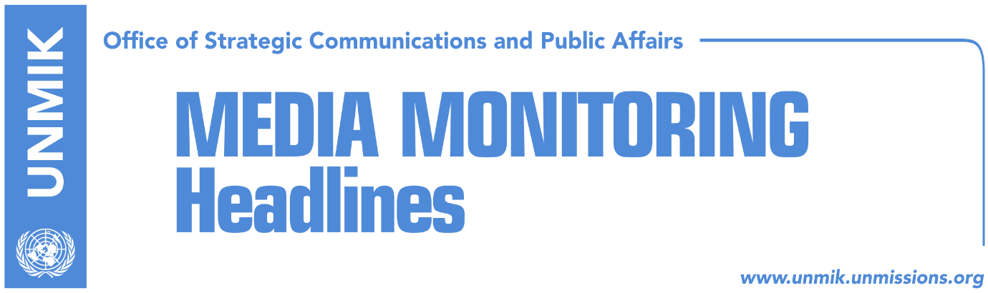

Main Stories 22 October 2018

- Thaci: Border correction, a historic opportunity for a peace deal (media)
- Veseli: Exchange of territories is not an option (DPA, RTK)
- Red lines in dialogue and KSF transformation irritate Serbia (Koha)
- “Correction of borders should not be issue of dialogue with Serbia” (RTK)
- LDK: Early general elections are inevitable (media)
- Kosovo leaders condemn attack on Serb pilgrims (media)
- Vetevendosje preparing draft law which would document war crimes (RTK)
- Prosecutor confirms arrest of Deputy Minister (Zeri)

Kosovo Media Highlights

Thaci: Border correction, a historic opportunity for a peace deal (media)
Kosovo’s President Hashim Thaci said in an interview to Vecernji List that border correction between Kosovo and Serbia represents a historic opportunity for a final peace deal with Serbia. Thaci repeated that Presevo, Medvedja and Bujanovac would join Kosovo and that under no circumstance he would agree to talk about Mitrovica North, the Gazivoda Lake or the Trepca mining complex. Thaci further argued that those who are against his initiative have no other alternative “which would secure Kosovo’s recognition by Serbia and membership of EU, NATO and UN”. On the transformation of the Kosovo Security Force (KSF) into the armed forces, Thaci said Kosovo is entitled to have its own regular army as every other country. He also added that in order to establish a proper army, Kosovo’s authorities must cooperate with the U.S. and NATO.

Veseli: Exchange of territories is not an option (DPA, RTK)
The President of the Assembly of Kosovo Kadri Veseli, told German news agency DPA he hopes that after the withdrawal of the German Bundeswehr from the biggest military camp in Prizren, German companies will arrive with their investments in this city. During this interview, Veseli denied the possibility of exchange of the territories between Kosovo and Serbia saying, “exchange of territories is not an option.” He added that reconciliation with Kosovo is Serbia’s main condition to become a European Union member.

Red lines in dialogue and KSF transformation irritate Serbia (Koha)
The paper reports on its front page that Germany’s red lines in the process of dialogue and the United States’ support for the transformation of the Kosovo Security Force (KSF) into the Kosovo Army have irritated Serbia. Serbian President Vucic, Prime Minister Brnabic and head of the Serbian government’s office for Kosovo, Djuric, have called for no limitations to an eventual agreement with Pristina. But the attempts by Serbian leaders to resolve the Kosovo problem through border correction has been slammed by European diplomats. The U.S. don’t have a preferred outcome for the final phase of dialogue between the two countries, even though Kosovo President Hashim Thaci counts on U.S. support for his idea for “border correction”. The paper quotes U.S. Deputy Assistant Secretary of State, Matthew Palmer, as saying that the United States is “neither pushing nor advocating for any particular outcome of dialogue between Belgrade and Pristina”. “We are encouraging the parties to find a way forward and find a lasting and sustainable solution that both sides will accept,” Palmer said.

“Correction of borders should not be issue of dialogue with Serbia” (RTK)
Deputy leader of the Democratic League of Kosovo Agim Veliu, met on Sunday with German Parliament MP from CDU, member of the Parliamentary Committee for Foreign Policy, and rapporteur for Western Balkans Peter Beyer as well as with the KAS Director for Former Yugoslav Republic of Macedonia (FYROM) and Kosovo, Johanes Rey. “During the meeting, Neyer was interested about the general political developments, especially about the issue of the correction of the territories, where our joint position was that the matter of the borders should not be part of the final phase of the dialogue with Serbia,” Veliu wrote on his Facebook account.

LDK: Early general elections are inevitable (media)
According to the Democratic League of Kosovo (LDK), early general elections are the only solution to the current political crisis. LDK Secretary General, Ismet Beqiri, said on Sunday that this party was coordinating with other political parties to initiate a motion of confidence against the Haradinaj-led government and argued that Kosovo will head to early elections soon.

Kosovo leaders condemn attack on Serb pilgrims (media)
The President of Kosovo Hashim Thaci condemned Sunday’s attack on the buses with Serb pilgrims in Istog/Istok. He took to Facebook to write that all citizens should enjoy the right on the freedom of movement and called on the order bodies to put perpetrators in front of the justice. Prime Minister of Kosovo Ramush Haradinaj said the attack is unacceptable and condemnable “no matter who the perpetrators or what the motives were”. “Kosovo and its institutions are committed to peace and stability and any kind of attack on citizens is an attack on our joint European values, and as such it is harmful for our Republic,” Haradinaj said.

Vetevendosje preparing draft law which would document war crimes (RTK)
Vetevendosje Movement is preparing a draft-law that would document Serbia’s crimes committed during 1998-1999. Kosovo Assembly MP from this political party, Albulean Haxhiu, said it is unfortunate that they never had official data on Serbia’s crimes committed in Kosovo. “I do not understand how these people could lead Kosovo institutions and never undertake this action. There are many places where crimes are documented even in their official pages. It is unacceptable for us not undertake any action on this direction,” she said.

Prosecutor confirms arrest of Deputy Minister (Zeri)
Chief Prosecutor of the Basic Court in Pristina Imer Beka, confirmed that the Basic Court in Pristina has ordered 30 days detention for the Deputy Minister of Regional Development, Musa Cena, and two businesspeople, suspected of receiving bribes and abuse of the official duty. According to him the hearing session on the case will take place on Monday.

Disclaimer
This media summary consists of selected local media articles for the information of UN personnel. The public distribution of this media summary is a courtesy service extended by UNMIK on the understanding that the choice of articles translated is exclusive, and the contents do not represent anything other than a selection of articles likely to be of interest to a United Nations readership. The inclusion of articles in this summary does not imply endorsement by UNMIK.

