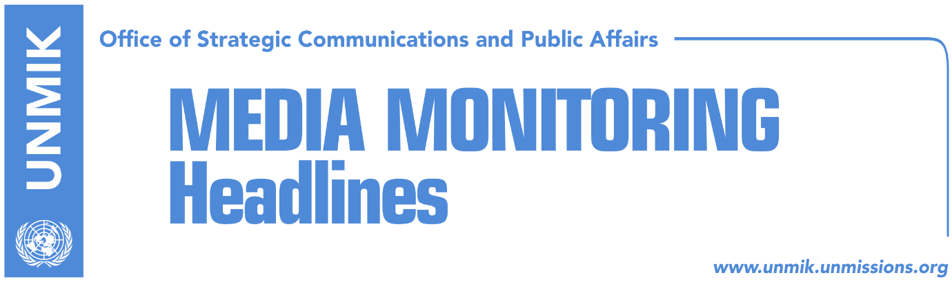

Main Stories 24 October 2018

- Haradinaj talks alternative to Thaci’s “border correction” idea (media)
- Palmer: US to support strengthening of Kosovo statehood (Zeri)
- German MP warns against Kosovo-Serbia land swap idea (media)
- EU requests do not set Kosovo back from its army creation plan (Zeri)
- Montenegro minister: Army is internal matter of Kosovo (Zeri)
- Committee forms working group on KSF draft laws (media)
- Dacic: No Kosovo army as long as Resolution 1244 is in force (media)
- Kocijancic: EC and Serbia have different views on dialogue (Koha/Beta)
- Hoxhaj: We should use EU’s conditioning of Serbia (RTK)
- EU integration minister hints at possibility of visa liberalisation delay (Zeri)
- Vetevendosje: For 14 months, government caused more scandals than work (RTK)

Kosovo Media Highlights

Haradinaj talks alternative to Thaci’s “border correction” idea (media)
Kosovo Prime Minister, Ramush Haradinaj, said in an interview to KTV on Tuesday evening, that the idea for border correction between Kosovo and Serbia is wrong and that he is categorically against it. “I think decision-making factors have understood that there is no room for such an option. The President [Hashim Thaci] said that if someone has an alternative, he is willing [to back down from his idea]. I think there is an alternative and that is for the two nations to live in peace, and not for Kosovo to open up because this is not peace this is instability … I think respecting the current borders, the territory, and recognition, is the alternative … [The border correction idea] is dead as an option. No one is willing to try such experiments,” Haradinaj said.

Palmer: US to support strengthening of Kosovo statehood (Zeri)
The US Deputy Assistant Secretary of State Matthew Palmer met during his visit to Kosovo Prime Minister Ramush Haradinaj, President Hashim Thaci and leader of the opposition Democratic League of Kosovo (LDK) Isa Mustafa. A press release issued by the government of Kosovo states that PM Haradinaj told the US official that Kosovo is firm in maintaining its constitutional order with regards to the final agreement with Serbia which he said has been achieved due to the sacrifice of the people of Kosovo and the longstanding US and international community’s support. Palmer on his part is reported to have said his country will continue supporting Kosovo in strengthening its statehood and the processes it is going through.

German MP warns against Kosovo-Serbia land swap idea (media)
Peter Beyer, MP from the German ruling party of CDU, said the idea of Kosovo and Serbia exchanging territories as part of the final agreement is both dangerous and unacceptable. Speaking to reporters in Pristina, Beyer said he conveyed this position to Kosovo President Hashim Thaci who in turn told him: “I am the president and I decide.” Beyer said he expects November to be a month of decisions in the dialogue between Kosovo and Serbia and pointed out that Kosovo legislators not the president represent the will of the people. While he did not mention any proposal that could be applied in the Kosovo-Serbia dialogue, Beyer did say that the model of two Germanys should not be ignored. With regards to visa liberalisation, German MP also said he would be optimistic to believe that this would be concluded this year and that whoever believes this will be the case, “is wrong.”

EU requests do not set Kosovo back from its army creation plan (Zeri)
The government of Kosovo will not step back on its plan to transform the Kosovo Security Force (KSF) into an army through a law despite the objection from the EU which noted that this should happen through constitutional changes and by taking into consideration concerns of all communities. Prime Minister Ramush Haradinaj said EU request is not in discordance to the actual way Kosovo is pursuing in setting up its armed force. He said calls for inclusiveness will be respected and the law on KSF transformation is in line with the Constitution of Kosovo.

Montenegro minister: Army is internal matter of Kosovo (Zeri)
Montenegro’s Defence Minister Predrag Boskovic said his country does not intend to interfere into Kosovo’s internal affairs regarding whether it decides to set up its army through constitutional changes or law. In a meeting with Kosovo Security Force Minister Rrustem Berisha, Boskovic said Montenegro is an honest ally to Kosovo and will support countries that aspire to join NATO.

Committee forms working group on KSF draft laws (media)
Most media report that the Kosovo Assembly’s Internal Affairs Committee has set up a working group on Tuesday that will work on the package of the draft laws for the transitioning of the Kosovo Security Force. Koha Ditore reports on its coverage that the working group will hold two hearings, in Prizren with different communities and in Gracanica with members of the Serb community. The paper also notes that the Serb representative in the committee said he would not attend the meeting of the working group. “The Serbian List must not contribute to this. We are against these laws,” he was quoted as saying.

Dacic: No Kosovo army as long as Resolution 1244 is in force (media)
Serbian Foreign Minister, Ivica Dacic, said in an interview to RTS on Tuesday that “Pristina is constantly looking for an alibi not to implement the agreements signed in Brussels” and that “Kosovo does not want to join INTERPOL to fight crime but to show that it is a state”. Dacic further argued that as long as UNSC Resolution 1244 remains in force, Kosovo cannot have its own army. According to him, the initiative to transform the Kosovo Security Force into an army “is an attempt by Western countries to please Kosovo’s authorities”. Dacic recalled a statement by EU High Representative Federica Mogherini that the EU will support the KSF transformation only based on the Constitution. “This is against the Constitution, so there is nothing there [the KSF transformation],” he added.

Kocijancic: EC and Serbia have different views on dialogue (Koha/Beta)
European Commission spokesperson Maja Kocijancic told Belgrade news agency Beta that they have different views with Belgrade on dialogue with Pristina in relation to some believing the process has come to a halt due to disagreements amongst Kosovo leaders and Kosovo’s plans to set up its army. “Our assessments on the position of dialogue are clearly different,” Kocijancic said adding that the EU is making efforts to schedule a new round of high-level meeting between Kosovo and Serbia officials.

Hoxhaj: We should use EU’s conditioning of Serbia (RTK)
Deputy Prime Minister of Kosovo Enver Hoxhaj said on Tuesday that Kosovo should use EU’s conditioning of Serbia on its membership. “EU has conditioned Serbia with normalization of relations with Kosovo. EU made it clear to Serbia that its journey to Europe goes through Pristina. This situation should be used,” Hoxhaj said adding that an agreement with Serbia should be reached. He also stressed that Kosovo’s political specter should be united when dialogue with Serbia is concerned. “Some of our colleagues are dealing with daily romanticisms,” Hoxhaj said.

EU integration minister hints at possibility of visa liberalisation delay (Zeri)
Kosovo’s Minister of European Integration Dhurata Hoxha has maintained until now that Kosovo will be granted visa liberalisation by the end of the year but the paper writes that as the end-year approaches, Hoxha has modified its position to that if majority of necessary votes is not achieved at the Council of EU Ministers, the voting set to take place early December could be postponed for some other time. However, Hoxha said at the government meeting that the process will not go back to square one and that it is only a matter of time before people of Kosovo will be able to travel freely to EU.

Vetevendosje: For 14 months, government caused more scandals than work (RTK)
Vetevendosje Movement held on Tuesday a press conference to speak about the fourteen months of Ramush Haradinaj’s governing. According to them, for this period, the government caused more scandals than work. “The government has degraded the economy of the country, violated local legislation and Stabilisation Association Agreement (SAA). The government of Kosovo has made some decisions on economy section which result with destruction of competition, SAA violation and damage of public property,” said Besnik Bislimi, deputy leader of this political party. “Decision of the Ministry for Infrastructure to pay € 50 million to Bechtel Enka is scandalous. Haradinaj’s government for 400 days has been active on degradation of performance at different agencies. The government has made arbitrary decision for selective increase of salaries, this violates the law,’ he added.

Disclaimer
This media summary consists of selected local media articles for the information of UN personnel. The public distribution of this media summary is a courtesy service extended by UNMIK on the understanding that the choice of articles translated is exclusive, and the contents do not represent anything other than a selection of articles likely to be of interest to a United Nations readership. The inclusion of articles in this summary does not imply endorsement by UNMIK.

