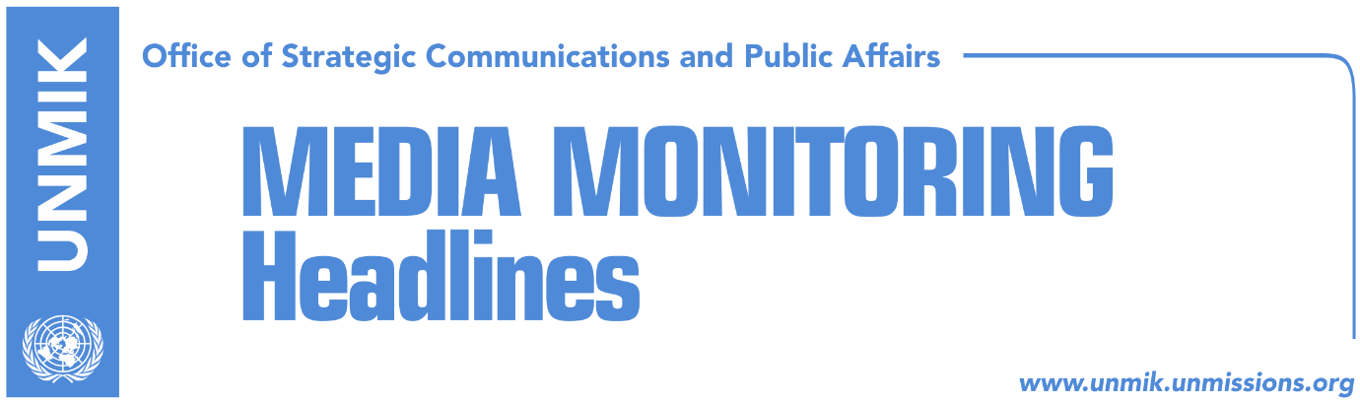

Main Stories 26 October 2018

- Haradinaj: Anytime Balkans borders are touched, tragedy ensues (Bota Sot)
- Palmer: US has no time to lose dwelling on Kosovo-Serbia problem (Klan Kosova)
- EP rapporteur warns of destabilisation if visa regime not lifted (Zeri/Express)
- Thaci waiting Constitutional Court’s view on international agreements (Zeri)
- LDK submits request for new extraordinary session (RTV21)
- Opposition alarmed over news that borders could be discussed in Paris (Koha)
- O’Connell: Kosovo should establish credible justice system (RTK)
- Pacolli visits Togo, Benin and Nigeria (Epoka)
- Ongoing excavations in Izbica for bodies of Albanians killed in conflict (Koha)

Kosovo Media Highlights

Haradinaj: Anytime Balkans borders are touched, tragedy ensues (Bota Sot)
In Budva, Montenegro for an EU-Western Balkans economic conference, Prime Minister of Kosovo Ramush Haradinaj said transformation of the Kosovo Security Force (KSF) into an army is an internal issue of Kosovo institutions while with regards to the idea of territorial exchange between Kosovo and Serbia as part of the final agreement, Haradinaj said anytime territories and borders in the Balkans were touched, it was followed by tragic events. “We don’t want that. We have lost a great deal in the past and we don’t want to relive it,” Haradinaj said.

Palmer: US has no time to lose dwelling on Kosovo-Serbia problem (Klan Kosova)
The US Deputy Assistant Secretary of State Matthew Palmer held a meeting with Kosovo political representatives at the premises of the US Embassy in Pristina. A source told Klan Kosova that Palmer directly asked the political leaders to specify what they would be willing to give up to secure recognition from Serbia. He is also reported to have said that the US has no time to lose dwelling on the Kosovo-Serbia problem. The US Embassy has not confirmed the meeting.

EP rapporteur warns of destabilisation if visa regime not lifted (Zeri/Express)
European Parliament rapporteur for Kosovo Igor Soltes warned of possible destabilisation in Kosovo if the EU fails to give green light for visa liberalisation. He said a positive decision would represent a sign of good trust between the EU and Kosovo. “No one wants to see destabilisation because of the lack of trust between the two parties,” Soltes said admitting however that there are EU member states that are still skeptical on supporting Kosovo’s visa-free travel.

Thaci waiting Constitutional Court’s view on international agreements (Zeri)
The paper reports that President of Kosovo Hashim Thaci has been waiting for two months for the Constitutional Court to reply on whether international agreements signed by the president of Kosovo need to be ratified by the Assembly. Article 18 of the Constitution of Kosovo states international agreements relating to the territory, peace, alliances, political and military issues are some of the issues that require ratification by two-thirds of the votes of all MPs while other fields not mentioned in the article could be considered as ratified upon signature from the president of Kosovo. Thaci’s request is considered as part of his attempt to sidestep the Assembly in case of agreement with Serbia while the Constitutional Court said it was still reviewing the case.

LDK submits request for new extraordinary session (RTV21)
Avdullah Hoti, caucus of the Democratic League of Kosovo (LDK) took to Facebook to inform that his political party submitted today a new request for an extraordinary session which would set the red lines for the dialogue between Kosovo and Serbia. “We have submitted today a new request for an extraordinary session to set the red line in the dialogue, that Kosovo’s territory is one and undivisive and no one can negotiate the territory of Kosovo,” Hoti wrote.

Opposition alarmed over news that borders could be discussed in Paris (Koha)
The paper reports on its front page that opposition parties in Kosovo are alarmed after President Hashim Thaci implied that his idea on border correction with Serbia could be discussed in Paris. French President Macron has invited Kosovo and Serbia presidents to attend the 100th anniversary of the ceasefire signed between Allied Forces and Germany that marked the end of World War I. Some media have reported that Thaci and Vucic could hold a meeting in Paris. Thaci’s office did not say if the meeting will take place or if the idea on border correction will be presented to international diplomats in Paris.

O’Connell: Kosovo should establish credible justice system (RTK)
Ruairi O’Connell, Ambassador of the United Kingdom to Kosovo said during a TV debate on Thursday that Kosovo should undertake serious reforms to create a credible justice system and with clean figures. “We and Kosovo have the same interest of having an efficient and clean justice system here. After the conclusion of the EULEX mission, Kosovo has a good chance to prove that it is ready to take over responsibilities of combating serious crimes and corruption,” the British Ambassador said.

Pacolli visits Togo, Benin and Nigeria (Epoka)
Kosovo’s Deputy Prime Minister and Minister for Foreign Affairs Behgjet Pacolli, after participating at the Crans Montana Forum in Switzerland, visited on Thursday Togo, Benin and Nigeria. “After the meetings at the Crans Monatana Forum in Switzerland, I visited today Togo, Benin and now I arrived in Nigeria, where I am waiting to meet with representatives of respective institutions from the fields of interest for Kosovo,” Pacolli wrote on his Facebook account.

Ongoing excavations in Izbica for bodies of Albanians killed in conflict (Koha)
Excavations have been ongoing for four days now in Izbica, Skenderaj municipality, for bodies of Kosovo Albanians killed during the conflict, the paper reports on page four. 137 bodies of Albanians were buried on that site and later exhumed by Serbian forces and taken to five different locations. Excavations resumed under the suspicion that there could be other bodies buried there. Prenk Gjetaj, head of the Kosovo government’s missing persons committee, told the paper on Thursday that so far, they have found no mortal remains.

Disclaimer
This media summary consists of selected local media articles for the information of UN personnel. The public distribution of this media summary is a courtesy service extended by UNMIK on the understanding that the choice of articles translated is exclusive, and the contents do not represent anything other than a selection of articles likely to be of interest to a United Nations readership. The inclusion of articles in this summary does not imply endorsement by UNMIK.

