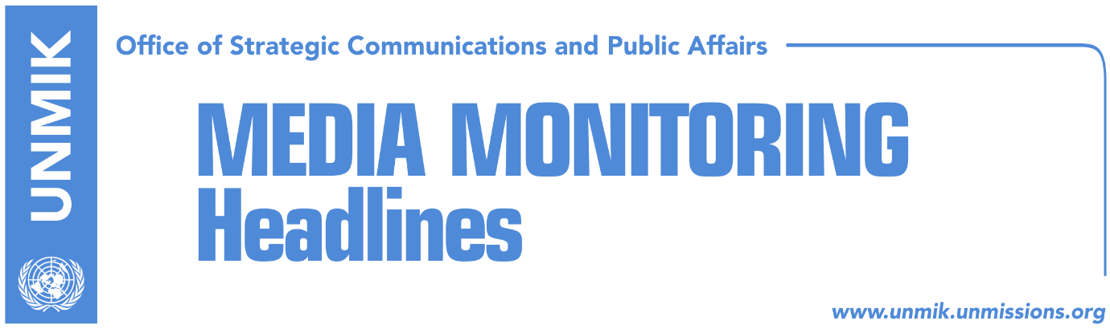

Main Stories 27 October 2018

- PM Haradinaj reiterates position against border correction with Serbia (media)
- Thaci says Kosovo – Serbia dialogue won’t be discussed in Paris (media)
- Hoti: Extraordinary session on dialogue red lines on 1 November (RTK)
- Haliti: Presevo’s unification with Kosovo, impossible (RTK)
- Dacic: Kosovo will not be accepted at INTERPOL (media)
- Sherifi: First consensus then elections (Epoka e Re)

Kosovo Media Highlights

PM Haradinaj reiterates position against border correction with Serbia (media)
In a press conference after the meeting of the government, Prime Minister of Kosovo Ramush Haradinaj reconfirmed on Friday his position against border changes. “There can be a legally binding agreement for mutual recognition with Serbia but not an agreement based on territory or border,” RTK quotes Haradinaj as saying.

Zeri reports that Haradinaj said they know what doesn’t work with regards to the dialogue with Serbia but that they still have no concrete proposal as to what would work. “It would be good if the opposition came out with something that would work. We have made it clear that no one can speak about something that will not work such as the borders,” Haradinaj said.

Asked about the meeting the US Deputy Assistant Secretary of State Matthew Palmer had with Kosovo political leaders, Haradinaj said it is not up to him to comment on what Palmer said there. “You can call the US Embassy and ask,” Haradinaj said. “You know our positions. It is important someone of the level of Matthew Palmer coming to Kosovo considering how busy the US is with other topics and developments. This demonstrates the determination of the US to be alongside Kosovo and the region. This is his message but for more you can ask the US Embassy,” Haradinaj is quoted by Klan Kosova.

Thaci says Kosovo – Serbia dialogue won’t be discussed in Paris (media)
Kosovo President Hashim Thaci told reporters in Pristina on Friday that dialogue between Kosovo and Serbia will not be discussed in Paris on November 11 and that the meeting there is a good opportunity to further promote the state of Kosovo. “There won’t be a dialogue between Kosovo and Serbia there (Paris), but it will be an opportunity to promote the state of Kosovo. My participation there, and that of Serbian President, will be under the authority of the French President, not the President of Kosovo. Serbia could have remarks in this respect, but this is their issue. As far as dialogue is concerned, I still hope the Assembly will do its job, so I call on all political parties, both from the ruling coalition and the opposition, to overcome the political and institutional stalemate and to pave way to the future of the country. The President will do his job, and I call on political parties to assume their state responsibilities, to approximate their positions, to have a joint platform and state agenda,” Thaci is quoted as saying.

Hoti: Extraordinary session on dialogue red lines on 1 November (RTK)
Avdullah Hoti, caucus of the Democratic Lague of Kosovo (LDK) said on Friday that an extraordinary Kosovo Assembly session with regards to the red lines on the dialogue with Serbia, will be held on 1 November. “No one has the right to negotiate the territory of Kosovo. This is the main red line of the dialogue process. I hope and I call on all political parties, all the MPs of the Assembly of Kosovo to participate at the 1 November session and to vote this resolution,” Hoti said.

Haliti: Presevo’s unification with Kosovo, impossible (RTK)
Xhavit Haliti, deputy president of the Assembly of Kosovo from the Democratic Party of Kosovo (PDK,) said unification of Presevo Valley with Kosovo is currently impossible. He added that unification of some Kosovo municipalities with Serbia is also impossible as Kosovo has a Constitution under which Kosovo MPs made an oath and which stresses clearly that Kosovo has no claims towards any other country. He added that statements of the state leaders for broadcasters are balloons which make noise, while actions are null.
“The President is not the one to sell Kosovo, his wish might be a good one, but possibilities are another matter,” Haliti said.

Dacic: Kosovo will not be accepted at INTERPOL (media)
Serbia’s Foreign Minister Ivica Dacic said on Friday that INTERPOL member states are facing major lobbying of Pristina for Kosovo’s membership at this international organization, however according to him, Kosovo will not become a member at November meeting which will be held in Dubai. He said Pristina officials are offering money to the foreign delegations for their membership and to travel to Dubai to vote in their favor. “As two thirds of the votes are required, I do not belive that Kosovo will pass,” Dacic said.

Sherifi: First consensus then elections (Epoka e Re)
Bilall Sherifi, caucus of the Social-Democratic Initiative (NISMA) objected the position of the Democratic League of Kosovo (LDK) and Vetevendosje Movement for early elections. According to Sherifi, a national consensus on the dialogue between Kosovo and Serbia should be initially reached between the government coalition and opposition political parties, in order for the discussions for new elections to resume.

Disclaimer
This media summary consists of selected local media articles for the information of UN personnel. The public distribution of this media summary is a courtesy service extended by UNMIK on the understanding that the choice of articles translated is exclusive, and the contents do not represent anything other than a selection of articles likely to be of interest to a United Nations readership. The inclusion of articles in this summary does not imply endorsement by UNMIK.

