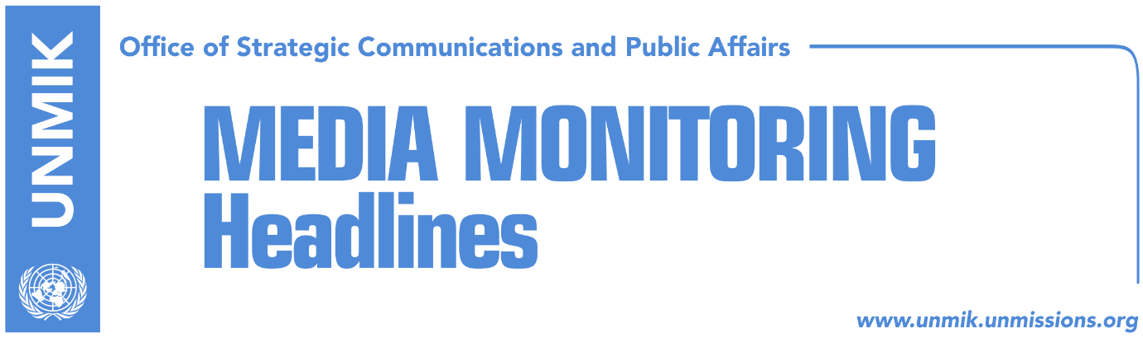

Main Stories 29 October 2018

- Haradinaj: I don’t want border experiments (Zeri)
- Veseli calls for unification on dialogue, warns US and EU will not wait (media)
- Ruling coalition too alarmed over risks from dialogue with Serbia (Koha)
- Cooper: There cannot be change of borders (Epoka)
- Busek: Change of borders between Kosovo and Serbia, realistic option (Kosova)
- Association/Community draft statute neither sent to Pristina or Brussels (RFE)
- Vetevendosje: There is no liberalization (RTK)
- Rashiti: Dozen EU countries against visa liberalisation for Kosovo (Zeri)
- Palokaj: Nothing will happen if visas are not removed (Koha)
- Pacolli slams Belgrade for publishing book of convicted war criminal (Bota Sot)
- Explosive device found in courtyard of KSF member in Mitrovica North (Kallxo)
- Naim Ternava reelected head of Islamic Community (Epoka)

Kosovo Media Highlights

Haradinaj: I don’t want border experiments (Zeri)
Prime Minister of Kosovo Ramush Haradinaj said in an interview for Croatian daily Vecernji List that he is against ‘experiments’ with borders. “I have made it clear that I do not split territories and I don’t want experiments with our country. It is dangerous to speak about borders or exchange of territories in the region,” Haradinaj said adding that the only issue that can be discussed with Serbia is that of mutual recognition. “There have been enough painful compromises to Serbia: the hardship during the war and crimes against Kosovans,” he said. Speaking about the creation of Kosovo army, Haradinaj said he sees no reason why anyone should be afraid of this development which he said is twenty years in making. “This is an unstoppable process. Every country needs to have its own army,” he underlined.

Veseli calls for unification on dialogue, warns US and EU will not wait (media)
In a video address to the people of Kosovo published on Facebook, Assembly Speaker Kadri Veseli said that the lack of unity in the dialogue with Serbia is damaging Kosovo and the current status quo is unacceptable for the United States and the European Union. “We cannot afford to lose our international partners with whom we’ve come this far,” Veseli said adding: “Dialogue requires unity, maturity and responsibility.” “We go to the dialogue with Serbia as an independent and sovereign country with inviolable territorial integrity,” Veseli said. He added the end-goal of the process will be Serbia’s recognition of Kosovo, UN, NATO, and EU membership but will not involve any partition, third-level government or association with executive powers.

Ruling coalition too alarmed over risks from dialogue with Serbia (Koha)
The paper reports on its front page that in early November, when negotiations between Kosovo and Serbia are expected to pick up, opposition parties in Kosovo will make another attempt to set red lines for President Hashim Thaci in dialogue. Even leaders of the ruling parties are alarmed over the risks that Kosovo faces from dialogue. Kosovo Assembly President and Democratic Party of Kosovo (PDK) leader, Kadri Veseli, said internal divisions in Kosovo have led to increased threats from abroad as a result of Serbia’s strengthened role. The paper further notes that the Assembly has so far has been caught in a decision-making crisis as no political camp has been able to push forward parliamentary initiatives on dialogue with Serbia. The paper also notes that the Assembly Presidency will meet today to decide if it will call an extraordinary session on President Thaci’s initiative for “land swap” or “border correction”.

Cooper: There cannot be change of borders (Epoka)
Former mediator of the technical dialogue between Pristina and Belgrade Robert Cooper said the parties should focus on implementation of the reached agreements so far. He said the parties should be cautious and consult the neighboring countries in order to avoid eventual shaking of stability and security of the region. Speaking about Kosovo President Hashim Thaci’s idea for correction of the border, the British diplomat said borders cannot change continuously and added that if such agreement exists, all countries of the region should be consulted. He said that prior to deciding to support this idea, western countries should make public all the details of its content.

Busek: Change of borders between Kosovo and Serbia, realistic option (Kosova)
Former coordinator of the Stability Pact for South-Eastern Europe Erhard Busek said Europe has continuously changed its borders during the history and added that there many such examples. “So, for us, change of borders is realistic even in Kosovo’s case. Busek made these comments at the international conference of the European Center for Peace and Development on the new security concepts in the world. He also added that the Eu should as soon as possible accept membership of Balkans countries in order to resolve problems.

Association/Community draft statute neither sent to Pristina or Brussels (RFE)
The government of Kosovo has no confirmed information as to whether the Managing Team for the drafting of the statute for Association/Community of Serb-majority municipalities has actually submitted its final product to the EU and that they have definitely not sent it to Pristina either. Head of the Kosovo’s technical team for dialogue with Serbia, Avni Arifi, said the Managing Team has only submitted to the government of Kosovo minutes of meetings with different stakeholders. Arifi said that initially, it was believed that the draft statute was sent to the EU but “based on the information I possess from Brussels, it was not delivered there either.”

Vetevendosje: There is no liberalization (RTK)
Kosovo Assembly MPs from the Vetevendosje Movement, Albulena Haxhiu and Fitore Pacolli, requested on Sunday resignation of the Prime Minister Ramush Haradinaj and other senior officials, starting from President Thaci. According to this political party, current government leaders are continuously harming Kosovo. They also requested resignation of the Deputy Prime Ministers Enver Hoxhaj and Behgjet Pacolli, that of Minister of Justice, Abelard Tahiri, and Minister for European Integration Dhurata Hoxha. According to Vetevendosje MPs, these officials deceived about visa liberalization claiming that Germany, Belgium, France and Holand are for liberalization of visas, while now it appears that they are against.

Rashiti: Dozen EU countries against visa liberalisation for Kosovo (Zeri)
The paper quotes on the front page Naim Rashiti from the Balkans Policy Group for Kosovo saying that on the last meeting of the permanent representatives of EU countries, also known as COREPER, around a dozen of countries expressed reservations towards granting Kosovo visa-free travel. Experts meanwhile warn that if the visa liberalisation decision is not taken this year, Kosovo risks remaining with visa regime until 2020. One of the reasons for the possible delay, according to the paper, is the fact that as of January Romania will take the EU presidency and as a non-recognising country it is not expected to push forward the visa liberalisation process for Kosovo. The situation could potentially become even more complicated by next year’s European Parliament elections.

Palokaj: Nothing will happen if visas are not removed (Koha)
The paper’s Brussels-based correspondent, Augustin Palokaj, argues in an opinion piece that “the European Union has no reason not to give visa liberalization to Kosovo”. “It is a great injustice that this discrimination is continuing. Corruption, organized crime, possible political tensions, the fear from exodus, are only excuses because the only real reason is the lack of political readiness. The EU bears the biggest blame for lack of visa liberalization. The problem is in the fact that Kosovo lacks the political power, and Kosovo’s political leaders lack the moral power, to force the EU into giving visa liberalization,” Palokaj writes.

Pacolli slams Belgrade for publishing book of convicted war criminal (Bota Sot)
Kosovo Foreign Minister Behgjet Pacolli said in a Facebook post that it was shameful that the government of Serbia sponsored the publishing of a book authored by Nebojsa Pavkovic, war criminal convicted by the Tribunal in The Hague for crimes against Albanians. He said he hoped his sentiments are shared by NATO member states and international justice institutions and that recent actions of Belgrade show Serbia “remains prisoner to its shameful past in the region.”

Explosive device found in courtyard of KSF member in Mitrovica North (Kallxo)
The news website reports that an explosive device was found in the courtyard of a Bosniak member of the Kosovo Security Force (KSF) in Mitrovica North on Saturday. A KSF spokesman confirmed the information and said that police were handling the case and that there have been no injuries. The news website also recalls that there have been several assaults and intimidation cases especially against Serb members of the KSF in the northern part of Kosovo.

Naim Ternava reelected head of Islamic Community (Epoka)
Kosovo’s Islamic Community reelected on Saturday Mufti Naim Ternava as head of this community. Ternava gained 52 votes while his counter candidate, Reshat Mexhiti, six votes. After the elections Ternava presented members of the leadership: Ahmet Rama for Pristina, Ejup Haziri for Mitrovica region, Musli Arifaj for Peja, Valon Myrta for Gjakova region, Reshat Mexhidi for Prizren, Fehmi Mehmeti for Ferizaj region, Ilmi Krasniqi for Gjilan and Sulejman Fejzulahu for Presevo region.

Disclaimer
This media summary consists of selected local media articles for the information of UN personnel. The public distribution of this media summary is a courtesy service extended by UNMIK on the understanding that the choice of articles translated is exclusive, and the contents do not represent anything other than a selection of articles likely to be of interest to a United Nations readership. The inclusion of articles in this summary does not imply endorsement by UNMIK.

