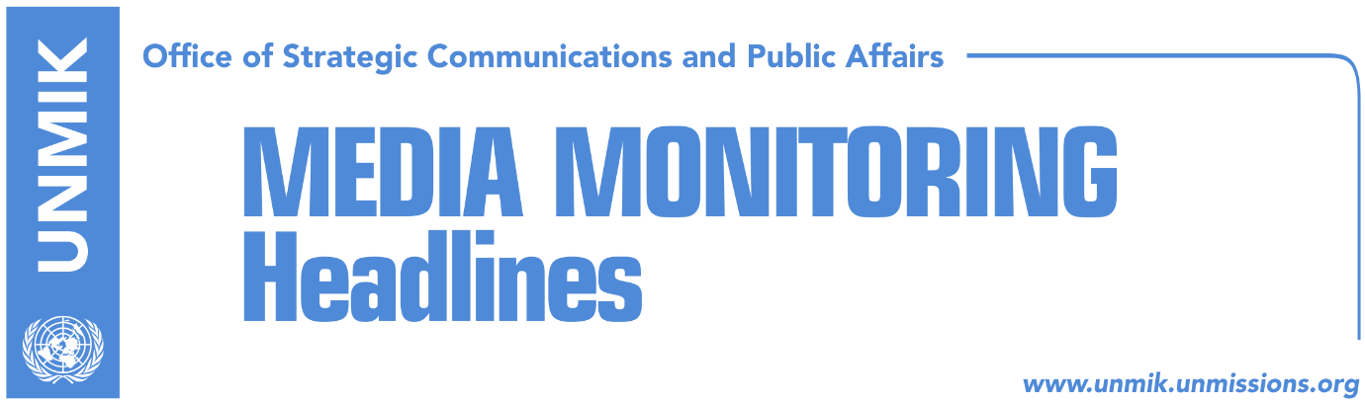

Main Stories 2 November 2018

- Resolution on dialogue fails to receive Assembly’s endorsement (Zeri)
- President Thaci calls on parties to draft joint platform on dialogue (media)
- Thaci: EU to support agreement with Serbia (RTK)
- Shala: Thaci and Vucic did not discuss land swap (media)
- Government officials advocate for border “correction” (Koha)
- Kosovo leaders: KSF transition, unstoppable process (Epoka e Re)
- Kosovo and Serbia both claim victory on UN SC sessions on Kosovo (Koha)
- Limaj: I am skeptical about Kosovo’s membership to INTERPOL (Telegrafi)
- PDK suffers major blow in Drenica (Zeri)

Kosovo Media Highlights

Resolution on dialogue fails to receive Assembly’s endorsement (Zeri)
Kosovo Assembly MPs did not approve yesterday resolution on dialogue with Serbia proposed by the Democratic League of Kosovo (LDK) and Vetevendosje which would oppose President Hashim Thaci negotiating Kosovo borders. MPs from the ruling parties did not vote on the resolution as the previous attempts at harmonising the text failed. Head of the Democratic League of Kosovo (LDK) parliamentary group, Avdullah Hoti, said they expressed readiness to incorporate the last of the six-point proposal of the Democratic Party of Kosovo (PDK) to the resolution’s text but Memli Krasniqi from PDK said he doesn’t see a reason why all the points would not be included in the final text of the resolution.

President Thaci calls on parties to draft joint platform on dialogue (media)
Kosovo President Hashim Thaci said in an interview to RTK on Thursday that the ruling coalition and opposition parties should draft a joint platform and set up a broad-based negotiating team for dialogue with Belgrade. Thaci said “we should stand united vis-à-vis Serbia and in this way we will win”. He added that Kosovo’s political representatives must not boycott the process of dialogue.

Thaci: EU to support agreement with Serbia (RTK)
President of Kosovo Hashim Thaci, in Belarus for the Munich Security Conference, met Slovakia’s Foreign Minister Miroslav Lajcak and tweeted after the meeting that he expects all EU member states to support “a final and comprehensive peace treaty” between Kosovo and Serbia which would ensure both countries as equals approach the EU family.

Shala: Thaci and Vucic did not discuss land swap (media)
Blerim Shala, political advisor to Kosovo President Hashim Thaci, said on Thursday that Thaci and his Serbian counterpart Aleksandar Vucic did not discuss the option of land swap, but focused on a possible border agreement. Shala said they also talked about normalizing relations between the two countries. “We need to aim for a formal recognition by Serbia. If they don’t do this, then there is no reason for us to talk with Serbia,” Shala said in a debate on T7.

Government officials advocate for border “correction” (Koha)
The paper reports on its front page that contrary to the position of Prime Minister Ramush Haradinaj, different government officials are advocating for “border correction” in private and official meetings with international officials. International sources told the paper on Thursday that they were surprised when they saw government officials – Ministers, advisors to ministers and other lower ranking officials - presenting this position that goes against that of Prime Minister Haradinaj. “There are different representatives, even ministers and senior political advisors, who represent the government in different events, conferences and closed meetings, and are advocating for the exchange of territories with Serbia,” an international source told the paper. “It is surprising how they talk on behalf of the government and present a position that is rejected by their prime minister”. The Office of the Prime Minister told the paper that Haradinaj’s position is the position of the government, but they did not say how they will act toward those officials that advocate for a different position in their meetings with internationals.

Kosovo leaders: KSF transition, unstoppable process (Epoka e Re)
Kosovo Prime Minister Ramush Haradinaj and Assembly Speaker Kadri Veseli said yesterday at a conference on Kosovo Security Force and partners that the transition into an army is an unstoppable process. PM Haradinaj said the KSF’s transition is a legitimate and democratic process and that it demonstrates maturity of Kosovo institutions to take on more responsibilities. He pointed out that KSF will not be replacing KFOR and that NATO’s presence in Kosovo will “forever be welcomed.” Haradinaj also said that the cases of threats and intimidation against Serb members of the KSF are “unacceptable” and that the KSF will maintain its multiethnic character. Veseli meanwhile said KSF has met all required standards to move to the next level of being transformed into a Kosovo army. He said a Kosovo army would contribute to the stability of the region.

Kosovo and Serbia both claim victory on UN SC sessions on Kosovo (Koha)
Officials from both Kosovo and Serbia have claimed victory concerning UN Security Council sessions on Kosovo. Kosovo’s consul general in New York, Teuta Sahatqija said she was pleased that UNMIK quarterly reporting cycle to the UN Security Council was broken and that six months, instead of previous three, have passed since the last session. She however confirmed that the upcoming debate will take place on 14 November. “Other changes are expected to come such as the decrease of presence, budget, frequency and the manner of reporting as well as the changing of UNMIK’s mission from a peacekeeping and administration into a UN political mission,” Sahatqija wrote on Facebook. Serbian Foreign Minister Ivica Dacic meanwhile considers victory the return of Kosovo debate at the Security Council under China’s initiative. Dacic thanked China and Russia for contributing to Kosovo issue being reintroduced to the UN Security Council agenda.

Limaj: I am skeptical about Kosovo’s membership to INTERPOL (Telegrafi)
Kosovo’s Deputy Prime Minister and NISMA leader Fatmir Limaj said in an interview to RTV Dukagjini on Thursday that he is skeptical about Kosovo’s chances to become a member of INTERPOL. “I’m skeptical. We are working on this but it’s not easy … We need a large number of votes. This also depends on the lobbying of our partners, but there is lobbying against Kosovo’s membership and it could come down to a few votes,” Limaj said. Asked to comment on visa liberalization, Limaj said Kosovo has met the requirements. “It is unjust that Serbia, Montenegro, Albania and Macedonia were given visa liberalization, and we are still isolated … The state of Kosovo cannot be treated differently from other countries of the Balkans,” he said.

PDK suffers major blow in Drenica (Zeri)
The paper writes on the front page that the region of Drenica could soon lose the title of being stronghold of the Democratic Party of Kosovo (PDK) following Mayor of Skenderaj/Srbica, Bekim Jashari, leaving the party and announcing plans to set up his own. According to the paper, many PDK officials from the area could decide to join Jashari. One of these is Nuredin Lushtaku, former PDK MP, who said that he plans to join Jashari as soon as he sets up the new party. “I believe that if the Mayor decides to form his own party or initiative there will be none that can surpass him in votes,” Lushtaku said. Valmir Ismaili from the Democracy Plus NGO said the divisions in PDK’s branch in Skenderaj/Srbica became evident in last local elections where two candidates were vying to run for mayor, Sami Lushtaku and Nuredin Lushtaku. The two eventually agreed on Bekim Jashari running for mayor as an independent candidate but with PDK’s support. “As PDK internal elections are approaching it is becoming clear that the branch in Skenderaj will go to Sami Lushtaku. It seems the other group has sensed this and has begun preparations for setting up a new political entity,” Ismaili said.

Disclaimer
This media summary consists of selected local media articles for the information of UN personnel. The public distribution of this media summary is a courtesy service extended by UNMIK on the understanding that the choice of articles translated is exclusive, and the contents do not represent anything other than a selection of articles likely to be of interest to a United Nations readership. The inclusion of articles in this summary does not imply endorsement by UNMIK.

