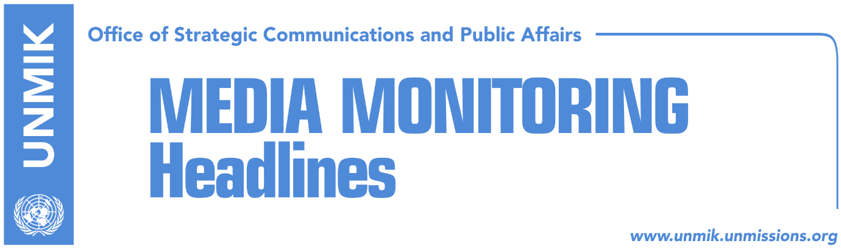

Main Stories 8 November 2018

- Thaci and Vucic to meet today in Brussels (dailies)
- Thaci: I would rather discuss with a devil than with Vucic (Kosovapress)
- Collaku: There is no date for reach of final agreement (RTK)
- Kosovo FMA rejects reports the Comoros have revoked recognition (dailies)
- Haradinaj: Kosovo deserves visa liberalisation (Zeri)
- Veseli: Kosovo entitled to visa liberalisation decision in December (media)
- Croatia opposes ‘border correction’ idea (Zeri)
- Shala: Tax on imports from Serbia and Bosnia, will remain in power (Epoka)
- Hoxhaj: Import tax to remain in force (Bota Sot)
- Kosovo Government gives in to Serbian List pressure (Koha Ditore)
- Kosovo seeks U.S. support for INTERPOL membership (Epoka)

Kosovo Media Highlights

Thaci and Vucic to meet today in Brussels (dailies)
European Union confirmed through a statement yesterday that President of Kosovo Hashim Thaci and President of Serbia Aleksandar Vucic will meet today in Brussels. “At the meeting, the two leaders are expected to confirm their readiness to intensify the work to reach a legally binding agreement on comprehensive normalisation, which is crucial for their respective European paths,” the statement reads. Zeri writes that the office of Kosovo President has not said whether Thaci plans to raise the ‘border correction’ idea in the meeting while analysts consider this is very likely to be the case. Opposition parties meanwhile maintain Thaci has no right to discuss territory of Kosovo and consider today’s meeting to be unlawful as it has not been authorised by the Assembly of Kosovo. Koha Ditore meanwhile reports that the EU continues to believe that a comprehensive agreement between Kosovo and Serbia is possible despite the polarising rhetoric by certain politicians in Pristina and Belgrade.

See the EU statement: https://bit.ly/2z1dqnL

Thaci: I would rather discuss with a devil than with Vucic (Kosovapress)
The President of Kosovo Hashim Thaci told KosovaPress that the meeting with Serbia’s President Aleksandar Vucic will be difficult and added that he would rather dialogue with a devil than with Vucic. He further appealed to the Kosovo political specter for a higher state awareness on a speedy decision-making for a wide political representation in this dialogue. He stressed that the dialogue enjoys both the EU and the U.S. support. “I hope that this process will conclude with reciprocal recognition, and internationally legally binding agreement. I hope that this process will conclude with an agreement which means definite recognition and Kosovo’s membership at the UN, which would open possibility of recognition of Kosovo by the five EU countries and certain opening of the European perspective for both Kosovo and Serbia,” Thaci said.

Collaku: There is no date for reach of final agreement (RTK)
Bekim Collaku, adviser to the President of Kosovo, who is currently in Brussels as part of the Kosovo delegation for the Thaci -Vucic meeting, told RTK that the presidents will discuss modalities of a final agreement between Kosovo and Serbia. He added that they will discuss a comprehensive and legally binding agreement, which would protect Kosovo’s national interest and that of the Albanians in the Presevo Valley. He said that there is no set date for the reach of the agreement as it does not depend only on Kosovo but the other party as well. He added that final agreement means mutual recognition between Kosovo and Serbia.

Kosovo FMA rejects reports the Comoros have revoked recognition (dailies)
Kosovo’s Ministry of Foreign Affairs has issued a statement rejecting the statement of Serbian Foreign Minister Ivica Dacic that the Union of the Comoros has revoked recognition of Kosovo saying it was ‘fake news’. In the statement, the Ministry said it possessed information from multiple reliable sources reconfirming that the countries Serbia refers to as having revoked recognition of Kosovo have not considered taking such an action.

See the statement: http://www.mfa-ks.net/en/single_lajmi/3542

Haradinaj: Kosovo deserves visa liberalisation (Zeri)
Prime Minister of Kosovo Ramush Haradinaj met yesterday Florence Mangin, Director for Europe at the French Ministry for Europe and Foreign Affairs, that Kosovo deserves visa liberalisation and that the role of France in this process is very important. In the meeting Haradinaj also spoke about efforts Kosovo institutions are making to join international organisations, particularly Interpol.

Veseli: Kosovo entitled to visa liberalisation decision in December (media)
Kosovo Assembly Speaker Kadri Veseli said that the citizens of Kosovo have remained unjustly isolated by not being able to travel freely to Europe. “Until now we were told liberalisation is not a political but entirely a technical issue. Now there are voices saying it is a political matter,” Veseli said after the meeting of Assembly presidency. “We are entitled to a European Union decision in December on visa liberalisation,” Veseli said adding that if this does not happen it would constitute an extreme case of racism towards Kosovo.

Croatia opposes ‘border correction’ idea (Zeri)
Croatian Ambassador to Kosovo, Marija Kapitanovic, said in an interview with the paper that her country does not support the idea of ‘border correction’ between Kosovo and Serbia noting that this would not make the region more sustainable. “With regards to border correction from the viewpoint of someone who comes from a country with a painful past, we don’t think this is the best possible solution,” Kapitanovic said.

Shala: Tax on imports from Serbia and Bosnia, will remain in power (Epoka)
Kosovo’s Minister of Trade and Industry Endrit Shala, told the paper that Kosovo was obliged to undertake measures toward imports from Serbia and Bosnian and Herzegovina, in order to protect local producers. According to him, this measure will remain in power until change of Serbia’s and Bosnia and Herzegovina’s approach towards Kosovo. He believes that despite the pressure from the EU, Kosovo government will not withdraw the decision.

Hoxhaj: Import tax to remain in force (Bota Sot)
Kosovo’s Deputy Prime Minister Enver Hoxhaj said that the 10 percent tax on imports from Serbia and Bosnia and Herzegovina will remain in force. In two consecutive Twitter posts, Hoxhaj said that Serbia was playing a ‘dirty’ and ‘corruptive’ campaign against Kosovo’s statehood while Bosnia’s foreign policy is an extension of that of Belgrade. “Kosovo Government is committed to cooperation but won’t withdraw economic measures until such approach is changed,” Hoxhaj wrote.

Kosovo Government gives in to Serbian List pressure (Koha Ditore)
The paper reports on the front page that the government of Kosovo has given in to the pressure from the Serbian List to halt the privatisation process in municipalities with Serb majority. In a statement, leader of the Serbian List Goran Rakic said ownership of all publicly-owned enterprises in the Serb-majority municipalities has been transferred to the municipalities. The Kosovo government spokesperson Donjeta Gashi said however that the decision affects certain properties that are intended to be used for public interests.

Kosovo seeks U.S. support for INTERPOL membership (Epoka)
Kosovo’s Minister of Justice Abelard Tahiri met during his visit in Washington with the U.S. General Prosecutor Jeff Sessions. Tahiri said the meeting was very important as they discussed empowering of the rule of law, reforms on this direction during the last fourteen months. “One of the major discussions was the U.S. support for Kosovo on INTERPOL agenda. So the meeting will take place on the 20 November and we hope to become a member with full rights as Kosovo. There is no doubt that I have received full support from Mr. Sessions that the U.S. will continue to work hard and ensure other votes for Kosovo in order for us to become full member of this very significant organization,” Tahiri said.

Disclaimer
This media summary consists of selected local media articles for the information of UN personnel. The public distribution of this media summary is a courtesy service extended by UNMIK on the understanding that the choice of articles translated is exclusive, and the contents do not represent anything other than a selection of articles likely to be of interest to a United Nations readership. The inclusion of articles in this summary does not imply endorsement by UNMIK.

