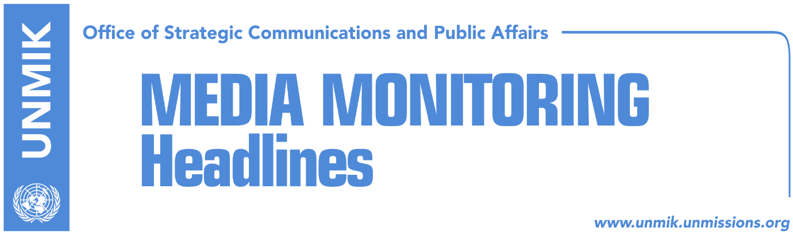

Main Stories 12 November 2018

- Thaci: Trump supports Kosovo-Serbia agreement 100 percent (Epoka)
- Status quo dangerous but reconciliation with Serbia is not impossible (RTK)
- Western diplomats seek consensus for agreement with Serbia (Koha)
- The failure to launch the agreement (Koha)
- Hoxhaj: If visas do not liberalize we will condition the dialogue (media)
- Haradinaj: They thought I want to send army to north, it’s not true (media)
- Soltes: I hope visa liberalisation will happen by May next year (Zeri)
- Mustafa: Dialogue with Serbia to be conditioned (Kosova Sot)
- VV doesn’t want Serbian List votes to bring down government (Bota/Zeri)
- Montenegro, FYROM abstain on Kosovo’s admission vote to ENTSO (Bota Sot)

Kosovo Media Highlights

Thaci: Trump supports Kosovo-Serbia agreement 100 percent (Epoka)
The President of Kosovo Hashim Thaci wrote on his Twitter account that he has gained strong support of the U.S. President Donald Trump for a final agreement with Serbia. After meeting the U.S. President, Thaci said that the most powerful man in the world supports a hundred percent reach of legally binding agreement between Kosovo and Serbia. He added that they both agreed about the need to expand peace and reconciliation in Western Balkans. In this day of Armistice100, commemorating the end of the World War I, we agreed with President Donald Trump on need to extend peace and reconciliation in Western Balkans by achieving final and comprehensive agreement between Kosovo and Serbia, enabling our Republic join NATO, UN, EU,” Thaci wrote. During his visit to Paris, Thaci also met with the German Chancellor Angela Merkel. I also had a brief talk with German Chancellor Angela Merkel in Paris. We discussed about the opportunity to achieve a comprehensive peaceful agreement between Kosovo and Serbia. We both agreed that Germany’s support is crucial for this agreement and our membership in the EU,” Thaci wrote on his Twitter account.

Status quo dangerous but reconciliation with Serbia is not impossible (RTK)
The President of Kosovo Hashim Thaci said that reconciliation with Serbia id difficult but not impossible. During his speech at the Peace Forum in Paris, within the margins of commemorating the end of the World War I, Thaci said no generation was saved from war, including the last one of the twentieth century. “Status quo for Kosovo is dangerous, and it should not be waited for conflicts with Serbia to continue for another generation. Who from us who are here wants to think about the long-term consequences if the agreement is not reached? Maybe wars, tragedies, increase of populism and nationalism. I consider that we should not wait for another generation without reaching a historic, peaceful agreement between Kosovo and Serbia,” Thaci said.

Western diplomats seek consensus for agreement with Serbia (Koha)
The paper reports on the front page that based on many western sources, the opposition to the idea of territorial exchange between Kosovo and Serbia makes such an agreement impossible and that the unchanged position of the German Government against the prospect of land swap remains a major obstacle in this direction. The paper adds that there are also other western countries that oppose border changes, including United Kingdom, but the major problem is that the vast majority of Kosovo political parties are also against the idea. As a result of this, western diplomats are now stressing the need for any agreement between Kosovo and Serbia to enjoy broad support in respective societies. “We have realized that only Thaci’s signature is not enough… and we now see that Thaci does not have sufficient support for this agreement,” an unnamed western diplomat told the paper.

The failure to launch the agreement (Koha)
Citing diplomatic sources, the paper reports on page three that several months ago it was believed that a possible Thaci – Vucic agreement would be launched at the Paris meeting commemorating the 100th anniversary of War World I, and then signed several months later in Brussels. However, the great opposition both in Kosovo and Berlin and some other European capitals, making this plan impossible. Another Western source told the paper that “they [the Presidents] have not given up on the [land swap] agreement”.

Hoxhaj: If visas do not liberalize we will condition the dialogue (media)
Deputy Prime Minister of Kosovo Enver Hoxhaj said Kosovo should condition dialogue with Serbia if visas for Kosovo citizens are not liberalized as soon as possible. “If the EU is not capable of keeping its promises in relation with visa liberalization and we have fulfilled all the criteria, from the first one to the 95th, and it is up to the EU now to make a decision as far as freedom of movement for 2019 is concerned. Then why should we trust EU that it would have instruments to convince Serbia to recognize Kosovo. We should be realistic in such approach,” Hoxhaj said.

Haradinaj: They thought I want to send army to north, it’s not true (media)
Kosovo Prime Minister Ramush Haradinaj, said in an interview to Kosovapress that the future army of Kosovo will have three units. “I also mentioned a unit for the north. They thought I want to send the army to the north, it is not true. The same way that KFOR is organized, in the south, center and the north, our army is also organized in three regions. This does not mean we want to send the army to the north, it is a misunderstanding. The same way that KFOR is structured, our force will be structured too. We have partnership with KFOR and we support KFOR. The way we support in Peja and Gjakova, we will support in every other part of Kosovo,” Haradinaj was quoted as saying.

Soltes: I hope visa liberalisation will happen by May next year (Zeri)
European Parliament rapporteur for Kosovo, Igor Soltes, said in an interview with the paper that certain EU countries do have reservations when it comes visa liberalisation for Kosovo but noted that the voting procedure at the EU Council of Ministers does not require absolute majority. He said he hoped the process would end by May next year, before the current mandate of European Parliament expires. “We all expect the EU countries to decide now and I truly hope they are aware of the importance of this issue. I hope there will not be any revolt or other forms of destabilisation in the region as this would be a major step back for all of us,” Soltes said.

Mustafa: Dialogue with Serbia to be conditioned (Kosova Sot)
Leader of the Democratic League of Kosovo (LDK), Isa Mustafa, said in a Facebook post that dialogue with Serbia cannot be conditioned with visa liberalisation but needs to be conditioned with Serbia immediately stopping ‘filthy’ campaign against Kosovo independence recognitions.

Vetevendosje does not want Serbian List votes to bring down government (Bota/Zeri)
Vetevendosje have not expressed interest in using the Serbian List to win enough votes to bring down the current government following the List’s announcement that it would support any no-confidence motion against the government to protest the ten percent import tax on products from Serbia. Vetevendosje MP Liburn Aliu said his party will not be requesting the Serbian List signatures for a no-confidence motion while MP Ismajl Kurteshi said cooperation with Serbian List to bring down Ramush Haradinaj-led government would not make sense. He said Vetevendosje supports the trade measures towards Serbia and Bosnia and Herzegovina.

Montenegro, FYROM abstain on Kosovo’s admission vote to ENTSO (Bota Sot)
Deputy leader of the Social Democratic Party (PSD), Visar Ymeri, said the government of Kosovo needs to seek immediate clarifications from authorities in the former Yugoslav Republic of Macedonia (FYROM) and Montenegro after the two countries abstained in the vote for admitting Kosovo to the European Network of Transmission System Operators (ENTSO). Ymeri said Kosovo’s membership of ENTSO would have secured its energy independence and the failure to join it will cause major losses to Kosovo.

Disclaimer
This media summary consists of selected local media articles for the information of UN personnel. The public distribution of this media summary is a courtesy service extended by UNMIK on the understanding that the choice of articles translated is exclusive, and the contents do not represent anything other than a selection of articles likely to be of interest to a United Nations readership. The inclusion of articles in this summary does not imply endorsement by UNMIK.

