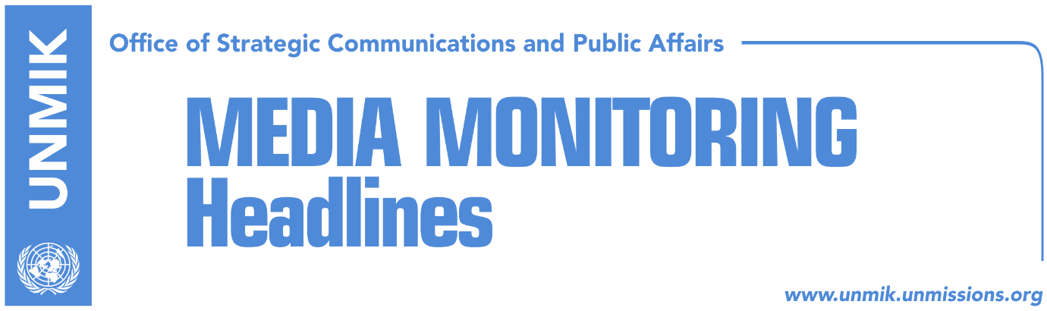

Main Stories 14 November 2018

- UN Security Council to discuss situation in Kosovo today (Zeri)
- Haradinaj: Elections are not on our agenda (Epoka)
- Hoxha: EU should keep its promise on visa liberalization (Epoka)
- Soltes: There is time to convince EU states on visa liberalization (media)
- Djukanovic: Thaci’s and Vucic’s idea, affecting progress in Balkans (Bota)
- U.S. opposes increase of tax on Serbian and Bosnian products (media)
- Thaci wont allow Haradinaj to appoint Shoshi as AKI deputy chief (Koha)
- Import from Serbia and Bosnia falls, incomes grow for €300 thousand (Epoka)

Kosovo Media Highlights

UN Security Council to discuss situation in Kosovo today (Zeri)
The UN Security Council will discuss today the report on the situation in Kosovo, despite calls from U.S. and UK not to discuss developments in Kosovo every three months, the paper reports on page two. Local media also report that UNMIK chief, Zahir Tanin, will submit his quarterly report covering the July 16-October 15 period on the situation on the ground and the UN mission’s activities. Meanwhile, the report of UN Secretary General, Antonio Guterres, welcomes the continued engagement of political leaders in Belgrade and Pristina within the EU-brokered mediated dialogue to normalize their relations, adding that the Presidents of Serbia and Kosovo, Aleksandar Vucic and Hashim Thaci, have presented their ideas on the demarcation as part of the efforts to reach a comprehensive agreement.

Haradinaj: Elections are not on our agenda (Epoka)
The Prime Minister of Kosovo Ramush Haradinaj does not believe that passing of Serbian List in opposition, could bring the government down. He said on Tuesday that new elections are not in the agenda. According to him, Kosovo is currently focused on INTERPOL membership and process of visa liberlaisation. Speaking about the final phase of the dialogue with Serbia, Haradinaj said pressure on Kosovo for increased competencies of the Association of Serb-majority Municipalities could increase. “It is completely reasonable that this could be used later as a form of pressure, so with territories and borders to be pleased later with a quite big Association. When the wave of this idea with borders and territories passes, then it will be about internal power. Just as Constitution obliges us about territories, it obliges us about a third power. However, it allows creation of a constitutional Association as we already have one. So that idea (change of borders) is dead. I have said it several times, now under different circumstances,” Haradinaj said.

Hoxha: EU should keep its promise on visa liberalization (Epoka)
Kosovo’s Minister for European Integration Dhurata Hoxha called the dilemma of some EU member states about visa liberalization for Kosovo citizens, irrational. She added that such dilemma harm seriously credibility of the EU. She said it is surprising that Kosovo has to face these dilemma despite the fulfillment of all the criteria. However, she hopes the EU will keep the given promise. She said it is crucial for the decision for visas to be made in the beginning of December. According to Hoxha, eventual failure of the EU to liberlaise visas after the fulfillment of the criteria, would out Kosovo’s trust on EU at a question mark.

Soltes: There is time to convince EU states on visa liberalization (media)
Most media report that the European Parliament rapporteur for Kosovo, Igor Soltes, said in an interview to Radio Free Europe that he does not know why some EU member states are refusing to agree on visa liberalization for Kosovo. “No doubt there is time to convince EU member states of importance of guaranteeing Kosovo citizens the possibility to travel without visas,” he said.

Djukanovic: Thaci’s and Vucic’s idea, affecting progress in Balkans (Bota)
The President of Montenegro Milo Djukanovic, told the French Le Figaro that negotiations between Thaci and Vucic on exchange of territories and movement of borders as well as aggravation of the relations between Belgrade and Zagreb, have affected the reached progress in Western Balkans. According to Djukanovic, the idea for eventual exchange of territories between Kosovo and Serbia is unexpected and they should be careful with such ideas. He added that such idea could cause a precedent and domino effect in the region.

U.S. opposes increase of tax on Serbian and Bosnian products (media)
Most media report that the U.S. Embassy in Kosovo says that Kosovo does not benefit from increasing customs duties on CEFTA members. US Embassy charge d’affaires Colleen Hyland wrote on Twitter on Tuesday: “increasing duties on fellow CEFTA members does not benefit Kosovo. Only creates uncertainty for businesses and generates economic instability. Better to put more effort into securing a prosperous future through Dialogue”.

Thaci wont allow Haradinaj to appoint Shoshi as AKI deputy chief (Koha)
The paper reports on page two that Kosovo Prime Minister Ramush Haradinaj has proposed Meriton Shoshi as deputy director of the Kosovo Intelligence Agency (KIA). Meriton is brother of Faton Shoshi, who in 2013 accused the KIA of attempted kidnapping. President Thaci however is keeping hostage this appointment. Citing an unnamed source, the paper reports that Thaci is refusing to sign the decree with the excuse that Shoshi has staged the attempted kidnapping and the position of deputy director of KIA cannot be held by a man whose family members are involved in such affairs.

Import from Serbia and Bosnia falls, incomes grow for €300 thousand (Epoka)
Officials from Kosovo Customs told Radio Free Europe that applying of the ten percent customs tax on the goods coming from Serbia and Bosnia and Herzegovina, has increased Customs incomes for € 300 thousand. Customs Director Bahri Berisha, told RFE that imports from these two countries have decreased for fifty percent. “The comparison was done one weak ahead and one week after the implementation of the decision. This shows that a week before the decision, we had around seven billion Euros imported products from these two countries, Serbia and Bosnia, while during the six following days, after the decision was in power, we have had 3.5 billion Euros import from both countries,” he said.

Disclaimer
This media summary consists of selected local media articles for the information of UN personnel. The public distribution of this media summary is a courtesy service extended by UNMIK on the understanding that the choice of articles translated is exclusive, and the contents do not represent anything other than a selection of articles likely to be of interest to a United Nations readership. The inclusion of articles in this summary does not imply endorsement by UNMIK.

