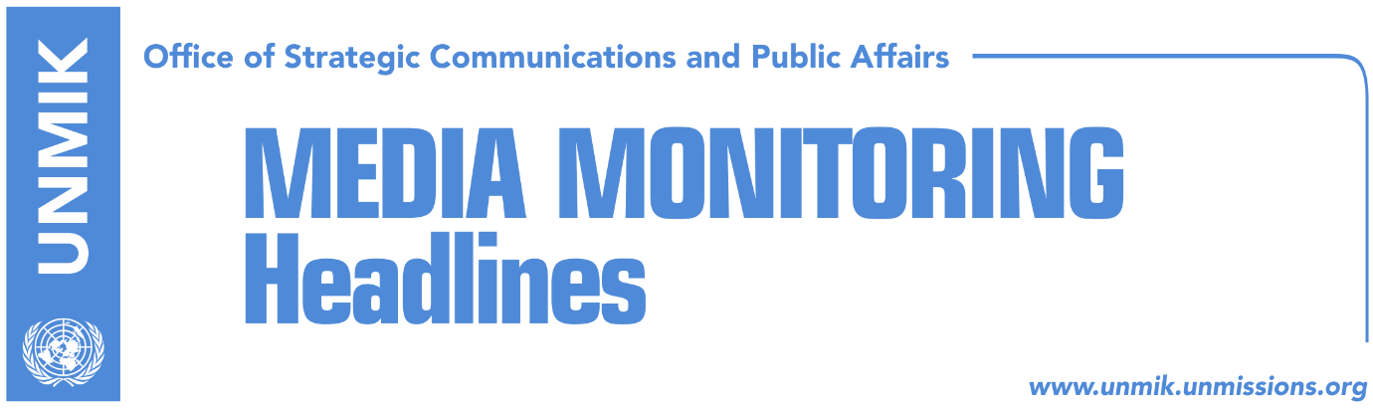

Main Stories 17 November 2018

- U.S. support Kosovo-Serbia dialogue, request national consensus (media)
- “Everyone wins from Kosovo’s INTEPOL membership, only transnational crime loses” (media)
- Kurti with an alternative for discussions with Serbia (RTK)
- Scott: Belgrade and Pristina should demonstrate flexibility (media)
- Kurti: Thaci helping Putin to return to Balkans (RTK)

Kosovo Media Highlights

U.S. support Kosovo-Serbia dialogue, request national consensus (media)
In a response to KosovaPress, the Embassy of the United States of America stressed that the U.S. supports Kosovo-Serbia dialogue and requests national consensus in order progress. The Embassy however did not want to comment on President Hashim Thaci’s meeting with Russia’s President Valadimir Putin.
“The United States continue to support the dialogue as means of reaching normalization of relations with Serbia, which is essential for the future of Kosovo. Political leadership, no matter the political party, should find common grounds related to Kosovo’s aims and they should pursue a way forward, which reflects interests of all its people. Kosovo is in an extraordinary and urgent need for its leaders to have this spirit of cooperation in order to reach progress. The Embassy cannot comment about discussions that happened in Paris,” is written in the replay of the U.S. Embassy.

“Everyone wins from Kosovo’s INTEPOL membership, only transnational crime loses” (media)
Media carry a press release issued by Kosovo’s Ministry of Foreign Affairs, which notes that “Kosovo’s membership to the INTERPOL strongly contributes to increasing the efficiency of neighbourhood, regional and international cooperation on prevention and combat of transnational crime and in parallel it helps in strengthening the security and maintaining the international order.

The Ministry of Foreign Affairs is deeply convinced that this process serves not only for the national interest of the Kosovo state and its citizens, but also for all member states of this organization and their citizens.

In support of this, the Ministry of Foreign Affairs considers that all of the member states and their citizens will benefit out of Kosovo’s membership to the INTERPOL, whereas only the transnational crime will lose.

The Republic of Kosovo, respectively its rule of law bodies have demonstrated a high level of professionalism during ten years of their existence and they were highly appraised for performing successful transnational joint operations, such as with the INTERPOL and other Organizations, and as a serious, credible and committed member of the Global Coalition in the fight against terrorism, violent extremism and radicalism.

The Ministry of Foreign Affairs duly presented its convincing legal and professional arguments to all member states supporting the membership of the country in this organization and it again calls on all member states to vote in favour of increasing the efficiency of neighbourhood, regional and international cooperation in preventing and fighting against the transnational crime, respectively the membership of Kosovo,” is written in the press release.

Kurti with an alternative for discussions with Serbia (RTK)
Vetevendosje Movement leader Albin Kurti, presented at a press conference an alternative for Kosovo’s discussions with Serbia. According to Kurti, the first step should be scrutinizing of the dialogue and its achievements. And then he talked about a platform with principals with regards to the dialogue. He said discussions should not be a scenario while the negotiating team should have the legitimacy of the Assembly.
Further Kurti called on the Alliance for the Future of Kosovo (AAK) and the Social Democratic Initiative (NISMA) not to become part of the negotiating team, in order to leave President Hashim Thaci alone.

Scott: Belgrade and Pristina should demonstrate flexibility (media)
The President of Serbia, Aleksandar Vucic, met on Friday with the U.S. Ambassador to Belgrade, Kyle Scott. They discussed bilateral relations, economic cooperation and the Belgrade-Pristina dialogue. According to a press release issued by the Office of the President of Serbia, Vucic informed Scott that, by introducing taxes on goods from Serbia and Bosnia-Herzegovina, Pristina had violated the Central European Free Trade Agreement (CEFTA).

Vucic "expressed his satisfaction with increasing trade between Serbia and the US, which was about 30 percent in the first nine months, as well as strengthening the interest of US investment companies in Serbia."

Scott "called on Belgrade and Pristina to show flexibility in reaching a solution that would contribute to regional stability and the continuation of dialogue," the statement said.

After the meeting, Scott took to Twitter to post the following message: "Excellent meeting with President Vucic during which we discussed the need for courageous leadership in the ongoing dialogue with Pristina in order to reach a comprehensive agreement on normalization."

Kurti: Thaci helping Putin to return to Balkans (RTK)
Vetevendosje Movement leader Albin Kurti, told Kosovo’s national broadcaster that by meeting Russia’s President Vladimir Putin, the President of Kosovo Hashim Thaci helped Russia return its impact on Balkans. “The meeting with Putin was bad news not only for Kosovo, but the region as well. Putin is trying to return to Balkans. Djukanovic and Zaev have backed him off. He has now re-found this man of ours, who is a president and is trying to return in the region. We should not change our allies, the U.S. and Germany. He has already violated this thick red line,” Kurti said.

Disclaimer
This media summary consists of selected local media articles for the information of UN personnel. The public distribution of this media summary is a courtesy service extended by UNMIK on the understanding that the choice of articles translated is exclusive, and the contents do not represent anything other than a selection of articles likely to be of interest to a United Nations readership. The inclusion of articles in this summary does not imply endorsement by UNMIK.

