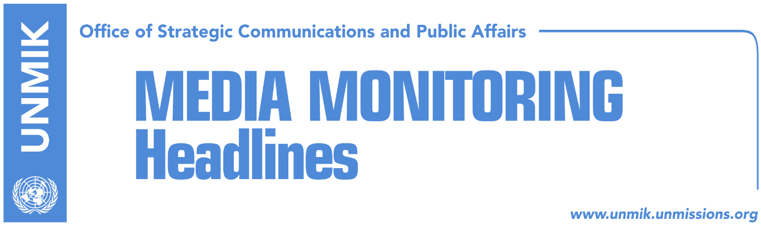

Main Stories 19 November 2018

- Voting for Kosovo’s membership at INTERPOL, on Tuesday (Epoka)
- Illegal migration and lack of reforms, obstacles for visa liberalisation (Koha)
- Kosovo Army will not be formed on November 28 (Zeri)
- Haradinaj: I did not compile veterans’ lists, I found them there (Zeri)
- Philips: Division of Kosovo, part of Putin’s strategic plan (Zeri)
- Haxhiu: Vetevendosje in coalition with LDK, under one condition (Gazeta Blic)
- Kurz assembles Balkans leaders, including Haradinaj and Brnabic (Bota Sot)
- Charges against Serbian criminals to be filed at Kosovo prosecution (Telegrafi)

Kosovo Media Highlights

Voting for Kosovo’s membership at INTERPOL, on Tuesday (Epoka)
One of the points of the agenda at the INTERPOL summit on Tuesday, will be voting for Kosovo’s membership at this organization. Deputy Prime Minister and Minister for Foreign Affairs, Behgjet Pacolli, took to Facebook to write that including Kosovo in the agenda is a good start, as the war against international organized crime and terrorism, is the aim of Kosovo. Other government representatives also expressed optimism for a positive response of the INTERPOL member states although they stressed that Serbia is not stopping with lobbying against Kosovo’s membership at this organization.

Illegal migration and lack of reforms, obstacles for visa liberalisation (Koha)
The paper reports on its front page that many EU member states have expressed their skepticism over eventual visa liberalisation for Kosovo, the paper reports on its front page. This was confirmed by a report that the Kosovo Ministry of Foreign Affairs prepared after a meeting in Brussels this month with representatives of 17 member states of the European Union. The paper claims to have seen the report which describes the position of every member state on visa liberalization for Kosovo. So far, only Bulgaria and Hungary have taken a clear positive and supporting stance on visa liberalization, while other countries, including France, Germany and the Netherlands are indecisive and have expressed concerns over different issues related to reforms and illegal migration. France has reportedly highlighted the threat of migration, security aspects and the high-level of visa rejections; Germany said some of their previous questions remain unanswered and that Kosovo’s authorities need to provide more concrete results in the fight against corruption and organized crime; Croatia said they prefer to see the report by the European Commission before announcing their position on the matter; Belgium said they are still traumatized by the misuse of visa liberalisation by some other countries.

Kosovo Army will not be formed on November 28 (Zeri)
Despite the fact that the three draft laws which enable transformation of the Kosovo Security Force (KSF) into an army were voted a month ago, on the first reading at the Assembly of Kosovo, the date of re-bringing them at the Assembly for the second reading, remains unknown. Haxhi Shala, head of the committee for supervision of the Kosovo Security Force confirmed for the paper that November 28 will not be the date of the creation of the army contrary to claims by Serbian officials, who related the creation of the Kosovo army with the Albanian national flag day.

Haradinaj: I did not compile veterans’ lists, I found them there (Zeri)
The Prime Minister of Kosovo Ramush Haradinaj said he is not aware of the exact number of the veterans from the last war in Kosovo. He claims that he has found the lists compiled when he became Prime Minister and does not want to speak about abuse prior to the decision of justice. He added that he has given permission to the prosecutor to investigate the lists and insists that the final decision should be made by justice.

Philips: Division of Kosovo, part of Putin’s strategic plan (Zeri)
U.S. Expert for foreign policy, David Philips told the paper that Russia’s President Vladimir Putin considers Kosovo to be an American project and destabilization of Kosovo is Putin’s way of dealing again with the U.S. for NATO intervention. According to him, division is part of Putin’s strategic plan to mine western impact in Kosovo and expand wild influence of his country by strengthening Serbia.

Haxhiu: Vetevendosje in coalition with LDK, under one condition (Gazeta Blic)
Vetevendosje (VV) MP, Albulena Haxhiu, said in an interview to the news website that her party would enter a pre-election coalition with the Democratic League of Kosovo (LDK) under the condition that they get the candidate for Prime Minister. “We have not discussed a pre-election coalition with the LDK. These decisions are made by the membership of Vetevendosje. My personal position however is that if Vetevendosje would enter such a coalition, then we should run with our candidate for Prime Minister … The Republic of Kosovo needs radical changes,” she said. Haxhiu also said VV would never cooperate with the Serbian List to bring down the Haradinaj-led government.

Kurz assembles Balkans leaders, including Haradinaj and Brnabic (Bota Sot)
Kosovo Prime Minister, Ramush Haradinaj, is expected to meet his Serbian counterpart, Ana Brnabic during a meeting between leaders of the Western Balkans called by Austrian Chancellor Sebastian Kurz, the paper reports on page four.

Charges against Serbian criminals to be filed at Kosovo prosecution (Telegrafi)
Civil Society Group representatives for gathering evidence of war crimes and preparing criminal charges against Serbian criminals during the 1998/99 war for the seventh time will file criminal charges against Serbian criminals at the Special Prosecution of Kosovo, Department for War Crimes. The criminal report will be filed today at 13:00, according to a statement by the Civil Society Group on the gathering of evidence of war crimes.

Disclaimer
This media summary consists of selected local media articles for the information of UN personnel. The public distribution of this media summary is a courtesy service extended by UNMIK on the understanding that the choice of articles translated is exclusive, and the contents do not represent anything other than a selection of articles likely to be of interest to a United Nations readership. The inclusion of articles in this summary does not imply endorsement by UNMIK.

