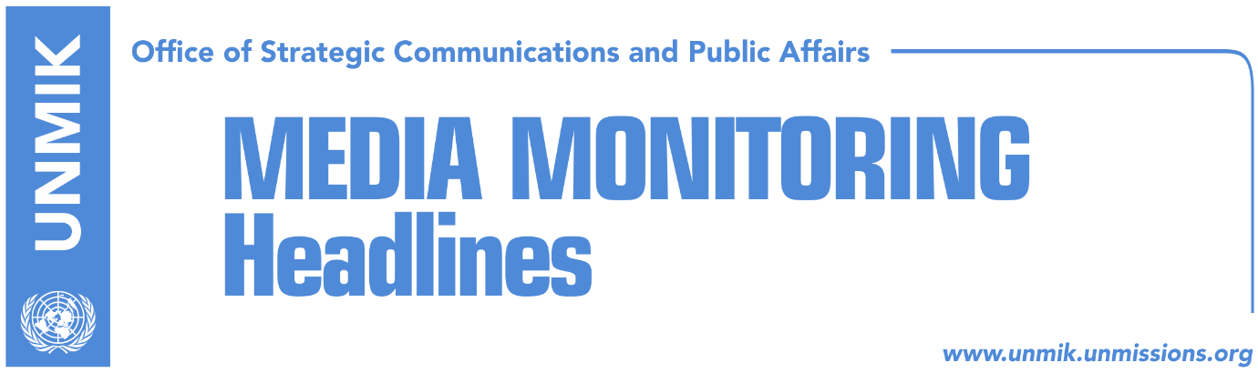

Main Stories 20 November 2018

- INTERPOL General Assembly to vote on Kosovo’s bid today (media)
- “Last-minute” lobbying (Koha)
- Veseli: All should give account about public property (Epoka)
- Veseli travels to Brussels, seeks Belgium’s support for visa liberalization (Epoka)
- CEFTA, hostage of Kosovo, Bosnia, Serbia disagreements (Zeri)
- Thaci asks court to interpret govt’s decision for properties in the north (media)
- Ministry of Trade and Industry issues new order (Facebook)
- Vucic: No dialogue until Pristina withdraws recent measures (Klan Kosova)

Kosovo Media Highlights

INTERPOL General Assembly to vote on Kosovo’s bid today (media)
All media report that the INTERPOL General Assembly in Dubai will vote on Kosovo’s membership today. Kosovo Foreign Minister Behgjet Pacolli said Kosovo has a good chance of becoming a member of INTERPOL. He spoke about the significance of Kosovo’s membership at this organization. “We are only a few hours apart from the important momentum and I believe that Kosovo will become an INTERPOL member because it would be a deserved vote for Kosovo as a state which is in the process of consolidating,” Pacolli said. Bota Sot reports that media in Serbia expressed shock that Russia has agreed with the INTERPOL agenda, which includes voting for Kosovo’s membership at this organization.

“Last-minute” lobbying (Koha)
The paper reports on its front that in the final weeks leading up to the meeting of the European Union’s Council of Ministers, Kosovo’s institutional leaders launched a diplomatic offensive in efforts to change the position of hesitant member states over visa liberalization for Kosovo. However, many of these EU member states, including the ones that Kosovo counted on for support, have recently expressed concerns about the lack of results in the fight against organized crime and corruption and fear from an increased number of asylum-seekers. Kosovo Prime Minister Ramush Haradinaj attended a working breakfast on Monday in Vienna between Western Balkans leaders and hosted by Austrian Chancellor Kurz, where he called for visa liberalization for Kosovo, but did not receive a definite answer if Kosovo will be included in the agenda of the EU Council of Ministers. “I only want to say that if Europe is not able to remove visas for Kosovo even after we met all the requirements, this will not be a good message for the citizens of Kosovo who were promised visa-free travel after the ratification of border demarcation with Montenegro,” Haradinaj was quoted as saying. The paper also notes that Assembly President Kadri Veseli met on Monday with Finance Minister Bedri Hamza, Justice Minister Abelard Tahiri and Anti-Corruption Agency chief Shaip Havolli. The meeting focused on furthering the fight against corruption and the full implementation of the new law on preventing conflict of interest during the performance of public functions. “We are doing our utmost to minimize the scope of abuses in institutions. Nobody is above the law,” Veseli was quoted as saying.

Veseli: All should give account about public property (Epoka)
Kosovo Assembly President Kadri Veseli met on Monday with the Minister of Justice Abelard Tahiri, Finance Minister Bedri Hamza, and Director of Anti-corruption Agency Shaip Havolli. He has requested from respective institutions to undertake immediate steps of increasing the war against corruption and complete implementation of the new Law for prevention of conflict of interest during exercising a public function. “All that we are doing is for the state and law to be above all of us. This initiative for prevention of conflict of interest is about that function. We, institutions of Kosovo are giving our maximum of our efforts to minimize abuse of the public officials’ position. We will not allow anyone to abuse, and if this happens, they will face the law and confiscation of property,” Veseli said.

Veseli travels to Brussels, seeks Belgium’s support for visa liberalization (Epoka)
Kosovo Assembly President Kadri Veseli, traveled on Monday to Brussels for an official visit. He is expected to meet Belgium’s state leaders, among them his counterpart, President of Belgium’s Senate, Christine Defraigne. Vesli will also meet Euro-deputies to discuss Kosovo’s integration processes, especially visa liberlaisation for Kosovo citizens.

CEFTA, hostage of Kosovo, Bosnia, Serbia disagreements (Zeri)
The paper reports that Pristina will host on Tuesday working groups of the Agreement for Free Trade in Balkans, CEFTA, however, it appears that the meeting will be held without participation of representatives from Bosnia and Herzegovina and Serbia. They warned that they would boycott activities in Pristina as long as the applied ten percent tax on their goods is in power in Kosovo. Serbia’s Deputy Minister for Trade, Rasim Lajic, even sent this announcement to CEFTA Secretariat in Brussels. Kosovo party on the other hand, has not given any sign of removing the ten percent tax.

Thaci asks court to interpret govt’s decision for properties in the north (media)
Several media report that the Legal Office of Kosovo President Hashim Thaci has called on the Constitutional Court to interpret Articles 92 and 94 of the Constitution following the government’s decision to withdraw from privatization in the north, and the transfer of some properties - previously managed by the Privatization Agency of Kosovo - to the municipalities of Mitrovica North, Kllokot and Ranillug and other municipalities. Zeri covers the story under the front-page headline Thaci “attacks” Haradinaj; Telegrafi news website reports that Thaci has sent Haradinaj to the Constitutional Court over the properties in the north; Kosova Sot reports on “aggravated relations” between Thaci and Haradinaj.

Ministry of Trade and Industry issues new order (Facebook)
Kosovo’s Minister for Trade and Industry, Endrit Shala, took to Facebook on Monday to say that he has ordered the Market Inspectorate of his ministry to remove etiquettes mentioning “Kosovo and Metohija” or “UNMIK” or “Kosovo Resolution 1244”. Shala wrote: “After concerns raised by you and some reports in the media, that there are products in Kosovo that contain the etiquette (for example: Representative - Distributor – Importer etc. for Kosovo and Metohija or UNMIK or Kosovo Resolution 1244”, I have today issued an order through which I oblige the Market Inspectorate of the Ministry of Trade and Industry to immediately remove such etiquettes with such content or description. At the same time, I have requested Kosovo Customs to prohibit entrance to Kosovo, for any type of product with the above-mentioned description which is in violation of the Constitution of the Republic of Kosovo, in this case the official name of our state. We are working every day that the quality and goods in the market of Kosovo are controllable in order for you to know what you are consuming”.

Vucic: No dialogue until Pristina withdraws recent measures (Klan Kosova)
Serbian President Aleksandar Vucic said on Monday evening that Serbia would not resume dialogue with Kosovo in Brussels until Pristina does not revoke its decision to introduce a 10 percent increase of the tax on Serbian and Bosnian products going into Kosovo. “We are ready to talk at any time. But how can we talk when even 12 years after signing the CEFTA agreement, someone fails to implement what we have agreed upon. How are we supposed to know that they won’t violate another agreement,” Vucic said.

Disclaimer
This media summary consists of selected local media articles for the information of UN personnel. The public distribution of this media summary is a courtesy service extended by UNMIK on the understanding that the choice of articles translated is exclusive, and the contents do not represent anything other than a selection of articles likely to be of interest to a United Nations readership. The inclusion of articles in this summary does not imply endorsement by UNMIK.

