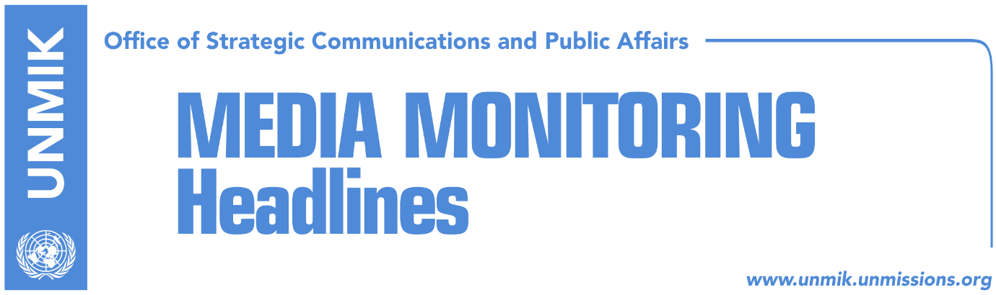

Main Stories 24 November 2018

- Haradinaj: Opening issue of borders would send us back to the past (media)
- Court session on Serbs arrested in the north to be held today (media)
- Serbia blocks European products destined for Kosovo (Insajderi)
- Serbian press willing to pay tax, but there’s another reason why it was not allowed to enter Kosovo (media)
- Person arrested for calling for forceful removal of Serbian license plates (Koha)
- U.S. Embassy congratulates Assembly for passing laws on judicial reforms (media)

Kosovo Media Highlights

Haradinaj: Opening issue of borders would send us back to the past (media)
Kosovo Prime Minister, Ramush Haradinaj, said in an interview to RTK 2, that Serbian President Aleksandar Vucic is using the Serbian List in an attempt to bring down the Kosovo government because he [Haradinaj] is not supporting the idea for Kosovo’s partition. “I believe Belgrade wants to sacrifice the Serbian List in the game for partition. President Vucic wants to bring down my government, because I don’t support the idea of partition. This means that in one way or another he has partners in Kosovo too. I don’t believe that this is the goal of the Serbian List, because most of them are not from the north, some are from other parts of Kosovo too,” he said. Haradinaj said “opening the issue of borders would send us back to the past and this is not good”. Asked to comment on the government’s decision to introduce a 100-percent tax on Serbian goods, Haradinaj said the decision would remain in force until Serbia recognizes Kosovo as a state. Haradinaj also commented on the police operation in the north on Friday during which four persons were arrested in relation to the murder of Kosovo Serb politician Oliver Ivanovic. “Radojicic was not in his house. It was known that he was in Belgrade, he was seen in a meeting in Belgrade on TV. But perhaps police did not have information that he has not returned, or they could not postpone the action for another day,” he said.

Court session on Serbs arrested in the north to be held today (media)
Several news websites report that a court session will be held today for the three Kosovo Serbs who were arrested in Mitrovica North on Friday for possible involvement in the murder of Kosovo Serb politician Oliver Ivanovic.

Serbia blocks European products destined for Kosovo (Insajderi)
The news website reports that the Serbian government has decided to not allow European products destined for Kosovo to pass through its territory. The decision has entered into force this morning. Kosovo businesses have told the news website that trucks with goods destined for Kosovo are not being allowed to enter Serbia through Croatia and Hungary. A spokeswoman for the Kosovo government said they have no official information that Serbia is blocking European goods destined for Kosovo.

Serbian press to pay tax, but there’s another reason why it was not allowed (media)
Citing reports in Serbian media, the news website reports that there won’t be any Serbian newspapers in Kosovo today, as Kosovo Customs officials are asking that all invoices should include the sentence “Republic of Kosovo”. A Serb who transports Serbian newspapers to Kosovo told Serbian media that they were willing to pay the 100-percent tax for all newspapers, but that Kosovo Customs officials said “Republic of Kosovo” should be included in all invoices.

Person arrested for calling forceful removal of Serbian license plates (Koha)
Kosovo Police arrested a person on Friday after he posted on Facebook calling for the forceful removal of Serbian license plates. The person was arrested in Pristina on charges of inciting hatred.

U.S Embassy congratulates Assembly for passing laws on judicial reforms (media)
The Chargé d'Affaires at the United States Embassy in Pristina, Colleen Hyland, posted on Twitter congratulating “the Kosovo Assembly for working together across political parties to pass key laws that improve judicial discipline, extend women’s inheritance rights, close loopholes on crime, and protect those who report corruption. Next challenge - consistent implementation!”

Disclaimer
This media summary consists of selected local media articles for the information of UN personnel. The public distribution of this media summary is a courtesy service extended by UNMIK on the understanding that the choice of articles translated is exclusive, and the contents do not represent anything other than a selection of articles likely to be of interest to a United Nations readership. The inclusion of articles in this summary does not imply endorsement by UNMIK.

