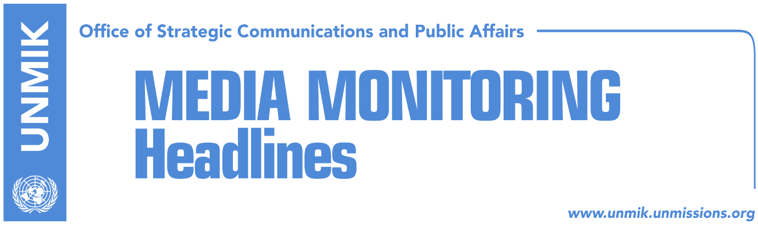

Main Stories 27 November 2018

- In the US, President Thaci meets Secretary of State Pompeo (media)
- Governments of Kosovo and Albania hold joint meeting (dailies)
- US ambassadors object Kosovo’s tax on Serbian goods (Epoka/Kosova Sot)
- First half of December to see Kosovo with army (Zeri)
- KFOR considers “in reality” there is no border between Kosovo and Serbia (Koha)
- Vucic instructs Radojcic about barricades in the North (RTK)
- Kosovo annuls participation at regional forum due to footnote (Epoka)
- Five Ministry of Infrastructure officials arrested on corruption charges (dailies)

Kosovo Media Highlights

In the US, President Thaci meets Secretary of State Pompeo (media)
In his first day of visit to the US, President of Kosovo Hashim Thaci met Secretary of State Mike Pompeo and thanked him for the US administration support to Kosovo and the historic support the American people have extended to the people of Kosovo. The two officials are reported to have discussed the new mandate of the Kosovo Security Force, regional cooperation and Kosovo’s Euro-Atlantic perspective. They also spoke about the final stage of dialogue between Kosovo and Serbia and Thaci is quoted as saying after the meeting that the US support Kosovo in reaching a comprehensive agreement with Serbia which paves way for mutual recognition and Kosovo’s membership to NATO, EU and UN. “It was a joint conclusion that if we do not seize this historic momentum, we risk entering a dangerous cycle not only as Kosovo but as a region. Therefore, the only way to close the Balkans issue once and for all is to achieve a final agreement between Kosovo and Serbia,” Thaci is quoted by Klan Kosova. Telegrafi meanwhile carries the statement of the US Statement Department saying US continues to support a sovereign and independent Kosovo. “The Secretary encouraged Kosovo to seize this unique window of opportunity to reach a historic comprehensive normalisation deal with Serbia under the EU-facilitated Dialogue process. He urged Kosovo authorities to rescind the tariffs placed on imports from Serbia and Bosnia and Herzegovina and to work with Serbia to avoid provocations and deescalate tensions,” the statement reads.

Governments of Kosovo and Albania hold joint meeting (dailies)
The governments of Kosovo and Albania held a joint meeting yesterday in the city of Peja/Pec and signed a number of agreements aimed at deepening bilateral cooperation. Prime Minister of Kosovo Ramush Haradinaj said that the signing of agreements will in the near future lead to an economic unification between Kosovo and Albania. He said the people in Kosovo and Albania expect more from the two governments and that they will continue cooperation in addressing the many challenges. “Kosovo today implements priorities of the European reform agenda and has successfully fulfilled all visa liberalisation criteria and expects its right to be respected by EU institutions,” Haradinaj said in his remarks at the opening of the meeting. Meanwhile Albanian Prime Minister, Edi Rama, said that the two countries should move toward customs unification. Commenting on the Kosovo government’s decision to introduce a 100-percent tax on Serbian goods, Rama said: “the tax would be an irrational decision under normal circumstances. Whoever views the 100-percent tax from the economic standpoint, they are wrong. The tax however is a political response to Serbia”. Rama also said that within six months all tariffs between Kosovo and Albania will be removed. Koha Ditore highlights Rama’s opening remarks at the meeting where he accused the EU of hypocrisy with regards to the visa liberalisation process for Kosovo and the opening of membership negotiations with Albania. “European Union should put an end to hypocritical approach. One face for Albania, one face for Kosovo,” Rama said.

US ambassadors object Kosovo’s tax on Serbian goods (Epoka/Kosova Sot)
The U.S. Charge de affairs Colleen Hyland has assessed Kosovo’s imposed tax on Serbian goods as harmful. “Tarif increase for CEFTA members is equal to the increase of pain of Kosovo citizens, increase of tensions and increase of the damage to Kosovo’s reputation. Strategic leadership, not emotional reactions, is required to ensure the European future of Kosovo and normalization of the relations with Serbia,” Hyland wrote on her Facebook account. At the same time, the US ambassador to Belgrade Kyle Scott also commented on the import tax calling it “discriminatory”. Scott is reported to have told Serbian media that what applies to Albanian population in Kosovo should also apply for Serbs and all other ethnic communities living there.

First half of December to see Kosovo with army (Zeri)
The paper reports on the front page that Kosovo is expected to have its army by the first half of next months. Sources told Zeri that the second reading of three draft laws relating to the transition of the Kosovo Security Force into a Kosovo army could take place most likely on 6 or 13 December. Officials from the government of Kosovo did not comment on the possible date saying the issue is now with the Assembly of Kosovo.

KFOR considers “in reality” there is no border between Kosovo and Serbia (Koha)
In the second part of the interview with the paper, outgoing KFOR Commander Salvatore Cuoci is quoted as saying that “in reality” there is no border between Kosovo and Serbia and that what separates the two is an administrative boundary line. “What was the border with Serbia is part of the agreement, the solution that would be reached with Serbia that would derive from the dialogue,” Cuoci said adding that KFOR’s mandate is very clear and that it does not include the political side. “We do not get involved in political decisions, are mandate is very specific, very clear, and we do exactly what we are here for and when it comes to the work on the ground and the actions that need to be taken, we are here to provide a safe environment,” he noted.

Vucic instructs Radojcic about barricades in the North (RTK)
Kosovo’s national broadcaster reports that Serbs in northern Kosovo has received Belgrade’s green light to undertake a range of radical actions in Kosovo’s northern municipalities. Deputy Leader of the Serbian List reportedly went on Monday in Belgrade, “to allegedly be questioned about Oliver Ivanovic’s murder. However, RTK sources informed that Radojcic went to Belgrade to receive instructions for the actions that Serbian state is going to undertake in the north. According to some sources, the four mayors of the northern municipalities, including also municipal directories and counselors will resign in order to paralyse institutional life. Resignations are further expected to affect Kosovo Police as well. Furthermore, according to the same sources, Serbs are planning to return to barricades in order to make physical access of Kosovo state there, impossible, RTK reports.

Kosovo annuls participation at regional forum due to footnote (Epoka)
Deputy Minister of Justice and National Coordinator for Protection from Domestic Violence, Naim Qelaj, has annulled his participation at the regional forum “Promotion and Implementation of Istanbul Convention for Western Balkans and Turkey’ which will be held in Skopje on 27 and 28 November. The reason for the annulment of participation is the Resolution 1244 on footnote of the name tags of Kosovo representatives. “I expect from the organisers to act and enable our participation by avoiding the footnote ore by marking the decision of the International Court of Justice and Declaration of the Independence of Kosovo,” was said among other things on Qelaj’s reaction.

Five Ministry of Infrastructure officials arrested on corruption charges (dailies)
Papers report that five officials from the Ministry of Infrastructure have been arrested yesterday on corruption charges. Koha Ditore reports that the persons arrested are close associates to Minister Pal Lekaj and their arrests follows an eight-month investigation process into allegations of corruption in issuing drivers’ licenses. In a statement to the press, the Ministry of Infrastructure called on all relevant judicial institutions to see the case through and underlined that no one is above the law.

Disclaimer
This media summary consists of selected local media articles for the information of UN personnel. The public distribution of this media summary is a courtesy service extended by UNMIK on the understanding that the choice of articles translated is exclusive, and the contents do not represent anything other than a selection of articles likely to be of interest to a United Nations readership. The inclusion of articles in this summary does not imply endorsement by UNMIK.

