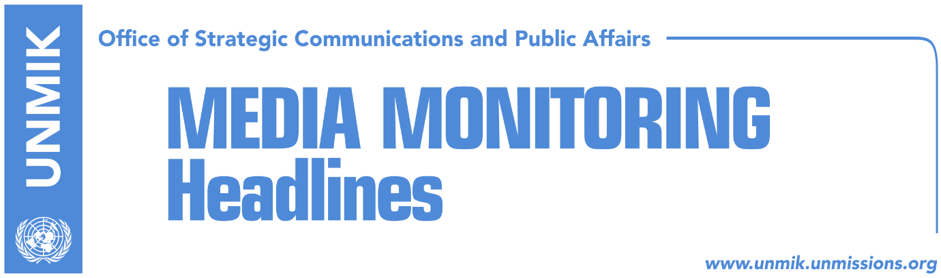

Main Stories 29 November 2018

- Haradinaj: We won’t accept Serbia’s violation of our sovereignty (WaPo)
- Thaci: U.S. support agreement that guarantees mutual recognition (Zeri/RTK)
- Pristina silent in face developments in the north (Koha Ditore)
- Mogherini calls on Kosovo to cancel 100-percent import tax (media)
- Hahn calls on Kosovo and Serbia to resume dialogue (Gazeta Express)
- Germany criticizes both Serbia and Kosovo, calls for dialogue (Koha)
- U.S. Adm. Foggo: Import tax risks isolating Kosovo (media)
- Fabrizi calls on Kosovo to immediately revoke tax on Serbian goods (media)
- McAllister: Serbia to open new chapters, Kosovo must remove the tax (Lajmi)
- Haradinaj’s advisor responds to Mogherini on 100-percent tax (Zeri)
- Evidence that led to arrest of suspects over Ivanovic’s murder (Koha)

Kosovo Media Highlights

Haradinaj: We won’t accept Serbia’s violation of our sovereignty (WaPo)
Most news websites cover an opinion piece that Kosovo Prime Minister Ramush Haradinaj wrote for The Washington Post. “My country, Kosovo, is being asked to make an impossible choice that would cheapen the sacrifice made by U.S. soldiers, undermine the stability of the region and threaten America’s allies. In the face of sustained attack from Serbia meant to undermine our sovereignty, security and prosperity, there are some who would like Kosovo to engage in so-called “peaceful” ethnic cleansing in the Balkans. This is a shortsighted attempt to give in to a bully in the hope that the bullying will stop. We will not do this — we will instead stand up against those who would seek to take advantage of us, while simultaneously working toward a long-lasting and comprehensive peace. Following a genocidal campaign of terror, Kosovo won its independence from Serbia through hard sacrifice, supported by the United States and NATO. Since the 1999 war and our declaration of independence in 2008, we have built a modern state committed to democracy and integration with NATO, the European Union and the United States. As of today, more than half of the United Nations’ members recognize our independence,” Haradinaj wrote.

More: https://wapo.st/2FN6Gjg

Thaci: U.S. support agreement that guarantees mutual recognition (Zeri/RTK)
President of Kosovo Hashim Thaci met in Washington D.C. the U.S. Senator Ron Johnson and said the U.S. supports agreement between Kosovo and Serbia which would secure Serbia’s recognition of Kosovo and its membership to NATO, EU, UN. “I know it will not be an easy process but with the support of the United States, Senator Johnson, things cane be achieved, they can become more concrete and a historic, peaceful settlement can be reached,” Thaci said after the meeting. During his visit to the U.S., Thaci also met senators Gary Peters and Robert Menendez.

Pristina silent in face developments in the north (Koha Ditore)
The paper reports on the front page that the government of Kosovo has not yet reacted to the recent developments in the four northern municipalities where the mayors announced their resignations and cut off all communication with authorities in Pristina. The paper notes that according to applicable legislation, once the government establishes the resignation of mayors the president of Kosovo is obliged to announce extraordinary elections in the affected municipalities which will then have to be organised by the Central Elections Commission. Meanwhile, highlights the paper, the CEC is at present incapable of any decision making as new members have yet to be appointed by the president.

Mogherini calls on Kosovo to cancel 100-percent import tax (media)
The EU High Representative Federica Mogherini told Kosovo President Hashim Thaci that Pristina’s decision to set a 100-percent tax on Serbian and Bosnian goods should be revoked “as it does not contribute to good neighborly relations”. A statement issued by Mogherini’s office said she had a telephone conversation with Thaci to discuss the recent events related to the EU-facilitated dialogue between Pristina and Belgrade. Mogherini told Thaci that the decision on the tax further complicated the situation and that it doesn’t bring any solution to the problems people have or to Kosovo’s aspirations for its present and future. “That measure does not contribute to establishing good neighbourly relations and should be withdrawn,” Mogherini said.

Hahn calls on Kosovo and Serbia to resume dialogue (Gazeta Express)
The EU Enlargement Commissioner, Johannes Hahn, has called on Serbia to continue working on becoming a member of the European Union regardless of recent problems. “The parties must resume dialogue. There is no other alternative if they want to advance on their path toward the European Union. No country can join the EU without resolving disputes. For Serbia this means concluding agreements with Pristina before it can join the European Union,” Hahn said.

Germany criticizes both Serbia and Kosovo, calls for dialogue (Koha)
The German Government has called on governments of Kosovo and Serbia to avoid escalation of tensions and resume dialogue. German Government spokesperson Steffen Seibert criticized Serbia’s campaign to prevent Kosovo from joining Interpol as well as Kosovo for introducing a 100 percent tax on imports from Serbia. Seibert added that normalisation of relations is a precondition for Serbia’s membership negotiations.

U.S. Adm. Foggo: Import tax risks isolating Kosovo (media)
U.S. Navy Admiral James Foggo, commander of Allied Joint Force Command Naples said in Pristina today during KFOR change of command ceremony that the decision to increase import tax on products from Serbia and Bosnia and Herzegovina risks isolating Kosovo and asked what the purpose of the measure was. Speaking about transition of the Kosovo Security Force, Adm. Foggo cautioned against haste. “Reliable sources told me the process could take up to ten years and this is not a bad thing. It would be wise not to rush and have necessary time to ensure all parties are satisfied with the transformation process,” Foggo is quoted by Koha.

Fabrizi calls on Kosovo to immediately revoke tax on Serbian goods (media)
The Head of the EU Delegation to the Republic of Serbia, Sem Fabrizi, has called on Kosovo to immediately revoke the 100-percent tax on Serbian goods. Serbian President Aleksandar Vucic has complained to Fabrizi about the tax and the situation in Kosovo. Vucic said the EU should apply pressure and force Kosovo to revoke the decision on the tax, because it threatens peace and stability in the region and that this could possibly escalate into new conflicts.

McAllister: Serbia to open new chapters, Kosovo must remove the tax (Lajmi)
The European Parliament’s Rapporteur for Serbia, David McAllister, has called on Serbia to continue dialogue and a policy of reconciliation regardless of Kosovo’s recent decision to introduce a 100-percent tax on Serbian goods. “It is clear that Kosovo’s decision on the 100-percent tax for goods from Serbia and Bosnia and Herzegovina is in violation of the CEFTA agreement and this is a clear sign against the spirit of good neighborly cooperation between Kosovo and Serbia,” McAllister said. He said regardless of recent developments, dialogue in Brussels is the only venue where the parties can address all issues and concerns. He also said that Serbia will open three new chapters in December, but that the final decision will be made by EU member states.

Haradinaj’s advisor responds to Mogherini on 100-percent tax (Zeri)
Avni Arifi, Chief of Staff to Kosovo Prime Minister Ramush Haradinaj, responded to a recent statement by EU High Representative Federica Mogherini who called on Kosovo to revoke its decision on a 100-percent tax on Serbia and Bosnian goods. “I wish Mogherini and her team were mobilized in implementing Energy agreement the way they are mobilized in removing 100% tax on Serbia. Surprised to see so much dynamic and emotions on protecting Serb interests. Unfortunately, this approach led to complete failure of dialogue,” Arifi wrote on Twitter.

Evidence that led to arrest of suspects over Ivanovic’s murder (Koha)
According to the prosecution and court notes that the paper claims to have obtained, the three suspects held in detention over the killing of Kosovo Serb political leader Oliver Ivanovic have cooperated closely with another yet unidentified suspect in organisng Ivanovic’s murder. One of the suspects, Nedeljko Spasojevic, is believed to have enabled the other members of the group to flee the crime scene using a police car. The other suspect Marko Rosic’s involvement in the murder is tied to a letter found in the victim’s pocket with a license plates of a car owned by Rosic’s family. The prosecution alleges the car was used to follow the victim’s brother even after the murder. The third suspect, Dragisa Mirkovic, in his capacity as a Kosovo Police officer, is believed to have leaked confidential information.

Disclaimer
This media summary consists of selected local media articles for the information of UN personnel. The public distribution of this media summary is a courtesy service extended by UNMIK on the understanding that the choice of articles translated is exclusive, and the contents do not represent anything other than a selection of articles likely to be of interest to a United Nations readership. The inclusion of articles in this summary does not imply endorsement by UNMIK.

