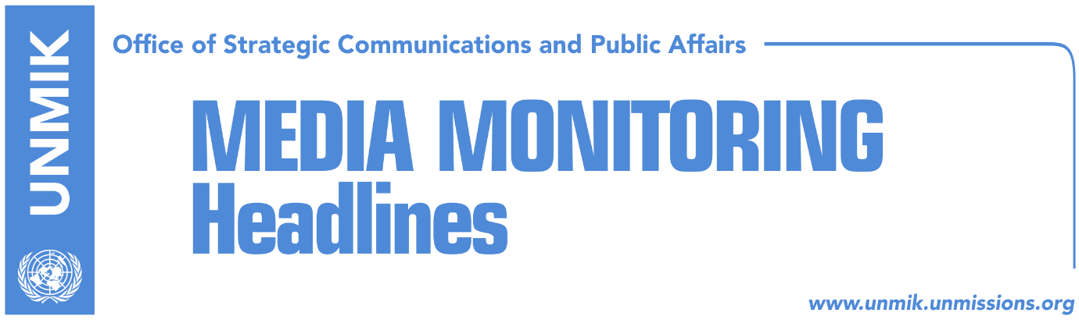

Main Stories 3 December 2018

- Hahn today in Pristina to meet institutional leaders (Zeri)
- Serbian List locked in the Assembly, waiting for Commissioner Hahn (media)
- Hoxhaj: I never said anything about a pact against Serbia (RTK)
- “Tax to remain in force until Serbia changes approach towards Kosovo” (RTV21)
- PSD seeks consensus on dialogue, LDK and Vetevendosje, elections (Zeri)
- Kosovo Assembly presidency to meet today, discuss formation of army (Lajmi)
- Solomon Islands retract recognition of Kosovo independence (media)
- Jablanovic: Serbian List wants to shift attention away from arrests (media)
- Ceric calls on Haradinaj to exclude Bosnia from 100-percent tax (Koha)
- Police ban bus from Serbia from entering Kosovo (media)

Kosovo Media Highlights

Hahn today in Pristina to meet institutional leaders (Zeri)
Johannes Hahn EU Commissioner for Neighborhood Policy and Enlargement Negotiations will be arriving today for an official visit in Pristina. He is expected to meet the President of Kosovo Hashim Thaci, Assembly President Kadri Veseli and the Prime Minister of Kosovo Ramush Haradinaj. The main topic of the discussions is expected to be the decision of the government of Kosovo for 100 percent tax on the goods imported from Serbia and Bosnia and Herzegovina. “Commissioner Hahn will reiterate the position of the European Union, he will appeal for removal of these measures and will focus on improvement of the neighborly relations as well as regional cooperation, principals that are accepted by Kosovo and all the countries of Western Balkans,” was said at the European Commission.

Serbian List locked in the Assembly, waiting for Commissioner Hahn (media)
Kosovo Assembly MPs from the Serbian List have locked themselves in the Assembly of Kosovo, seeking a meeting with EU Commissioner Neighborhood Policy and Enlargement Negotiations Johannes Hahn. A press release issued by these MPs notes that they want to inform Hahn about “humanitarian crisis which is endangering Serb population due to Pristina’s decision to impose 100 percent tax on Serbian products, which practically blocks distribution of food, medication, press and other necessary products”. Igor Simic from the Serbian List told a press conference on Sunday that that they will inform Hahn with “negative developments in the field since establishment of the 100 percent tax for Serbian products”. He also confirmed he has been in touch with the head of the EU office in Kosovo Natalya Apostolova.

Hoxhaj: I never said anything about a pact against Serbia (RTK)
Deputy Prime Minister of Kosovo Enver Hoxhaj said he never mentioned a creation of a pact against Serbia during his interview given to Zagreb daily Vecernji List. “The headline of the text and what I really said are two completely different things,” Hoxhaj told Montenegrin broadcaster Antena M. “As far as my comments that Serbia is conducting an aggressive policy against neighboring countries and that western partners should use their influence on Serbia, which is Russia’s base and extended hand in Balkans, they are all my well-known positions stated repeatedly during the last decade,” Hoxhaj said.

“Tax to remain in force until Serbia changes approach towards Kosovo” (RTV21)
Haki Shatri, economy adviser to Prime Minister Ramush Haradinaj, said on Sunday that the decision on 100-percent tax on goods coming from Serbia and Bosnia and Herzegovina will remain in power until these two countries change their approach towards Kosovo. He added that the international community should be objective and unbiased on the matter. Shatri further argued that Serbia had continuously violated CEFTA and SAA decisions. He also said the tax will be removed when Serbia recognizes Kosovo as a sovereign and independent state.

PSD seeks consensus on dialogue, LDK and Vetevendosje, elections (Zeri)
The Social Democratic Party (PSD) has submitted to the Assembly of Kosovo a draft resolution, which aims to give to the opposition political parties half of the responsibilities in dialogue with Serbia. This political party considers that Kosovo should have one representative from the government and one from the opposition in the discussions with Serbia. However, both the Democratic League of Kosovo (LDK) and Vetevendosje Movement consider that only new elections could legitimize a delegation that would represent Kosovo in the dialogue with Serbia.

Kosovo Assembly presidency to meet today, discuss formation of army (Lajmi)
Kosovo Assembly President, Kadri Veseli, will chair the meeting of the Assembly presidency today, which is expected to discuss on the formation of the Kosovo Armed Forces. Citing unnamed sources, the news website reports that Veseli requested the meeting in order to decide on the laws for the transformation of the Kosovo Security Force into an army. The same sources said that the Assembly will most likely in mid-December to adopt the laws for the transformation of the KSF.

Solomon Islands retract recognition of Kosovo independence (media)
All media report that the Solomon Islands have retracted their recognition of Kosovo’s independence. Pristina-based KTV managed to secure a copy of the diplomatic note that the Solomon Islands sent to Kosovo’s Embassy in Australia. Kosovo’s Ministry of Foreign Affairs meanwhile denied receiving such a decision. “The Ministry of Foreign Affairs has received no such document through official channels. We consider this is all part of Serbia’s propaganda,” a spokesman for the Foreign Ministry told Koha Ditore on Sunday.

Jablanovic: Serbian List wants to shift attention away from arrests (media)
Several news websites report that the Party of Kosovo Serbs, led by Aleksandar Jablanovic, said on Sunday that the recent actions of the Serbian List are aimed at shifting the attention away from arrests related to the murder of Kosovo Serb politician Oliver Ivanovic. “We call on the Serbian List not to hide behind the Serb people and not to force people into protests, but to force their partner in the ruling coalition, Haradinaj, to revoke the decision on the 100-percent tax,” a press release issued by the party noted.

Ceric calls on Haradinaj to exclude Bosnia from 100-percent tax (Koha)
The former head of the Islamic Community in Bosnia and Herzegovina, Mustafa Ceric, called on Kosovo Prime Minister Ramush Haradinaj to exclude Bosnia from the 100-percent tax. In an open letter, Ceric explained the situation in Bosnia, arguing that it is not their fault that Bosnia has recognized Kosovo’s independence. Ceric wrote: “Neither we good Bosnians, nor you good Kosovars, can completely be freed from Serbian hegemony. But you good Kosovars can do something, which good Bosnians cannot and that is to exclude Bosnia from the decision on imported goods”.

Police ban bus from Serbia from entering Kosovo (media)
Several news websites cite a press release issued by Kosovo Police informing that police have denied entry to a bus from Serbia at the Jarinje border crossing on Sunday. The passengers were mainly women and they were planning to participate in a protest in Mitrovica North. “Based on legal procedures, they were denied entry to our country because they pose a threat to order and security,” the police press release noted.

Disclaimer
This media summary consists of selected local media articles for the information of UN personnel. The public distribution of this media summary is a courtesy service extended by UNMIK on the understanding that the choice of articles translated is exclusive, and the contents do not represent anything other than a selection of articles likely to be of interest to a United Nations readership. The inclusion of articles in this summary does not imply endorsement by UNMIK.

