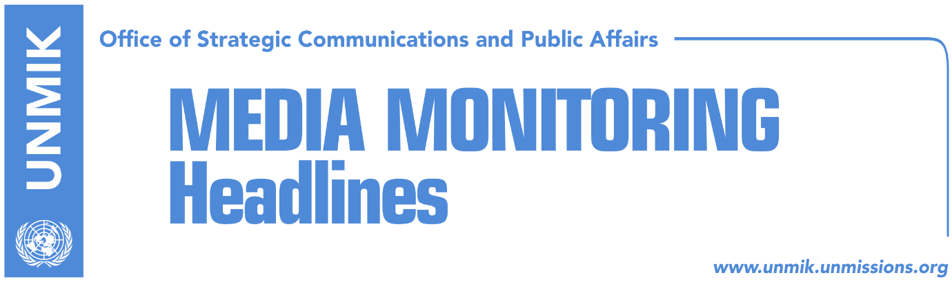

Main Stories 8 December 2018

- Haradinaj: Stoltenberg’s statement for the army is not a “NO” (media)
- Haradinaj implies bigger measures than 100-percent tax (Lajmi)
- Thaci: Blair supports dialogue on final deal between Kosovo and Serbia (media)
- Limaj supports PSD’s proposal on law on dialogue with Serbia (media)
- The “storm” of the special court (Zeri)

Kosovo Media Highlights

Haradinaj: Stoltenberg’s statement for the army is not a “NO” (media)
Kosovo’s Prime Minister, Ramush Haradinaj, said today that recent remarks by NATO Secretary General Jens Stoltenberg on the transformation of the Kosovo Security Force into an army, are not aimed against the process. “There are no requests against the formation of the army. If we read Stoltenberg’s position closely, we can see that it is not a ‘NO’,” Haradinaj said. He added that Kosovo, as a sovereign country, is entitled to have its armed forces. “This is a sovereign decision by a country and it does not violate any of NATO standards,” he said. Haradinaj said he was confident that the Kosovo Assembly will meet on December 14 to vote on the three draft laws for the transformation of the KSF into an army, and that there are enough votes to pass the laws.

Haradinaj implies bigger measures than 100-percent tax (Lajmi)
Kosovo Prime Minister Ramush Haradinaj said in an interview to Albanian TV station A2 that the Kosovo government could introduce other measures vis-à-vis Serbia even bigger than the 100-percent tax on Serbian goods. “There are other actions that we might implement that are not related to tariffs. You will see them when they happen,” Haradinaj was quoted as saying. The news website reports that the European Union has called on Pristina to revoke the 100-percent tax saying that it violates CEFTA agreement.

Thaci: Blair supports dialogue on final deal between Kosovo and Serbia (media)
Kosovo President Hashim Thaci took to Twitter today to write that former Tony Blair, former Prime Minister of the United Kingdom, fully supports talks on a final agreement between Kosovo and Serbia. “I had a great meeting in London with my friend Tony Blair. His contribution to our freedom and independence is extraordinary. He fully supports dialogue process for a final comprehensive deal between Kosovo and Serbia leading to mutual recognition and NATO, EU, UN membership for Kosovo,” Thaci tweeted.

Limaj supports PSD’s proposal on law on dialogue with Serbia (media)
Kosovo’s Deputy Prime Minister and Social-Democratic Initiative leader, Fatmir Limaj, said in an interview to Ekonomia Online that the Social Democratic Party of Kosovo (PSD) led by Shpend Ahmeti will be part of Kosovo’s team for negotiations with Serbia. Limaj, who has been proposed by the Kosovo government as coordinator for dialogue with Serbia, said they are working with the PSD in drafting a document for the process. He also said he hopes the new delegation will be adopted by the Kosovo Assembly and that a law on dialogue, proposed by the PSD, will be drafted.

The “storm” of the special court (Zeri)
The paper quotes political commentators in Pristina as saying that the invitation for an interview by the specialist chambers to Rrustem Mustafa, former KLA commander, is part of a process aimed at preparing the public for future arrests of influential political and military personalities in Kosovo. They argue that the activation of the specialist chambers could have also an impact on the ruling coalition. Mustafa’s attorney told media in a short statement that his client will be interviewed on January 14 next year but did not say in what capacity he will be interviewed. The paper contacted the office of the specialist prosecutor but they neither denied nor confirmed the information. Chris Bennet, from the office of the specialist prosecutor, told the paper: “I am aware media reports in Kosovo. I am also aware of a Facebook post by Mr. Mustafa’s attorney. However, the Office of the Specialist Prosecutor does not comment on the status of investigations, the time of possible indictments or future activities”.

Disclaimer
This media summary consists of selected local media articles for the information of UN personnel. The public distribution of this media summary is a courtesy service extended by UNMIK on the understanding that the choice of articles translated is exclusive, and the contents do not represent anything other than a selection of articles likely to be of interest to a United Nations readership. The inclusion of articles in this summary does not imply endorsement by UNMIK.

