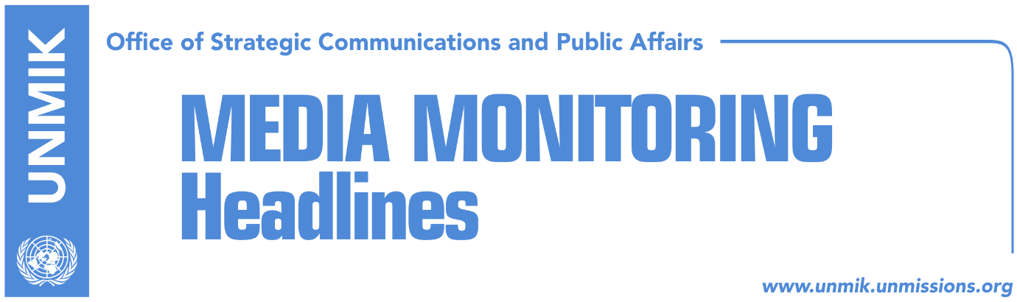

Main Stories 12 December 2018

- Haradinaj: Mogherini has ‘killed’ the dialogue (media)
- Mogherini’s office doesn’t comment on Haradinaj’s statement (Koha)
- German FM reiterates position against border changes (Zeri)
- PSD requests from MPs to support draft resolution for dialogue (Epoka)
- Specialist Chambers say Kosovo institutions have a duty to cooperate (Koha)
- KLA commander refuses to cooperate with Specialist Chambers (Bota Sot)
- Haradinaj: Not the end of the world if freedom fighters to go to Hague (RTK)
- Government has identified additional measures towards Serbia (Koha)
- Kosovo DPM Hoxhaj meets U.S. Defence Secretary Mattis (Bota Sot)

Kosovo Media Highlights

Haradinaj: Mogherini has ‘killed’ the dialogue (media)
The Prime Minister of Kosovo Ramush Haradinaj, said that the Eu High Representative Federica Mogherini has killed and disoriented the dialogue between Kosovo and Serbia. He said the Mogherini has transformed the dialogue for normalization of the relations between two countries into a dialogue for territories and borders, which means destabilization of Western Balkans. “She has harmed the region by allowing discussion about territories and by taking the courage to make a public announcement on the matter. Her position is unacceptable and of course her opinion is not valid for us, at least not for me,” Haradinaj said. He added that debate on borders has pushed dialogue process out of control. He said that it is regrettable that there is such disruption after such a major investment of the EU. He added that Kosovo remains committed on fulfillment of its obligations in order to become part of the European family. Within this context, Haradinaj said that relations between the EU and Kosovo do not depend on commissioner or a prime minister. “I have no personal issue with anyone, anyone who allows him/herself to speak about border options, knows that he or she is against Balkans, knows that he is against peace and against normalization. Those are the very causes that brought us where we are today, these disruptions of the dialogue,” Haradinaj said.

Mogherini’s office doesn’t comment on Haradinaj’s statement (Koha)
The office of the EU High Representative for Foreign Affairs and Security Policy Federica Mogherini has not commented on the recent statement by Kosovo Prime Minister Ramush Haradinaj who accused her of “killing” the dialogue for normalisation of relations between Belgrade and Pristina and rerouting it into talks of territorial exchange. “We do not comment on comments. While presidents Vucic and Thaci continue work within the framework of the high level dialogue for normalisation of relations between Serbia and Kosovo, it is important to refrain from words, actions and measures that are in violation to the spirit of normalisation,” Maja Kocijancic, spokesperson said.

German FM reiterates position against border changes (Zeri)
Germany’s Foreign Minister Heiko Maas said improvement of relations between Kosovo and Serbia would accelerate their European integration process. “Instead of thinking about border changes, Belgrade and Pristina should focus their efforts on reaching a sustainable solution that covers all open issues making a comprehensive normalisation possible,” Maas said. The German minister further called on Kosovo institutions to lift the 100-percent import tax on Serbia and Bosnia and Herzegovina or at least suspend it.

PSD requests from MPs to support draft resolution for dialogue (Epoka)
Deputy leader of the Social-Democratic Party (PSD) Visar Ymeri called on Tuesday political parties to support the draft resolution and draft law on the dialogue with Serbia initiated by PSD-NISMA-Alternativa. He said that the current dialogue process is acceptable only if results with mutual recognition of the parties involved in this process, Kosovo’s membership at UN and acceleration of the integration processes of Kosovo in NATO and EU. He said that it belongs to the Assembly of Kosovo to vote the state delegation that would represent Kosovo in these discussions. “The state delegation has the exclusive right of communication and public interpretation of proceedings, content and achievements in the dialogue process.

Specialist Chambers say Kosovo institutions have a duty to cooperate (Koha)
The paper reports on the front page that officials at the Specialist Prosecutor have recalled that Kosovo institutions have a duty to cooperate with the Specialist Chambers. “All entities and persons in Kosovo, including all Kosovo authorities, are obliged by the Law on Specialist Chambers and the Office of Specialist Prosecutor to respect without delay any request for assistance or any other order given by the OSP,” Chris Bennet, spokesperson said adding that they do not give any information on the status of investigations. The persons who have so far made public invitation from the Specialist Chambers include Sami Lushtaku, Rrustem Mustafa, Sokol Dobruna, Nazif Mehmeti – all senior members of the former Kosovo Liberation Army (KLA).

KLA commander refuses to cooperate with Specialist Chambers (Bota Sot)
Remzi Shala, former commander of KLA special units, has confirmed having received invitation by the Specialist Prosecutor in The Hague but said he does not plan on positively responding to it. Shala said he does not recognise the court.

Haradinaj: Not the end of the world if freedom fighters to go to Hague (RTK)
The Prime Minister of Kosovo Ramush Haradinaj said it is not the end of the world if some of his comrades were called by the Special Chambers in Hague. “It is not a big deal for the freedom fighters, they go and come back,” he said. “It is not a major deal, but I pray for their return,” Haradinaj added.

Government has identified additional measures towards Serbia (Koha)
Prime Minister of Kosovo Ramush Haradinaj warned with additional measures against Serbia if, as he said, it commits aggression against Kosovo such as the case with Interpol membership bid. Although he did not reveal what these measures could contain, Haradinaj said they have already identified potential actions. Most recently the media have reported that these could banning vehicles with Serbian license plates into Kosovo along the same principle Serbia applies to Kosovo license plates and reciprocity with documents.

Kosovo DPM Hoxhaj meets U.S. Defence Secretary Mattis (Bota Sot)
Kosovo’s Deputy Prime Minister Enver Hoxhaj met in Zagreb at the sidelines of the Special U.S.-Adriatic Charter meeting the U.S. Defence Secretary James Mattis whom the paper describes as the man that gave the approval for the creation of Kosovo army. The brief meeting between Hoxhaj and Mattis focused on U.S. support for transformation of the Kosovo Security Force (KSF) into a Kosovo army.

Disclaimer
This media summary consists of selected local media articles for the information of UN personnel. The public distribution of this media summary is a courtesy service extended by UNMIK on the understanding that the choice of articles translated is exclusive, and the contents do not represent anything other than a selection of articles likely to be of interest to a United Nations readership. The inclusion of articles in this summary does not imply endorsement by UNMIK.

