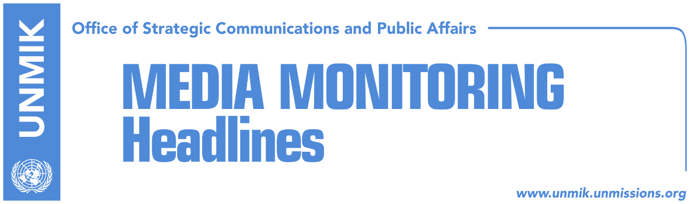

Main Stories 19 December 2018

- Trump urges Kosovo leaders to speak with unified voice (dailies)
- Haradinaj: Trump’s letter, good news for Kosovo (RTK)
- Veseli on Trump’s letter: Clear message of support for Kosovo (media)
- Trump also sends letter to Serbian President Vucic (Telegrafi)
- Hoxhaj: Agreement with Serbia in March 2019 (T7/Bota Sot)
- NATO: No change of KFOR mandate (EWB/Zeri)
- Haradinaj: EU to normalise dialogue and liberalise visas (dailies)
- EU agenda rejects Haradinaj’s expectation on visa liberalisation (Koha)
- Mogherini repeats call for import tax to be lifted (Zeri)

Kosovo Media Highlights

Trump urges Kosovo leaders to speak with unified voice (dailies)
In a letter to President of Kosovo Hashim Thaci, the U.S. President Donald Trump said Kosovo is an important partner in efforts to guarantee peace and stability in Europe and welcomed efforts for normalisation of relations with Serbia. “Failure to capitalize on this unique opportunity would be a tragic setback,” Trump said and called on Kosovo leaders to seize the moment and speak with a unified voice while refraining from actions that would make an agreement more difficult to achieve. “The United States has invested heavily in the success of Kosovo as an independent, sovereign state. We want your country to continue to grow. We stand ready to assist your efforts to reach an agreement that balances the interests of both Kosovo and Serbia. Such an agreement is within reach. I look forward to hosting you and President Aleksander Vucic at the White House to celebrate what would be an historic accord,” Trump said.

Haradinaj: Trump’s letter, good news for Kosovo (RTK)
Prime Minister of Kosovo Ramush Haradinaj commented on the letter the U.S. President Donald Trump addressed to Kosovo President Hashim Thaci saying it was good news for Kosovo. In a Facebook post, Haradinaj wrote: “From the outset, the U.S. was and remains the strongest supporter of the state of Kosovo, its sovereignty and territorial integrity. As Prime Minister of the Government of Kosovo I strongly support any effort to unification of the political spectrum positions and swift preparations for reaching a comprehensive, legally binding agreement between the two countries, Kosovo and Serbia.”

Veseli on Trump’s letter: Clear message of support for Kosovo (media)
Kosovo Assembly Speaker Kadri Veseli said the letter the U.S. President Donald Trump addressed to Kosovo President Hashim Thaci was a clear message of the U.S. support for Kosovo’s statehood. In a statement published on Facebook, Veseli said dialogue is the only way forwards in settling disputes and Trump’s message is a call for all political actors in Kosovo to join the process. “I call once again the Democratic League of Kosovo (LDK) and Vetevendosje Movement to join the State Team approved by the Kosovo Assembly several days ago and to jointly strengthen Kosovo. Kosovo is blessed to have the friendship of the United States of America,” Veseli said.

Trump also sends letter to Serbian President Vucic (Telegrafi)
President of Serbia, Aleksandar Vucic, is reported to have received a letter from the U.S. President Donald Trump similar to that sent to Kosovo President Hashim Thaci. An advisor to the Serbian president told Politico.eu that Trump’s letter to Vucic also mentions the possibility of Thaci and Vucic meeting at the White House when agreement is reached.

Hoxhaj: Agreement with Serbia in March 2019 (T7/Bota Sot)
Kosovo’s Deputy Prime Minister Enver Hoxhaj said in an interview with T7 that he expects agreement between Kosovo and Serbia to be reached by March of next year and that it will provide for mutual recognition. Hoxhaj said the U.S. President Trump’s letter to President of Kosovo Thaci sets out the role the U.S. has in the process and creates a “new situation.”

NATO: No change of KFOR mandate (EWB/Zeri)
NATO Deputy Assistant Secretary General for Political Affairs, James Appathurai, said in an interview with European Western Balkans that the Alliance was not discussing the of withdrawing KFOR peacekeeping troops from Kosovo nor is it reviewing its mandate. “I think it is very important to stress that the role of KFOR in terms of a safe and secure environment is not open to the question or discussion within NATO. As I said, we have a mandate from the UN, and it will continue to be implemented. I think that it is the most important foundation for security and stability not just in Kosovo but also in the region,” he said. Appathurai added that NATO was concerned that the decision to form Kosovo army would not lead to more stability and could have a counter-effect: “The Secretary General has been very clear about his and NATO’s concerns. One of the key words that he used has been ‘untimely’. We are concerned that this will not lead to greater stability, potentially on the contrary, and that this was not the right time to take that step. Different allies have expressed their national views, but this is the NATO leadership view.”

Find the full interview here: https://bit.ly/2QzW0JE

Haradinaj: EU to normalise dialogue and liberalise visas (dailies)
Speaking to reporters following the government meeting, Prime Minister of Kosovo Ramush Haradinaj said that he expects visa liberalisation to happen in the near future and that this process is not linked to the import tax on Serbia and Bosnia and Herzegovina. “EU has not said no, this is clear. We are making efforts to make this happen after the New Year’s, in a near and not so very distant future,” Haradinaj said about visa-free travel to Europe. As for the tax, he said the decision will not be revoked until Serbia recognises Kosovo. “The tariff will not be lifted and the decision will be consolidated as Kosovo’s position regardless of who is prime minister,” Haradinaj said. He said Kosovo requests two things from the EU: normalisation of dialogue with Serbia which he said has “derailed” and visa liberalisation.

EU agenda rejects Haradinaj’s expectation on visa liberalisation (Koha)
In a press conference yesterday, Prime Minister of Kosovo Ramush Haradinaj said that the decision on visa liberalisation for Kosovo will be taken by the end of this year or shortly after but Koha Ditore says this is not supported by the EU’s agenda as visa liberalisation is not included in any of the ten upcoming meetings of the European Union Council of Ministers.

Mogherini repeats call for import tax to be lifted (Zeri/Koha)
The EU High Representative for Foreign Affairs and Security Policy, Federica Mogherini, has reiterated her call to Kosovo authorities to lift the import tax decision on goods from Serbia and Bosnia and Herzegovina. In a press conference with Serbian Prime Minister Ana Brnabic, Mogherini said the European Commission’s position on the matter has been made clear from the beginning and the move is in violation to the CEFTA agreement. She also called for continuation of dialogue between Kosovo and Serbia to reach a comprehensive agreement. She said the parties should know that no good will come of trading accusations and that they should instead focus on finding a solution. Mogherini also said Serbia’s engagement in normalisation of relations with Kosovo is one of the key elements of progress in its EU membership negotiations but according to Koha Ditore she also, for the first time, admitted that some Belgrade steps have not helped in creating an atmosphere for normalisation of relations.

Disclaimer
This media summary consists of selected local media articles for the information of UN personnel. The public distribution of this media summary is a courtesy service extended by UNMIK on the understanding that the choice of articles translated is exclusive, and the contents do not represent anything other than a selection of articles likely to be of interest to a United Nations readership. The inclusion of articles in this summary does not imply endorsement by UNMIK.

