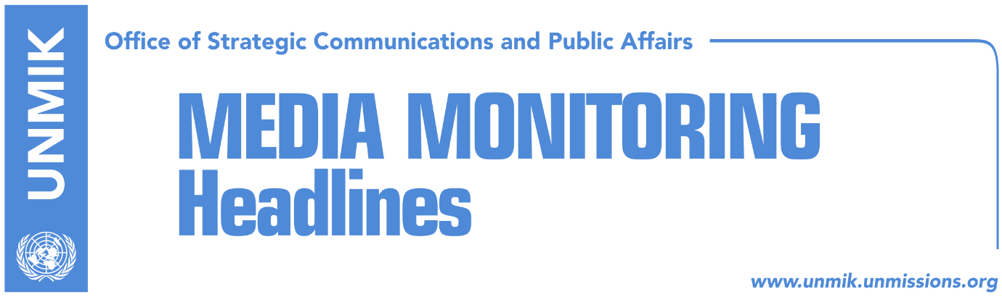

Main Stories 4 January 2018

- President Thaci: New era will start after agreement with Serbia (RTK)
- NATO supports dialogue, doesn’t change position on Kosovo Army (media)
- Lack of exchange of information between state delegation and president (Koha)
- Limaj: Missing persons, main topic of Brussels meeting (media)
- EU confirms meeting with Kosovo team on January 8 (media)
- Hoti: LDK doesn’t support current format of dialogue (media)
- LDK, VV determined to call extraordinary assembly session (Koha)

Kosovo Media Highlights

President Thaci: New era will start after agreement with Serbia (RTK)
Kosovo President Hashim Thaci said on Thursday that a new era will begin after Kosovo and Serbia reach a final settlement, RTK reports. “As we are nearing the second decade of Kosovo’s liberation, we should reflect on the achievements we have made and the challenges that await us. The mutual recognitions between Kosovo and Serbia would bring about a process of transformed leadership and governance in our country. I am confident that a new era will begin after the agreement [with Serbia] and that no one will be able to try to win votes on behalf of an unresolved political struggle with Serbia. Kosovo needs this process of transformation … We should do this for our children’s sake,” Thaci said.

NATO supports dialogue, doesn’t change position on Kosovo Army (media)
NATO Secretary General Jens Stoltenberg told CdM that he regrets the Kosovo Assembly’s decision to adopt a series of laws that enabled the transformation of the Kosovo Security Force (KSF) into the Kosovo Army, despite warnings from NATO. “Even though in principle, the transitioning of the KSF is an issue for Kosovo to decide, we have made it clear that this action comes at the wrong time. With the changing of the KSF mandate, the North-Atlantic Council will have to review the level of NATO’s engagement with the KSF. All parties need to make sure that this decision, which comes at a bad time, will not further increase tensions in the region. All political stakeholders in the region must focus on progress in reforms and dialogue. I have talked with Serbian President Aleksandar Vucic and Kosovo Prime Minister Ramush Haradinaj and informed them about the ongoing discussions among NATO member states,” Stoltenberg said. He added that it was very important for the parties to refrain from any statements or actions that can lead to further tensions. “In this respect, I welcome the constant communication between our KFOR Commander, Lorenzo D’Addari and his colleagues in the region, including his recent meeting in Nis with the chief of the General Staff of Serbian Armed Forces, Milan Mojsilovic. We fully support the process of normalization between Belgrade and Pristina through the EU-brokered dialogue. This is crucial for peace and security in the region,” Stoltenberg said.

Lack of exchange of information between state delegation and president (Koha)
The paper reports on its front page that Kosovo President Hashim Thaci has yet to provide to the Negotiating Team the documents on dialogue with Serbia. Before the team was formed, Thaci held several meetings with his Serbian counterpart, Aleksandar Vucic, but nothing in written has been presented. Fatmir Limaj, who co-heads the negotiating team, told the paper on Thursday that they have confirmation from Thaci that they will receive all documents. “So far however we haven’t received anything,” Limaj added. Representatives from Thaci’s office did not say why they haven’t offered the documents to the negotiating team.

Limaj: Missing persons, main topic of Brussels meeting (media)
Fatmir Limaj, co-head of Kosovo’s negotiating team in talks with Serbia, said on Thursday that the main topic of discussion in the talks will be missing persons. Limaj said the negotiating team was drafting Kosovo’s platform for the process. He also added the dialogue cannot be conditioned with the withdrawal of Kosovo’s 100-percent tax on goods from Serbia and Bosnia and Herzegovina.

EU confirms meeting with Kosovo team on January 8 (media)
Maja Kocijancic, spokeswoman for EU High Representative Federica Mogherini, confirmed on Thursday the meeting with the Kosovo state delegation on dialogue with Serbia. She said the meeting between EEAS and Kosovo representatives will be held in Brussels on January 8. “The European External Action Service (EEAS) has invited the Kosovo dialogue team for consultations on 8 January,” Kocijancic told Serbian news agency Tanjug.

Hoti: LDK doesn’t support current format of dialogue (media)
Avdullah Hoti, head of the Democratic League of Kosovo (LDK) parliamentary group, argued on Thursday that invitations to opposition parties to join the process of talks with Serbia “are not sincere”. Hoti said the LDK supports dialogue, “but not in the current format”. He also claimed that the ruling coalition was trying to cover up its own failures through the process of dialogue.

LDK, VV determined to call extraordinary assembly session (Koha)
The Democratic League of Kosovo (LDK) and the Vetevendosje Movement (VV), both parties in the position, are determined to call an extraordinary session of the Kosovo Assembly on the government-sponsored draft agreement between Kosovo and Serbia, the paper reports on page three. The paper recalls that an earlier session called by the parties in late December was not held due to lack of quorum. LDK and VV officials told Koha Ditore on Thursday that they will meet today to agree on a date for the extraordinary session. They also claimed that the government-sponsored draft agreement “is problematic and should therefore be retracted”.

Threats from the Special Court (Zeri)
The paper reports on its front page that the first former KLA members that received summons from the specialist chambers will travel to The Hague starting next week. A spokesman for the specialist chambers told the paper on Thursday that if those summoned by the court refuse to testify, they could be held in detention. “Pursuant to the law, they remain in detention until they decide to testify, if the testimony becomes irrelevant, or until the end of criminal procedure, which should last no longer than a month,” Chris Bennet, spokesperson for the specialist chamber, is quoted as saying. He also added that among those summoned by the court include suspects, victims, and witnesses. These people will in one way or another help the prosecutors to collect information related to allegations of war crimes committed during the Kosovo conflict.

Disclaimer
This media summary consists of selected local media articles for the information of UN personnel. The public distribution of this media summary is a courtesy service extended by UNMIK on the understanding that the choice of articles translated is exclusive, and the contents do not represent anything other than a selection of articles likely to be of interest to a United Nations readership. The inclusion of articles in this summary does not imply endorsement by UNMIK.

