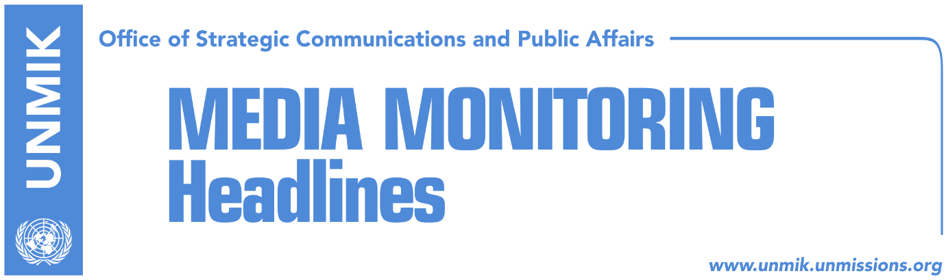

Main Stories 8 January 2018

- Thaci: PDK initiated the tax, Haradinaj only voted (Klan Kosova)
- Haradinaj: Tax will remain in power until Serbia recognizes Kosovo (media)
- Government: Thaci should protect state interests, not deal with taxes (media)
- EU hopes state team will support Thaci’s efforts and retraction of tariff (Koha)
- EU: Consultations with the team, dialogue with Presidents (Zeri)
- Limaj: Tax won’t be rescinded until Serbia recognizes Kosovo (media)
- Kosovo state delegation to travel to U.S. to get “visa” (Zeri)
- Opposition parties have no strategy to stop negotiating team (Zeri)
- Bislimi: Negotiating team lacks support from Albanian majority (Epoka)

Kosovo Media Highlights

Thaci: PDK initiated the tax, Haradinaj only voted (Klan Kosova)
Kosovo President Hashim Thaci told Klan Kosova on Monday evening that Deputy Prime Minister Enver Hoxhaj initiated the idea of the tariff on Serbia goods and that PDK leader Kadri Veseli empowered the 100-percent tariff. “Deputy Prime Minister Enver Hoxhaj initiated the 10-percent tax as a result of developments between Kosovo and Serbia. Later on, PDK leader Kadri Veseli suggested that there should be a 100-percent tariff …” Thaci was quoted as saying. “This is why I believe that Hoxhaj and Veseli will discuss with other partners of the ruling coalition and heads of institutions … Hoxhaj initiated it, Veseli empowered it to 100 percent, and the government only voted on the tax. I haven’t discussed the issue with Haradinaj because he was not involved. Haradinaj and the others voted this in the government,” Thaci added.

Haradinaj: Tax will remain in power until Serbia recognizes Kosovo (media)
Kosovo Prime Minister Ramush Haradinaj has shown no sign of backing down on the 100-percent tariff on goods from Serbia and Bosnia and Herzegovina, one day after President Hashim Thaci pledged that Kosovo is ready to reconsider this decision, Koha Ditore reports on its front page. Thaci said Kosovo would reconsider the position if it is given a clear road to a final peace agreement with Serbia, with guarantees from the United States of America. Haradinaj’s office however said they maintain their position and did not comment on Thaci’s remarks. “The position of the government on the tax is clear,” a spokeswoman for the government told the paper on Monday. Zeri reports that Thaci’s remarks about the tariff have triggered numerous reactions and some are arguing that Thaci is interfering in the competencies of the government. Government officials said they were surprised by Thaci’s remarks and that the President has not even consulted the government on the matter. Shpend Ahmeti, co-head of the Kosovo state delegation for talks with Serbia, told Klan Kosova on Monday that they will tell EU officials in Brussels today that only the government can rescind the 100-percent tariff on Serbian goods.

Government: Thaci should protect state interests, not deal with taxes (media)
The Kosovo Government has reacted to President Hashim Thaci’s remarks that Kosovo is ready to reconsider the 100-percent tariff on Serbian goods. Haki Shatri, economy advisor to Prime Minister Ramush Haradinaj, told KTV on Monday that Thaci has not discussed the matter with Haradinaj. Shatri argued that Thaci should represent the interests of the state of Kosovo and that he has no competencies to change the government’s decision on the 100-percent tariff.

EU hopes state team will support Thaci’s efforts and retraction of tariff (Koha)
The Kosovo state delegation will meet today in Brussels with experts from the European External Action Service (EEAS) and will also have a brief meeting with EU High Representative Federica Mogherini, the paper reports on page three. Citing sources in Brussels, the paper also notes that the state delegation will not meet their Serbian counterparts and that the visit to Brussels has an advisory character. EU officials told the paper they hope the state delegation will play a constructive role in support of President Hashim Thaci’s efforts for an agreement with Serbian President Aleksandar Vucic, and the retraction of the 100-percent tax on goods from Serbia and Bosnia and Herzegovina.

EU: Consultations with the team, dialogue with Presidents (Zeri)
The paper quotes Maja Kocijancic, spokesperson for Foreign Affairs and Security Policy/European Neighbourhood Policy and Enlargement Negotiations, as saying that in today’s meeting with the Kosovo state delegation they will exchange opinions about the process of normalization of relations between Kosovo and Serbia. “Consultations are a good opportunity to exchange opinions with Kosovo’s representatives for the EU-facilitated dialogue on the normalization of relations between Pristina and Belgrade. The high-level dialogue will be held with the two President and this does not change,” Kocijancic said.

Limaj: Tax won’t be rescinded until Serbia recognizes Kosovo (media)
Fatmir Limaj, co-head of the state delegation for talks with Serbia, told Klan Kosova on Monday that the 100-percent tariff on goods from Serbia and Bosnia and Herzegovina will not be rescinded until Serbia recognizes Kosovo’s independence. “Serbia does not recognize Kosovo’s documents. Our businesses are faced with millions of obstacles to enter the Serbian market. When Serbia recognizes Kosovo and when we reach an agreement, the tax will become obsolete,” he said.

Kosovo state delegation to travel to U.S. to get “visa” (Zeri)
The paper reports in its leading front-page story that Kosovo’s state delegation for talks with Serbia, co-led by Fatmir Limaj and Shpend Ahmeti, is expected to travel to the United States of America to discuss a final settlement with Serbia. Citing unnamed sources, the paper notes that the date of the visit will be announced soon and that the delegation will hold meetings with senior U.S. officials. Political commentators told the paper that in the meetings, the state delegation will be informed about the U.S. position on a final agreement with Serbia. Deputy Prime Minister Enver Hoxhaj, who is part of the state delegation, told the paper on Monday that the meetings were not requested by the delegation and that a final settlement with Serbia cannot be reached without U.S. support. “I cannot say when the team will be invited to Washington. It is too early to say,” Hoxhaj said.

Opposition parties have no strategy to stop negotiating team (Zeri)
The paper reports that the two main opposition parties, the Democratic League of Kosovo (LDK) and the Vetevendosje Movement (VV), who are opposing Kosovo’s state delegation for talks with Serbia, lack a strategy to stop the final phase of dialogue with Belgrade. LDK representatives believe that Kosovo should go to early parliamentary elections and that the Haradinaj-led government should resign. A senior LDK member told the paper that early elections would result in a government with constitutional and political legitimacy for talks with Belgrade.

Bislimi: Negotiating team lacks support from Albanian majority (Epoka)
Besnik Bislimi, deputy leader of the Vetevendosje Movement, says in a front-page interview to the paper, that Kosovo’s state delegation for talks with Serbia lacks the support of the Albanian majority. Bislimi argued that only the Vetevendosje Movement is serious enough to lead the final phase of dialogue with Serbia.

Disclaimer
This media summary consists of selected local media articles for the information of UN personnel. The public distribution of this media summary is a courtesy service extended by UNMIK on the understanding that the choice of articles translated is exclusive, and the contents do not represent anything other than a selection of articles likely to be of interest to a United Nations readership. The inclusion of articles in this summary does not imply endorsement by UNMIK.

