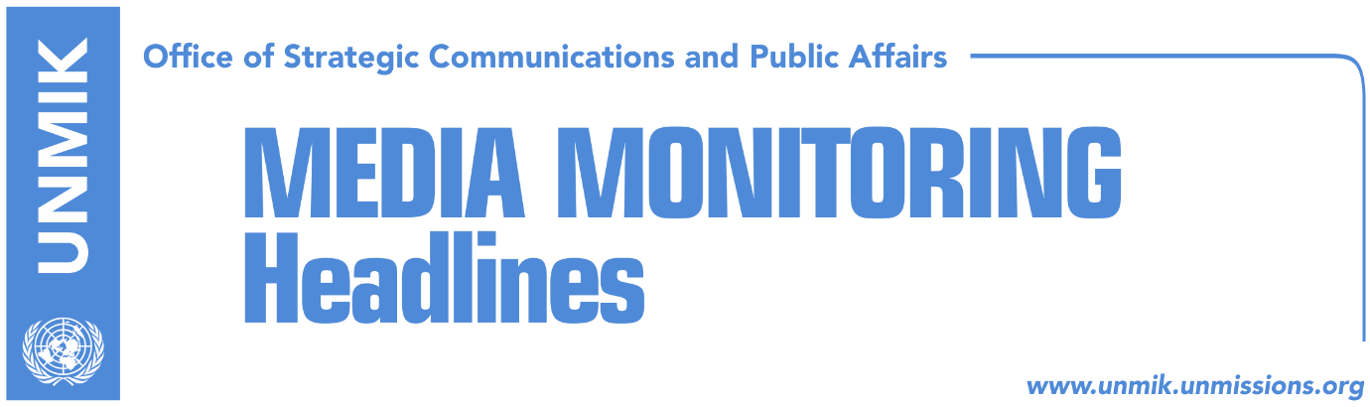

Main Stories 9 January 2018

- EU calls for suspension of 100-percent tariff (media)
- Haradinaj: 100-percent tax to be lifted when Serbia recognizes Kosovo (media)
- President Thaci congratulates state delegation for dialogue (media)
- Veseli: We won’t allow any result that hurts integrity of our state (media)
- Hoti: Kosovo’s presentation in Brussels was never weaker (RTK)
- Serwer: Exchange of territories is not on the table anymore (media)
- Kurti meets Albanian President Meta (media)
- Haxhiu: Specialist chambers are using files prepared by LDK (T7)

Kosovo Media Highlights

EU calls for suspension of 100-percent tariff (media)
The leading story in most media is the visit of the Kosovo state delegation to Brussels on Tuesday and the meetings with the European External Action Service (EEAS) and EU High Representative Federica Mogherini. Koha Ditore reports on its front page that the suspension of the tax is seen as a way out to resume dialogue between Pristina and Belgrade. The paper reports that Mogherini has again requested the suspension of the tax on Serbian goods. “Reaching a comprehensive legally binding agreement on full normalization of relations in the context of the Pristina-Belgrade Dialogue requires a climate that contributes to good neighborly relations, whereby past agreements are respected and implemented, and actions and statements which are not compatible with the overall interest and strategic objectives of the region are avoided,” Mogherini was quoted as saying. The paper also reports that as part of efforts to emerge from the current stalemate, EEAS Director Angelina Eicchorst will visit Belgrade and Pristina soon. Epoka e Re reports on its front page that Fatmir Limaj, co-head of the state delegation, said that Pristina is willing to resume dialogue with Belgrade but that the 100-percent tariff will not be rescinded. Zeri reports on its front page that Mogherini has called for the tax to be rescinded, but the Kosovo state delegation has rejected the request saying that Serbia would have to recognize Kosovo’s independence first. Media quote Shpend Ahmeti, co-head of the state delegation, as saying that “tariffs are the only instrument in Kosovo’s foreign policy to put pressure on Serbia”. Ahmeti said the tariffs as a result of Serbia’s long and aggressive campaign against Kosovo. Kosova Sot reports in its coverage that Mogherini has stepped up pressure on the tax. Bota Sot carries a press release issued by the Pristina-based Council for the Defense of Human Rights and Freedoms accusing Mogherini of “using lies and isolating 2 million citizens of Kosovo”.

Haradinaj: 100-percent tax to be lifted when Serbia recognizes Kosovo (media)
Kosovo Prime Minister Ramush Haradinaj said after meeting the Minister of Trade and Industry Endrit Shala on Tuesday, that the Kosovo government is interested to rescind the 100-percent tax if Serbia recognizes Kosovo’s statehood. Haradinaj did not want to comment on President Hashim Thaci’s remarks about the tax, saying that “we love the President very much but roles of the institutions are divided”. “You have put us in a bad position about the President, I don’t have a comment. The President has his own duties and the government has its own,” Haradinaj said. Haradinaj further said that he has received good news related to the strategic investors for approximately €2 billion investments in the first ten days of this year in sectors of tourism and energy. Asked about the demands of the Trepca miners, Haradinaj said this enterprise has been hostage to political issues, and added that the government is ready to unblock the situation. Asked about eventual dismissal of the Minister for Agriculture, Nenad Rikalo, Haradinaj said that this will happen when the time comes.

President Thaci congratulates state delegation for dialogue (media)
Kosovo President Hashim Thaci congratulated the Kosovo state delegation for dialogue for their presentation in Brussels on Tuesday, most media report. Thaci said Kosovo’s objectives are recognition by Serbia and membership to the United Nations. “I congratulate the state delegation on dialogue, for a correct, united and professional presentation in Brussels, as part of the final phase of dialogue between Kosovo and Serbia. Our objectives are recognition by Serbia and membership to the United Nastions. The final and comprehensive agreement between Kosovo and Serbia will bring more peace and stability to our countries and the whole region,” Thaci said.

Veseli: We won’t allow any result that hurts integrity of our state (media)
Kosovo Assembly President and Democratic Party of Kosovo (PDK) leader, Kadri Veseli, welcomed the meeting of the Kosovo state delegation with EU High Representative Federica Mogherini on Tuesday. Veseli said the delegation has a full mandate and legitimacy from the Kosovo Assembly. “Kosovo is willing and determined for dialogue with Serbia. The decisions that will be made will be in full respect for the independent and sovereign state of Kosovo and in coordination with our international partners and the supporters of our state,” Veseli wrote in a Facebook post. He added that rejecting dialogue is neither an alternative nor a solution. “Kosovo enters dialogue with clear objectives: recognition by Serbia and membership in the United Nations. We will not allow any result that could hurt the integrity of the state of Kosovo”. Veseli said the work of the state delegation will be transparent in all phases and that the final decision will be legitimized with the free will of the sovereign. “In this respect, we will very soon vote on the law on referendum in the Kosovo Assembly. The citizens of Kosovo will have the final say on the results of the process”.

Hoti: Kosovo’s presentation in Brussels was never weaker (RTK)
Avdullah Hoti, caucus of the Democratic League of Kosovo (LDK) called representation of Kosovo’s negotiating team on Tuesday in Brussels as the weakest possible one. He took to Facebook to write that this negotiating team is simply a décor to mask legitimacy of PAN coalition and added that this team does not have the power to make decisions that would defend interests of Kosovo citizens. ”Never in the past did it happen for a Kosovo delegation to go to Brussels with such unclear and enigmatic intentions as this decorating “negotiating” team,” Hoti wrote.

Serwer: Exchange of territories is not on the table anymore (media)
Daniel Serwer, an U.S. expert on Balkans issues, said on Tuesday that there is possibility to resolve the issue between Kosovo and Serbia, but he added that everything depends on the political will of both parties. “It is impossible to foresee if they will decide to resolve this matter within this year. It appears that Pristina is more eager than Belgrade to do so, but I hope that this will change, as it is becoming clear that it is much better to have early solutions than waiting for EU membership,” Serwer said. He added that territorial exchange between Kosovo and Serbia is a bad idea. “It appears that Vucic does not want to give to Thaci what he needs, but also it seems that Thaci does not want to give what Vucic wants and needs for territorial (population) exchange either. In my opinion, this is good, because territorial exchange is a bad idea,” Serwer said.

Kurti meets Albanian President Meta (media)
Albin Kurti, leader of the Vetevendosje Movement, together with Kosovo Assembly MP Liburn Aliu, met the President of Albania Ilir Meta on Tuesday. “We discussed the political situation in Kosovo and Albania, the announced dialogue with Serbia as well as about the developments in the region. We jointly concluded that our states should cooperate and align as much as possible in the international arena, for European and national integrations, as well as on Balkan matters,” Kurti wrote on his Facebook profile.

Haxhiu: Specialist chambers are using files prepared by LDK (T7)
Bekim Haxhiu, Democratic Party of Kosovo (PDK) MP, told T7 on Tuesday evening that the specialist chambers are using files prepared by the Democratic League of Kosovo (LDK). According to Haxhiu, the files were submitted to Kosovo Police and UNMIK. He further argued that an LDK commission worked “to attack political opponents and eliminate leaders of the former Kosovo Liberation Army from politics”.

Disclaimer
This media summary consists of selected local media articles for the information of UN personnel. The public distribution of this media summary is a courtesy service extended by UNMIK on the understanding that the choice of articles translated is exclusive, and the contents do not represent anything other than a selection of articles likely to be of interest to a United Nations readership. The inclusion of articles in this summary does not imply endorsement by UNMIK.

