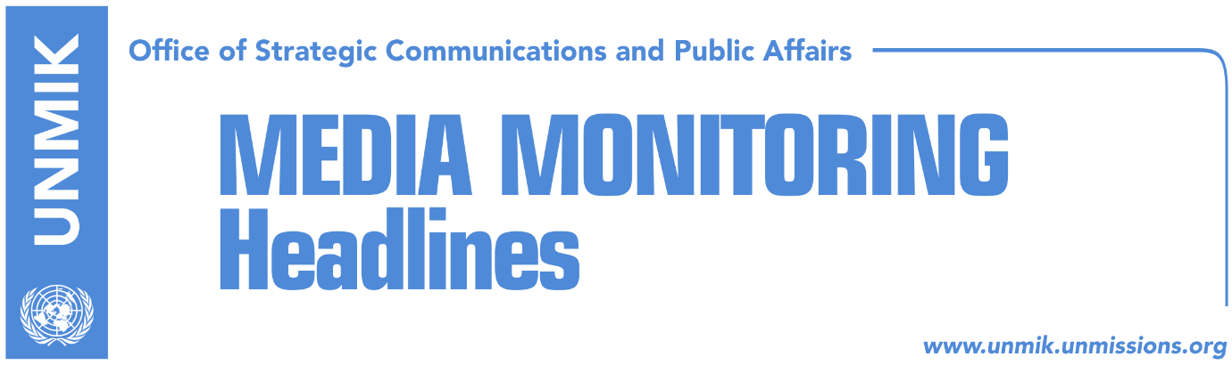

Main Stories 11 January 2018

- Two funding sources for “clients” of the specialist chambers (Koha/Zeri)
- PM Haradinaj commends state delegation’s presentation in Brussels (Zeri)
- EU supports conditioning of dialogue with retraction of tariff (Zeri)
- Germany supports visa liberalization for Kosovo (media)
- Pacolli meets German Foreign Minister in Berlin (media)
- Haradinaj condemns anti-Kosovo chants in Banja Luka (Express)

Kosovo Media Highlights

Two funding sources for “clients” of the specialist chambers (Koha/Zeri)
The paper reports on its front page that the expenses of persons summoned by the Specialist Chambers in The Hague will be covered by two different budgets. The Office of the Specialist Prosecutor will cover the expenses of those summoned as suspects, while the state of Kosovo will cover the expenses of those that will be indicted by the court. The Office of the Specialist Prosecutor, in its invitation to the suspects, told them that they will be covering the expenses. “Given that there is reasonable doubt you have been involved in crimes within the jurisdiction of the Kosovo Specialist Chambers (KSC), you are entitled to be assisted by a lawyer related on this issue and the right that your lawyer be present in representation of these materials. In case you cannot afford to pay a lawyer, you have the right to be represented by a lawyer free of charge,” says the invitation, which the paper claims to have seen. In an article related to the same issue, Zeri reports that the Kosovo government in its 2017 budget had allocated a fund of €1.5 million for legal and financial aid to potential indictees of the specialist chambers. Defense attorneys however told the paper that the fund is insufficient and that another fund will be allocated soon.

PM Haradinaj commends state delegation’s presentation in Brussels (Zeri)
Kosovo Prime Minister Ramush Haradinaj met on Thursday with the co-heads of Kosovo’s state delegation for talks with Serbia, Fatmir Limaj and Shpend Ahmeti. Haradinaj wrote in a Facebook post after the meeting: “I commended the state delegation for their excellent presentation of Kosovo’s position on dialogue with Serbia to EU officials … A comprehensive agreement with Serbia, which would result in mutual recognition between the two countries, would also pave way to Kosovo’s membership of the United Nations and other international organizations”.

EU supports conditioning of dialogue with retraction of tariff (Zeri)
The paper reports that the European Union, as mediator of talks between Kosovo and Serbia, called on both countries not to set any conditions in the process, but after Pristina’s decision to introduce a 100-percent tariff on goods from Serbia, the EU is supporting Belgrade’s conditioning of the process with the retraction of the tariff. Maja Kocijancic, spokeswoman for EU High Representative Federica Mogherini, said both Serbia and Kosovo must swiftly deliver on their commitment to the process of dialogue. Kocijancic said the position of the EU on the tariff is clear: “the Kosovo government’s decision to increase by 100 percent the tax on goods from Serbia and Bosnia and Herzegovina is a clear violation of the CEFTA agreement and the Stabilization/Association Agreement between the EU and Kosovo”.

Germany supports visa liberalization for Kosovo (media)
The German Minister for State and European Affairs, Michael Roth, said on Thursday that Kosovo has met all the requirements in the visa liberalization process. “Kosovo has fulfilled the EU’s conditions to be granted visa liberalization. It is therefore only fair to give green light to Kosovars now. We will strongly advocate this in Brussels,” Roth wrote in a Twitter post.

Pacolli meets German Foreign Minister in Berlin (media)
Most media cover Kosovo Foreign Minister Behgjet Pacolli’s meeting on Thursday in Berlin with his German counterpart, Heiko Maas. The latter said Germany supports Kosovo’s European integration but that “Kosovo must do more in the rule of law area, the fight against organized crime and corruption”. Maas also said that relations between Serbia and Kosovo are important and that there has been a recent setback. Pacolli said Kosovo was committed to dialogue and that it is willing to sign a final settlement with Serbia. Pacolli also said that Pristina decided to introduce the 100-percent tariff on Serbian goods as a result of Serbia’s aggressive campaign Kosovo and to remind Serbia that Kosovo is an independent state.

Haradinaj condemns anti-Kosovo chants in Banja Luka (Express)
The news website reports that Kosovo’s Prime Minister Ramush Haradinaj condemned chants against Kosovo during a march in Banja Luka on the occasion of the Republika Srpska Day. Haradinaj said such actions are aimed at destabilizing the Balkans and criticized the European Union for not reacting to Serbia’s destabilizing actions. “Serbia continues to make provocations against Kosovo, this time in their satellite the Republika Srpska. It is a shame that Serbia refuses integration processes and European values. A unit with paramilitary features in Banja Luka called for revenge and invasion of Kosovo. The song ‘Heroes of Kosovo’ was followed also by anti-European chants,” Haradinaj said in a Facebook post.

Disclaimer
This media summary consists of selected local media articles for the information of UN personnel. The public distribution of this media summary is a courtesy service extended by UNMIK on the understanding that the choice of articles translated is exclusive, and the contents do not represent anything other than a selection of articles likely to be of interest to a United Nations readership. The inclusion of articles in this summary does not imply endorsement by UNMIK.

