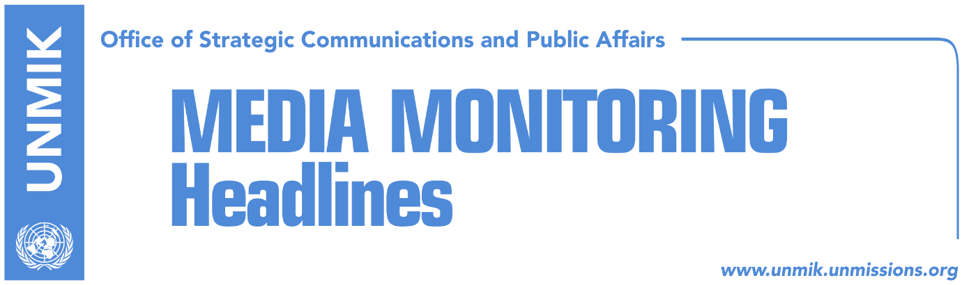

Main Stories 12 January 2019

- Veseli invites opposition to the dialogue meeting (RTK)
- Vetevendosje to boycott again the dialogue meeting called by Veseli (media)
- LDK rejects Veseli’s invitation, calls the meeting a farce (Telegrafi)
- Kosovo leaders hail FYROM’s decision on name change (media)
- Mustafa: The government should go home (media)
- First facing with the Special Chambers (Zeri)

Kosovo Media Highlights

Veseli invites opposition to the dialogue meeting (RTK)
Kosovo Assembly President Kadri Vaseli has invited once again institutional leaders and representatives of opposition political parties to coordinate on dialogue with Serbia. He has invited again the President of Kosovo, the Prime Minister, Negotiating Team as well as caucuses from the opposition political parties for a joint meeting in order to coordinate on the dialogue. The meeting will be held on Monday, 14 January at 11:00 hours at the Assembly of Kosovo. Veseli had announced in December that he would invite all political actors from the government and opposition prior and after each meeting of the Kosovo party in Brussels, in order to coordinate about the final phase of the dialogue.

Vetevendosje to boycott again the dialogue meeting called by Veseli (media)
Vetevendosje Movement has decided not to respond to the meeting called by the Assembly President Kadri Veseli. “These meetings are being held to legitimize Thaci in the dialogue with Serbia and to create the impression that he has the support which in reality he lacks. He is alone in this action. All that he has with him is some minor political parties for which the greatest challenge is to pass the threshold,” said Vetevendosje movement spokesperson Tinka Kurti. She added that instead of the meetings, Veseli should call a session to discuss the government report on the 33 reached agreements.

LDK rejects Veseli’s invitation, calls the meeting a farce (Telegrafi)
Vjosa Osmani, Kosovo Assembly MP from the Democratic League of Kosovo (LDK), told the news portal that meetings called by the Assembly President Kadri Veseli to coordinate about the dialogue with Serbia are only a farce. “I do not see any reason to participate in such meeting which is only a farce and nothing else. Mr. Veseli represents the second political party at the Assembly based on the number of MPs, and he cannot pretend to take over neither a unifying role nor a leading one,” Osmani said.

Kosovo leaders hail FYROM’s decision on name change (media)
Kosovo’s President Hashim Thaci hailed the voting of the constitutional amendments by the Parliament of Former Yugoslav Republic of Macedonia (FYROM) on Friday evening, which unblock the path to NATO and EU. “The Republic of Macedonia or North Macedonia, as it will be called now, made a great step forward, by opening perspective to political stability, continuance of reforms and integration of the country in Euro-Atlantic institutions, in order to guarantee a better life to its citizens and young generations. 2019 should be a year of great decisions also for Kosovo. A year when the centuries long conflict between Kosovo and Serbia should conclude with a final and comprehensive agreement for peace and normalization of the inter-state relations,” Thaci wrote on his Facebook profile.
Kosovo Assembly Presdient Kadri Veseli also hailed “the historic vote by my colleagues in Skopje to ratify Prespa Agreement,” which according to him prove once again that dialogue and understanding is the best way to resolve problems inherited from the past.
Kosovo’s Prime Minister Ramush Haradinaj also hailed the constitutional amendments saying that this historical event is a hope that the region is moving towards eternal peace. He also complemented Albanians in FYROM for playing a key role in these changes.
Kosovo’s Foreign Minister Begjet Pacolli and Deputy Prime Minister Fatmir Limaj also hailed the decision.

Mustafa: The government should go home (media)
Isa Mustafa, leader of the Democratic League of Kosovo (LDK), has addressed a series of criticisms against the Kosovo Government, led by Ramush Haradinaj. He said at a press conference today, that the government has lost the concept of an economy they had vowed for.

According to Mustafa, this government has to change its behavior, it must go home as soon as possible as it has punt under a question mark the relations with the EU and the SAA implementation of the European reform agenda that would lead the Kosovo towards the EU .

"The government wants to deceive the citizens by blaming the European community. We have appreciated President Trump's letter and the mobilization of all institutions in Kosovo for the dialogue to move to the US, because we saw in the letter a US engagement that we welcome. It is pointless that Kosovo institutions at the moment when the country has received a letter stating that each party should refrain from actions, the Government for its own reasons is adding 100% tax measures instead of considering the letter coming from the president of a special state, on which the agreement also depends on," stressed Mustafa.

He assessed that Kosovo institutions should take responsibility for the dialogue, which is not taken into account when the President spoke about border correction, when the government drafted agreement with which the Prime Minister removes himself from the role in dialogue and with the group nominated by the parliament.

"As LDK, we in this process remain loyal to our document on the basis of dialogue development and that document represents the politics of the overwhelming majority of the party. Dialogue should end in the interest and benefit of Kosovo citizens, concluding all the problems. We have the greatest trust of all citizens, because the support comes from 27-30% of the citizens, and we will increase it further because we are determined to work on most on issues that concern the citizens. We will concentrate on employment and unemployment, which is the biggest problem that causes citizens to flee from Kosovo, as well as the fight against crime and corruption. We will take over the responsibilities that belong to LDK as the party with the largest parliamentary group in the Assembly of the Republic of Kosovo," Mustafa said.

"There is no handicap for Kosovo if a government that has over 80 deputy ministers and many indicted ministers, is brought down. I represent the views of LDK, which is that the Government should be brought down," Mustafa added.

According to him, it is not a good act not to respect the letter of President Donald Trump, because without the support of the United States, Kosovo would never become a state.

First facing with the Special Chambers (Zeri)
The paper reports that former KLA commanders Sami Lushtaku and Rrustem Mustafa will travel to The Hague during this weekend to be interviewed by the Special Prosecutor's Office, while Sabajdin Cena, former KLA superior from the Pashtrik Operative Zone, will be travelling to The Hague by the beginning of the next week.

Lushtaku’s and Mustafa’s, defense attorney Arianit Koci, confirmed for the Koha.net portal that he will be heading for the Hague this weekend along with his clients.

I am currently with Sami Lushtaku and this weekend we will be traveling to The Hague by a regular line. It remains to be seen with what route we will take, "Koci said.

Disclaimer
This media summary consists of selected local media articles for the information of UN personnel. The public distribution of this media summary is a courtesy service extended by UNMIK on the understanding that the choice of articles translated is exclusive, and the contents do not represent anything other than a selection of articles likely to be of interest to a United Nations readership. The inclusion of articles in this summary does not imply endorsement by UNMIK.

