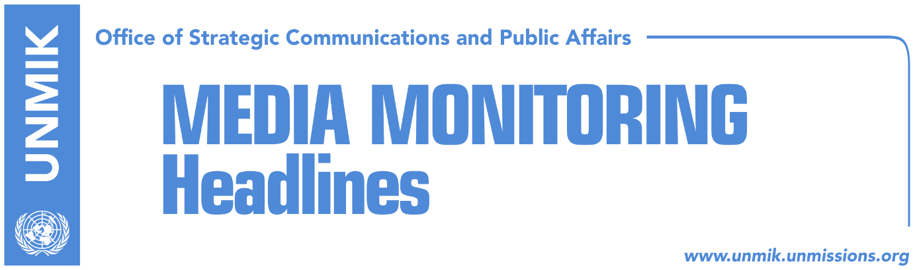

Main Stories 21 January 2019

- Thaci confirms agreement with Serbia will involve border correction (dailies)
- Thaci to meet Kosovo negotiating team today (dailies)
- Prime Minister’s Office: We have consensus in government, tax remains (Koha)
- Veseli to meet Haradinaj and Kosnett to discuss suspension of tax (Zeri)
- Maliqi: Tax suspension, necessary step (Epoka e Re)
- President Thaci meets Albanian PM Rama in Tirana (media)
- UN Security Council to hold session on Kosovo in February (dailies)
- Official launch of KSF transition into army (RTK)
- Teachers union rejects PM Haradinaj’s offer for pay raise (media)
- Serbian police interview two Bosniak members of KSF (media)

Kosovo Media Highlights

Thaci confirms agreement with Serbia will involve border correction (dailies)
President of Kosovo Hashim Thaci said in an interview with Austrian press agency APA that there is EU and U.S. support for an agreement between Kosovo and Serbia to be reached at this time and that the novelty is that Russia would also be prepared to accept an agreement approved by the two sides. “It is therefore important to use this momentum to reach an agreement that is balanced and takes into account interests of the two countries,” Thaci said adding however that the agreement would not only deal with border correction but other aspects as well: “It will be a comprehensive agreement that addresses other issues, such as that of missing persons.” Thaci ruled out the possibility of a Great Albania or Great Kosovo being created at the end of the process. “There will be no monoethnic borders, both countries will be multiethnic,” he said.

Thaci to meet Kosovo negotiating team today (dailies)
President of Kosovo Hashim Thaci is expected to meet members of the Kosovo negotiating team for dialogue with Serbia today and present them with a written account of what has been discussed in the process. “I have made it clear that there is no written document or draft agreement prepared by the EU,” Zeri quotes Thaci as telling RFE last week. however, Thaci said he will meet the team and provide to them a general outline of the course of dialogue for normalisation of relations with Serbia.

Prime Minister’s Office: We have consensus in government, tax remains (Koha)
The paper reports on its front page that the Kosovo government is ready to coordinate activities with the United States of America, but it shows no signs of backing down from the 100-percent tax on Serbian products. U.S. Ambassador Philip Kosnett and Prime Minister Ramush Haradinaj and Assembly President Kadri Veseli are scheduled to meet this week to discuss the matter. The U.S. has already called on Pristina to immediately suspend the tax and pave way to an agreement between Kosovo and Serbia in the first half of this year. The Prime Minister’s Office told the paper on Sunday that there is consensus among partners of the ruling coalition to keep the tax in force. Avni Arifi, advisor to Prime Minister Haradinaj, told the paper: “the policy on the tax is not the policy of a single institutional leader, but the position of many leaders, parties and institutions in the country. There is consensus and strong support both within the coalition and outside it to keep the tax in force”.

Veseli to meet Haradinaj and Kosnett to discuss suspension of tax (Zeri)
Kosovo Assembly Speaker Kadri Veseli has called a meeting on Tuesday with Prime Minister Ramush Haradinaj and the U.S. Ambassador Philip Kosnett to discuss the request for suspension of tax on imports from Serbia and Bosnia and Herzegovina. Officials from the Democratic Party of Kosovo (PDK) said they expect the meeting to conclude in an agreement that would guarantee Kosovo’s relations with the U.S. are not impaired.

Maliqi: Tax suspension, necessary step (Epoka e Re)
Political analyst Shkelzen Maliqi told the paper that Kosovo should seriously take into consideration the U.S. request for suspension of import tax on Serbia warning that the issue is threatening to damage Kosovo’s relations with its key ally, the United States. “These are serious threats that should not be neglected,” Maliqi said. He argued that the tax should be temporarily suspended pending conclusion of dialogue: “If the dialogue were to fail, the tax would automatically be reinstated.” As for Bosnia and Herzegovina, Maliqi said the tax on the country should continue but that negotiations would have to take place within the CEFTA framework that would enable both Kosovo and Bosnia to trade on equal footing.

President Thaci meets Albanian PM Rama in Tirana (media)
Several media report that Kosovo President Hashim Thaci met the Albanian Prime Minister Edi Rama in Tirana on Sunday. Rama posted a photo with Thaci on social media.

UN Security Council to hold session on Kosovo in February (dailies)
The UN Security Council session on Kosovo is expected to take place sometime during the month of February, Zeri quotes Serbian Foreign Minister Ivica Dacic. He said the decision to include Kosovo on the agenda was taken by Equatorial Guinea which will preside over the Security Council in February. Meanwhile Bota Sot quotes Presheva e Jone agency saying the meeting of the Security Council will be held on 7 February.

Official launch of KSF transition into army (RTK)
The transition of the Kosovo Security Force (KSF) into Kosovo army has officially begun by Prime Minister Ramush Haradinaj, Minister of Defence Rrustem Berisha and KSF Commander Rrahman Rama unveiling entrance sign at the KSF building reading The Ministry of Defence. Berisha said at the occasion that the transition process which is expected to last ten years has officially begun and thanked all those that contributed to this important development.

Teachers union rejects PM Haradinaj’s offer for pay raise (media)
Representatives of Kosovo teachers’ union have rejected the offer made to them by Prime Minister of Kosovo Ramush Haradinaj for a pay raise through allocation of additional €20 million to the education budget. In a press conference last night, Haradinaj said he was very concerned by the strike which is entering the second week and called on teachers to end it. Meanwhile, the union leaders said the government’s offer provides a ten percent raise while they insist on thirty percent.

Serbian police interview two Bosniak members of KSF (media)
Most media report that Serbian police interviewed two Bosniak members of the Kosovo Security Force on Friday. The two KSF members, who are brothers, were travelling from Leposavic to visit their relatives in Serbia. Kosovo’s Foreign Minister, Behgjet Pacolli, called on the European Union to react immediately on the incident.

Disclaimer
This media summary consists of selected local media articles for the information of UN personnel. The public distribution of this media summary is a courtesy service extended by UNMIK on the understanding that the choice of articles translated is exclusive, and the contents do not represent anything other than a selection of articles likely to be of interest to a United Nations readership. The inclusion of articles in this summary does not imply endorsement by UNMIK.

