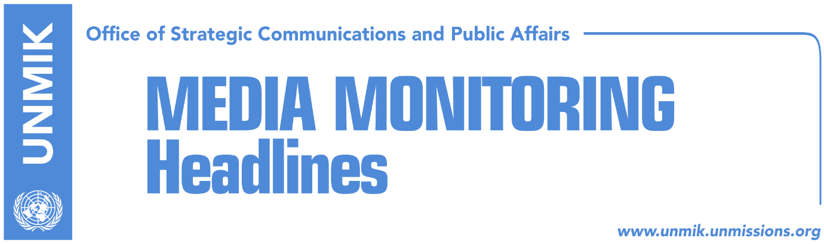

Main Stories 23 January 2019

- Government insists import tax will remain in force (dailies)
- Shala: Tax should not be lifted (Telegrafi/Zeri)
- Arifi: We could temporarily suspend tax on Serbia (Klan Kosova)
- Thaci: Unification of Mitrovica, unstoppable (media)
- Rakic: We will not allow unification of Mitrovica (RTK)
- U.S. top diplomat for Europe resigns (media)
- EU: Kosovo has fulfilled all visa liberalization criteria (Klan Kosova)

Kosovo Media Highlights

Government insists import tax will remain in force (dailies)
The government of Kosovo continues to stick to its import tax on Serbia and Bosnia and Herzegovina despite international pressure, Zeri writes adding that even yesterday’s meeting between Kosovo Assembly Speaker Kadri Veseli, Prime Minister Ramush Haradinaj and the U.S. Ambassador Philip Kosnett did not result in a breakthrough. Koha Ditore however reports that Haradinaj has toned down his position on import tax hinting yesterday at a press conference that the EU could be helping the situation if it were to come up with an agreement on free trade and reciprocity with Serbia. “We would be ready to lift is as early as today if a comprehensive agreement on mutual recognition were to be reached… We are interested to lift the tax but some things are not done the way some people may think,” Haradinaj said. “Kosovo is not the one to be told what to do. Kosovo is sovereign and decides for itself,” he underlined. Haradinaj further said that the meeting with Veseli and Kosnett was not only about the tax but about dialogue with Serbia. “The conversation was quiet,” he said. Veseli meanwhile noted that all major decisions will be taken in coordination with the U.S. “We will work together to ensure decisions of Kosovo institutions on important processes to be in the interest of our citizens and full coordination with the U.S. and other international partners,” Veseli said. The U.S. Ambassador Kosnett did not make any comments after the meeting.

Shala: Tax should not be lifted (Telegrafi/Zeri)
Kosovo’s Minister of Trade and Industry, Endrit Shala, said that the tax on imports from Serbia and Bosnia and Herzegovina should not be lifted because of Serbia’s campaign against independence of Kosovo. Shala said he as a minister will never propose the tax’s withdrawal. “The tax continues to be applicable until reasons that forced the Government of Kosovo to take such a decision are eliminated,” Shala said.

Arifi: We could temporarily suspend tax on Serbia (Klan Kosova)
Avni Arifi, chief of staff to Prime Minister Ramush Haradinaj, is quoted as saying in an interview with KTV that the government could temporarily suspend the tax for a limited time period during which Kosovo and Serbia would intensively work on reaching a final agreement. “If there is greater seriousness for talks and there would be for instance plans to have talks from 1 to 28 February, we could decide to suspend the tax for that period,” he said. Speaking about yesterday’s meeting between Kosovo Assembly Speaker Kadri Veseli, Prime Minister Ramush Haradinaj and the U.S. Ambassador Philip Kosnett, Arifi said the meeting was constructive and there was no ultimatum on the part of the U.S. to lift the tax.

Thaci: Unification of Mitrovica, unstoppable (media)
President of Kosovo Hashim Thaci said that unification of the city of Mitrovica is an “unstoppable process.” In a Facebook post following his meeting with Mitrovica Mayor Agim Bahtiri, Thaci wrote that the two agreed that the citizens of Mitrovica have had their say with regards to the petition calling for unification of two Mitrovica municipalities. “It is now up to institutions to act: Government, Assembly, and Presidency,” Thaci said.

Rakic: We will not allow unification of Mitrovica (RTK)
Goran Rakic, leader of the Serbian List and resigning mayor of Mitrovica North, said on Tuesday that he will not allow unification of Mitrovica North with Mitrovica South. According to him, unification of this city, mentioned by Kosovo President Hashim Thaci, is only a cover-up for the ethnic cleansing of Serbs. “Over 1,000 attacks carried out by some of Thaci’s friends against Serbs at the main bridge from 1999 until now, were aimed at removing all Serbs from the north, just as there are no Serbs in the south of Mitrovica.” Rakic said. “Peace does not have an alternative, but the right to live and the right to freedom also do not have an alternative, and we will safeguard it with the help of the Serbian state and its President, Aleksandar Vucic,” Rakic added.

U.S. top diplomat for Europe resigns (media)
All media report that Wes Mitchell, the most senior U.S. State Department official for Europe, has resigned and will leave his post on February 15. The Washington Post reported that Mitchell’s resignation comes at a time when U.S. President Donald Trump is questioning historical alliances with Europe. Koha Ditore notes that Mitchell was deeply engaged in the process of relations between Kosovo and Serbia, and paid several visits to Pristina and Belgrade. Serbian media had reported that Mitchell even presented a plan for an agreement between the two countries, but he denied the reports. Mitchell, on behalf of the U.S., welcomed the formation of the Kosovo Army. Citing unnamed sources, Klan Kosova reports that Mitchell will be appointed ambassador either to London or Brussels.

EU: Kosovo has fulfilled all visa liberalization criteria (Klan Kosova)
Nataliya Apostolova, head of the EU Office in Kosovo, said on Tuesday that there will be no additional conditions for visa liberalization for the people of Kosovo. She said that Kosovo has met all the requirements and that it is now up to the member states which have to come up with their decisions. “The European Commission has done its job, it gave its recommendation to the European Parliament and Council, now the ball is in the hands of the member states to come up with a decision,” Apostolova said.

Disclaimer
This media summary consists of selected local media articles for the information of UN personnel. The public distribution of this media summary is a courtesy service extended by UNMIK on the understanding that the choice of articles translated is exclusive, and the contents do not represent anything other than a selection of articles likely to be of interest to a United Nations readership. The inclusion of articles in this summary does not imply endorsement by UNMIK.

