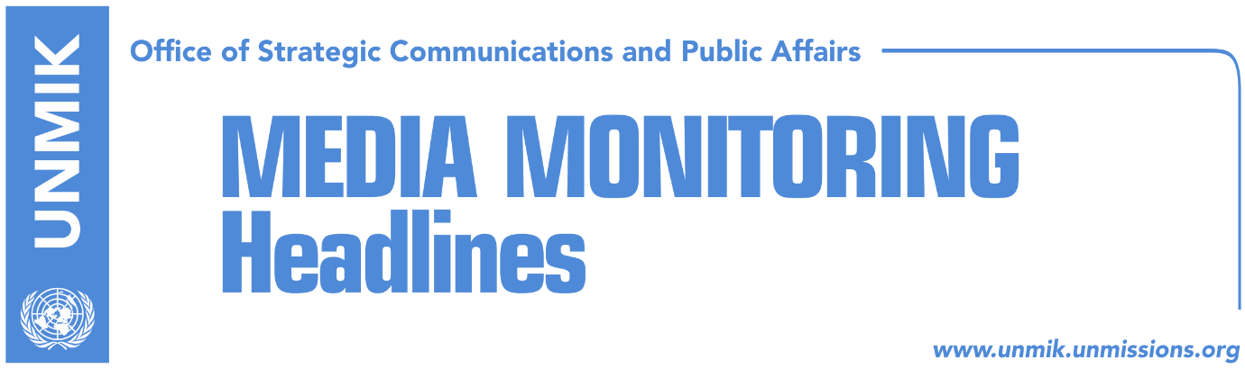

Main Stories 28 January 2019

- Thaci: Important decisions in the coming days and weeks (media)
- EU: Lift tax, engage in dialogue (Zeri)
- Haradinaj does not withdraw from tax, despite U.S. call (Epoka)
- Leaders’ manipulation with U.S. position on tax (Koha)
- Haradinaj: No agreement on border changes, it would bring new war (media)
- Kurti: Mass protest if there is an agreement on border changes (media)
- Negotiating team in Brussels for consultative meetings (Zeri)
- Arifi: In nine years, dialogue served only Serbia’s interests (media)
- Minister Rikalo could resign this week (Klan Kosova)
- Union leader: Teachers strike to continue indefinitely (RFE/Koha)
- Parents warn of protest if no breakthrough in strike is reached (media)
- Bajrami: Classes on Tuesday, otherwise government must resign (media)

Kosovo Media Highlights

Thaci: Important decisions in the coming days and weeks (media)
Kosovo President Hashim Thaci said on Sunday that Kosovo’s institutions will make important decisions and actions in the coming days and weeks, for state interests and for strengthening partnership with international allies. Thaci wrote on a Facebook post: “All state institutions are in the service of protecting, promoting and achieving our strategic state interests. Dialogue and the eventual peace agreement will accelerate our objective of membership to EU, NATO and the UN. These objectives can be achieved as long as we – the government, opposition and civil society – are united, we speak in unison and we have the support of our international allies, namely the support of the U.S.”

EU: Lift tax, engage in dialogue (Zeri)
It’s been more than two months since Kosovo authorities introduced import tariff on products from Serbia and Bosnia and Herzegovina and the EU continues to press Kosovo to lift the measure but at the same time it is not doing the same with Serbia which is continuing to wage a diplomatic war against Kosovo, the paper writes on the front page. European Union Spokesperson, Maja Kocijancic, told Zeri that the EU’s position on the tax remain unchanged in it that it needs to be lifted and added that the EU expects Kosovo and Serbia to engage in dialogue leading to normalisation of relations. “A comprehensive, legally binding agreement for full normalisation of relations between Belgrade and Pristina requires a climate that contributes to good neighbourly relations where the past agreements are respected and fully implemented,” Kocijancic said. She said that to achieve this, the parties need to refrain from statements and actions which are not in the interests and objectives of the region. “EU expects Serbia and Kosovo to demonstrate fast engagement to dialogue considering the direct link between normalisation of relations and their concrete EU accession perspectives,” Kocijancic noted.

Haradinaj does not withdraw from tax, despite U.S. call (Epoka)
The Prime Minister of Kosovo Ramush Haradinaj has spoken again about the 100 percent tax on Serbian goods, reiterating that the tax will not be suspended without recognition of Kosovo by Serbia. “If Belgrade claims we will never recognize you, we cannot use other words either. If they say we will never recognize you, we can also say we will never lift the tax,” Haradinaj said during a meeting of his political party in Ferizaj.

Leaders’ manipulation with U.S. position on tax (Koha)
The paper reports on its front page that despite attempts by some of Kosovo’s leaders to downplay statements by the U.S. about the 100-percent tax on Serbian goods, the U.S. warned Kosovo’s authorities on Friday that they will face serious consequences if the tax remains in force. The U.S. said the tax is against its strategic interests and that it undermines efforts for a final agreement between Kosovo and Serbia. The paper notes that their reaction comes after repeated statements by Kosovo Assembly President Kadri Veseli and Prime Minister Ramush Haradinaj who claimed that the U.S. did not call for the suspension of the tax.

Haradinaj: No agreement on border changes, it would bring new war (media)
Kosovo’s Prime Minister, Ramush Haradinaj, said in an interview to France 24 that an agreement between Kosovo and Serbia could be reached this year, but ruled out an agreement on border changes. Haradinaj said a possible land swap between the two countries could open old wounds in the Balkans and lead to a new war. “Talks on territories and borders would open the wounds of the past and the past is tragic,” he said. “Border changes would not bring us closer to an agreement”.

Kurti: Mass protest if there is an agreement on border changes (media)
Vetevendosje leader Albin Kurti said on Sunday that this movement would organize mass protest in the event of a land swap deal with Serbia, several media report. Referring to a Vetevendosje-organized protest in September last year, Kurti said VV would organize other protests if Kosovo’s territory is threatened. “President Thaci and his people are insisting on deals with territories, and they should know that if they try to reach an agreement that violates Kosovo’s territory, the protest will not only be repeated but it will be bigger than the previous one,” Kurti said.

Negotiating team in Brussels for consultative meetings (Zeri)
Two chairpersons of the Kosovo negotiating team, Shpend Ahmeti and Fatmir Limaj, are expected to travel Tuesday to Brussels and meet with officials from the EU High Representative Federica Mogherini’s office. The paper reports that alike the previous 8 January meeting, the upcoming one will also be consultative in nature with the members of the Kosovo team not being entirely sure as to what will be discussed. “It will be more of a preparatory meeting for dialogue. Shpend and I will go and maybe a representative from the President’s Office,” Limaj said last week.

Arifi: In nine years, dialogue served only Serbia’s interests (media)
Avni Arifi, chief of staff to Prime Minister Ramush Haradinaj, said that since the dialogue between Pristina and Belgrade began nine years ago, it has only served Serbia’s interest and said this is supported by a statement made by President of Serbia Aleksandar Vucic in an interview for daily Danas where he said that dialogue has strengthened Serbia’s position and “with talks we bought time and came back in the game.” “The current government and state delegation will no longer be in the function of such a dialogue,” Arifi wrote on Facebook.

Minister Rikalo could resign this week (Klan Kosova)
Kosovo’s Minister of Agriculture and Rural Development, Nenad Rikalo, is expected to resign during this week, in order to fulfil the condition of the Social-Democratic Party (PSD), on voting the budget for 2019 at the 31 January Assembly session. PM Ramush Haradinaj also spoke about the possibility resignation during the meeting of the government. “If Rikalo is dismissed, it is not as if I am making a work assessment, he has almost resigned,” Haradinaj said. “I did not communicate with the Serbian List, we spoke with PSD for the support on budget,” Haradinaj said.

Union leader: Teachers strike to continue indefinitely (RFE/Koha)
Rrahman Jashari, head of the teachers’ union, said no agreement has been reached with the government of Kosovo and the strike will therefore continue ‘indefinitely’. “We are optimistic that seeing the situation the parliamentary committee on administration will act accordingly and either meet our demands or recall the draft law,” Jashari said for Radio Free Europe. The schools in Kosovo have been out for the third week now with teachers demanding amendment of the law on salaries which they claim has treated them unjustly.

Parents warn of protest if no breakthrough in strike is reached (media)
The Council of Parents in Pristina said in a statement that if the government and the unions fail to reach an agreement by Tuesday they will call citizen protests. The parents expressed outrage that the schools have been closed for the third week now and warned that they were losing their patience. They called on the Ministry of Education and Teachers’ Union to make utmost efforts to approximate their positions and enable the children right to education.

Bajrami: Classes to resume on Tuesday, otherwise government must resign (media)
Democratic League of Kosovo (LDK) MP, Hykmete Bajrami, said on Sunday that classes in Kosovo schools must resume on Tuesday, otherwise the Haradinaj-led government must resign. Bajrami wrote on a Facebook post: “Prime Minister, the education sector is entering the third week of their strike on Monday. You, together with your deputies, 22 ministers and 50 deputy ministers, must urgently meet SBASHK [The Teachers’ Union]. The meeting must last until a final agreement to resume classes is reached. Classes must resume on Tuesday otherwise the government must resign, because you cannot do your homework”.

Disclaimer
This media summary consists of selected local media articles for the information of UN personnel. The public distribution of this media summary is a courtesy service extended by UNMIK on the understanding that the choice of articles translated is exclusive, and the contents do not represent anything other than a selection of articles likely to be of interest to a United Nations readership. The inclusion of articles in this summary does not imply endorsement by UNMIK.

