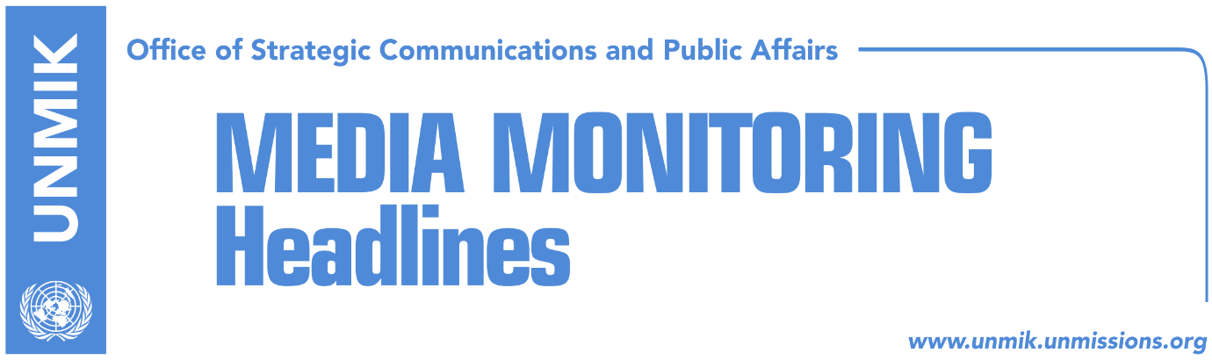

Main Stories 31 January 2019

- Prime Minister Haradinaj dismisses Agriculture Minister Nenad Rikalo (media)
- Lekaj: Haradinaj will not lift 100-percent tariff on Serbian goods (media)
- Opposition calls for resignation of Haradinaj-led government (Zeri)
- Kosovo Police confirms it arrested a Serb suspected of war crimes (media)

Kosovo Media Highlights

Prime Minister Haradinaj dismisses Agriculture Minister Nenad Rikalo (media)
All online media report that Prime Minister Ramush Haradinaj has dismissed today the Minister of Agriculture, Nenad Rikalo. Rikalo’s dismissal is among the conditions of the Social Democratic Party of Kosovo (PSD) to vote in favor of this year’s budget. The Serbian List issued a reaction following Rikalo’s dismissal saying that their party member was dismissed “because the Serbian List and its members do not agree with policies aimed against the rights and interests of Serbs”. Klan Kosova reports based on unnamed sources from the Independent Liberal Party, that Boban Stankovic is expected to replace Rikalo as Minister of Agriculture. Stankovic is currently Deputy Minister of Culture.

Lekaj: Haradinaj will not lift 100-percent tariff on Serbian goods (media)
Kosovo’s Minister of Infrastructure, Pal Lekaj, said on Friday that Prime Minister Ramush Haradinaj does not even think about lifting the 100-percent import tariff on Serbian and Bosnian goods. Lekaj, who is deputy leader in the Haradinaj-led Alliance for the Future of Kosovo (AAK), said in an interview to RTV Dukagjini that Haradinaj supports dialogue with Serbia but that “Belgrade’s wishes will not be fulfilled”. He also said that the ruling coalition jointly decided on the tariff and that the leaders had agreed to stand firmly behind their decision. “Haradinaj agreed with the Assembly President to increase the tariff by 100 percent. They also agreed that they would not change their position and that the tariff would remain in force until Serbia recognizes Kosovo’s independence,” Lekaj said.

Opposition calls for resignation of Haradinaj-led government (Zeri)
The paper reports that Kosovo’s Prime Minister, Ramush Haradinaj, is “waging battles” on many fronts as a result of his insistence not to lift the 100-percent tariff on Serbian and Bosnian goods. The Democratic Party of Kosovo (PDK), a partner in the ruling coalition, has called for the suspension of the tariff, whereas Serbian President Vucic, the United States of America and the European Union have made repeated calls on Kosovo’s authorities to rescind the tariff. The paper predicts that Kosovo could very soon go to early parliamentary elections if no compromise is reached on the tariff. Vetevendosje MP Albulena Haxhiu told the paper on Friday that her party has a completely different position on the matter from that of leaders of institutions. “They want to lift the tax and for this government to remain in power. Whereas, we want the tax to remain in fore and for the Haradinaj-led government to resign,” she said.

Kosovo Police confirms it arrested a Serb suspected of war crimes (media)
Most news websites report that Kosovo Police have detained a Serb at the Jarinje border crossing point on Friday evening. A police spokesman told Lajmi that the Serb is suspected of committing war crimes in the Peja region.

Disclaimer
This media summary consists of selected local media articles for the information of UN personnel. The public distribution of this media summary is a courtesy service extended by UNMIK on the understanding that the choice of articles translated is exclusive, and the contents do not represent anything other than a selection of articles likely to be of interest to a United Nations readership. The inclusion of articles in this summary does not imply endorsement by UNMIK.

