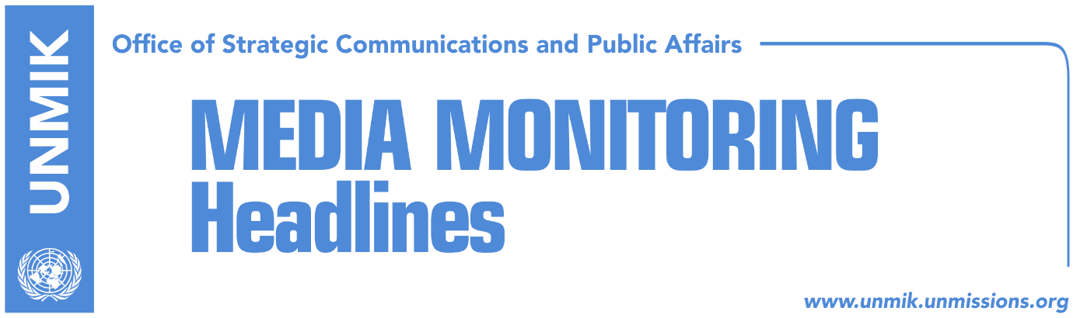

Main Stories 7 February 2019

- Thaci: Tariff to be suspended, creative solution with Serbia required (VOA)
- Haradinaj firm in opposing border changes (Koha)
- EU: Belgrade and Pristina decide agenda of dialogue (RFE)
- Discussion of borders, threat to Kosovo’s resources (Koha/Zeri)
- EU continues pressure on Kosovo to lift tax (Kallxo)
- Ahmeti: I will share responsibility for tax’s possible suspension (RTK/Koha)
- LDK, Vetevendosje: Thaci cannot negotiate inter-state aspects (media)
- Veseli signs decision on Trepca statute (media)
- Kosnett: War criminals have no place in Kosovo’s government (media)

Kosovo Media Highlights

Thaci: Tariff to be suspended, creative solution with Serbia required (VOA)
In an interview with Voice of America in Albanian, President of Kosovo Hashim Thaci said that any advice from the U.S. will be fully respected by Kosovo institutions. “However, it should be realized that the state of Kosovo faced aggressive actions from Serbia, actions which hurt the state of Kosovo, the functioning of the state internally and externally. Therefore the measure undertaken by Kosovo institutions was a right step at the right time but at the same time we now have to think to the future and the future is respecting the prevailing opinion not to withdraw the tariff but to suspend is as advised by the U.S. EU, NATO, Kosovo political spectrum, civil society,” Thaci said adding: “I am optimistic Kosovo will not take the burden of being responsible for blocking the negotiations process.” Speaking about the final agreement with Serbia, Thaci said a creative solution is required which would guarantee that the interests of the two sides will be fulfilled as well as those of the U.S., NATO and EU. “And of course, at the end there can be no recognition between the two countries without a clear definition of the Kosovo-Serbia interstate border. I would like to reemphasise that I work and think inclusion of Presevo, Medvedje and Bujanovc in the territory of the Republic of Kosovo would be logical but at the same time by not undermining Kosovo state resources like Gazivoda, or Mitrovica north, Trepca, or other assets,” Thaci said. Asked about Kosovo’s red lines, Thaci said: “There can be no dialogue where there is no assurance from Serbia of recognition and of opening the way for Kosovo’s membership to the UN. Without these two things, no dialogue makes sense.” On the prospect of border correction, Thaci said Kosovo already ‘corrected’ its border line with the former Yugoslav Republic of Macedonia (FYROM) and Montenegro and the one with Serbia needs to be defined prior to an agreement being achieved.

Haradinaj firm in opposing border changes (Koha)
Prime Minister of Kosovo Ramush Haradinaj rejected the idea of “slight” border correction with Serbia as proposed by President Hashim Thaci. “Kosovo is ready for an agreement that regulates everything, but not one on borders,” Haradinaj said yesterday during a visit to a potato chips factory in Vushtrri.

EU: Belgrade and Pristina decide agenda of dialogue (RFE)
European Commission spokeswoman Maja Kocijancic clarified the position of European institutions on the possible inclusion of the Trepca mining complex in the dialogue for normalization of relations between Kosovo and Serbia. “With regards to the matter if ‘Trepca’ is part of dialogue, the European Union, as a facilitator in the process, has always been clear that the agenda of dialogue is decided by Belgrade and Pristina. We don’t comment on points that they don’t want to discuss. They bring to the table issues that they consider open and then they have to agree on whether they want to discuss every issue, in order to reach a legally-binding agreement on all open issues,” Kocijancic said today. She added that dialogue is aimed at resolving all open issues between Kosovo and Serbia. “Without a full and comprehensive normalization of relations between Belgrade and Pristina through the EU-facilitated dialogue, there can be no long-term stability in the region. A comprehensive and legally-binding agreement on normalization is urgent and crucial for Serbia and Kosovo to move forward in their European path”. Kocijancic’s remarks follow harsh reactions from leaders and politicians in Pristina to media reports quoting her as saying that the European Union wants the Trepca issues to be solved through the process of dialogue.

Discussion of borders, threat to Kosovo’s resources (Koha/Zeri)
The statement of EU officials that Trepca should be a topic of discussion in the Pristina-Belgrade dialogue has triggered outrage in Kosovo but a day later the EU “corrected” the statement stating now that it is up to the parties involved in the dialogue to determine what they discussion topics will be, Koha Ditore reports on the front page. Analysts meanwhile say that the readiness on the part of Kosovo leaders to discuss everything with Serbia has paved way for the negotiations extending to Kosovo’s economic resources. Krenar Shala believes once Kosovo’s borders are put up for negotiations, it is inevitable that the issue of economic resources will follow. Similarly, Zeri also reports that the EU statement on Trepca has causes an uproar in Kosovo and quotes analysts saying that this was all a “game” the EU played to see how Kosovo would react if its most strategic asset is put up for negotiations.

EU continues pressure on Kosovo to lift tax (Kallxo)
The EU High Representative for Foreign Affairs and Security Policy, Federica Mogherini, has reiterated the position against the tax imposed by the government of Kosovo on imports from Serbia and Bosnia and Herzegovina. In a Twitter post, Mogherini said an urgent agreement between Kosovo and Serbia would normalise the situation. Mogherini said she spoke to Serbian President Aleksandar Vucic on the way forward in the dialogue and that “comprehensive, legally binding normalisation agreement on all open issued is urgent and crucial for Serbia and Kosovo to advance to EU and for stability, peace in region. Tariffs need to go, talks need to resume,” she wrote.

Ahmeti: I will share responsibility for tax’s possible suspension (RTK/Koha)
Leader of the Social Democratic Party (PSD) and co-head of the Kosovo Negotiating Team for dialogue with Serbia, Shpend Ahmeti, was quoted as telling RTK that he supports the view of the import tax on Serbia and Bosnia and Herzegovina being suspended in order to give the dialogue a chance to succeed. Ahmeti said he conveyed his view to Prime Minister Ramush Haradinaj. "The tax is right but it is not good for Haradinaj to feel alone in this issue, coordination is required and if there is a decision, it needs to be taken jointly," Ahmeti said. In a subsequent Facebook post he said that his statement was misconstrued and that what he told Haradinaj was: “We are together on the tax. If we decide together to keep it, we will share the pressure! If we decide together to temporarily suspend it to give dialogue a chance, we will together share the public criticism.”

LDK, Vetevendosje: Thaci cannot negotiate inter-state aspects (media)
The leader of the Democratic League of Kosovo (LDK) Isa Mustafa and leader of Vetevendosje Albin Kurti issued a joint statement saying they will remain engaged for an independent state of Kosovo as a parliamentary republic with a territorial and institutional integrity, state sovereignty and inviolable borders. LDK and Vetevendosje said that negotiation of a final agreement with Serbia needs to be done through a parliamentary formula that guarantees broad political unity: “Assembly of Kosovo is the only institution that exercises authority over what can and cannot be negotiated, through a transparent decision-making process with at least two-thirds of qualified majority.” The two leaders agreed that: “Serbia cannot join the EU without reaching an agreement with Kosovo and this is therefore the only thing Kosovo can give to Serbia in exchange for it recognising the independent state of Kosovo.” The opposition parties also said Kosovo will have full coordination and appreciation for the position of the U.S., Germany, France, United Kingdom, and Italy and will seek their assistance in empowering its independence. Kurti and Mustafa concluded that calling an international conference for an agreement between Kosovo and Serbia would be unnecessary and unacceptable as this would pave way for Russia and China to interfere in Kosovo’s independence process concluded in 2008. “Kosovo is an independent country and its statehood cannot be renegotiated in any of its constitutive elements. Kosovo will remain as such in the international law with or without recognition from Serbia,” the two parties declared.

Veseli signs decision on Trepca statute (media)
Kosovo Assembly President Kadri Veseli signed yesterday decision on the statute of Trepca mining complex approved by the Assembly last week. The decision stipulates the mine becoming a shareholding company owned entirely by Kosovo.

Kosnett: War criminals have no place in Kosovo’s government (media)
The U.S. Ambassador to Kosovo, Philip Kosnett, has reacted to the appointment of Sylejman Selimi, former KLA commander convicted of war crimes, as advisor to Prime Minister Ramush Haradinaj. “Convicted war criminals have no place in Kosovo’s government. Leaders of all parties should stop supporting such individuals. Such support calls into question Kosovo’s commitment to the rule of law,” Kosnett wrote on Twitter.

Disclaimer
This media summary consists of selected local media articles for the information of UN personnel. The public distribution of this media summary is a courtesy service extended by UNMIK on the understanding that the choice of articles translated is exclusive, and the contents do not represent anything other than a selection of articles likely to be of interest to a United Nations readership. The inclusion of articles in this summary does not imply endorsement by UNMIK.

