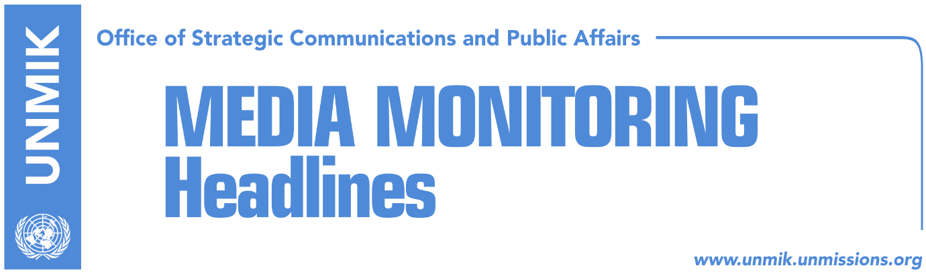

Main Stories 11 February 2019

- Import tariff: U.S. General cancels visit to Kosovo (dailies)
- Limaj: Dialogue platform to be ready this week (RTK)
- Lluka: Trepca cannot be topic of Kosovo-Serbia dialogue (Bota Sot)
- “Secret discussions for change of Kosovo’s borders are being held” (media)
- Serbian media report on five possible scenarios of Kosovo-Serbia deal (Zeri)
- Thaci denies being summoned by Specialist Chambers (Klan Kosova)
- KFOR sees no direct threat in Kosovo, expresses concern over rhetoric (Koha)
- Ramadani: Kosovo will be NATO’s 31 member (Epoka)
- Kosovo cannot ‘shut its door’ to UNMIK (RFE, Epoka)
- Vucic: Someone from Kosovo is behind protests in Belgrade (Tanjug, media)

Kosovo Media Highlights

Import tariff: U.S. General cancels visit to Kosovo (dailies)
Papers report that the U.S. has cancelled the upcoming visit of the Iowa National Guard Commander, Major General Timothy Orr, to Kosovo as a result of discontent with the trade measures Kosovo government has imposed on Serbia and Kosovo. The U.S. army official was scheduled to visit Kosovo during 16-18 February but sent a letter to Kosovo Security Force Commander, General Rrahman Rama, saying his visit would not take place. Furthermore, in the letter, Major General Orr said all training activities and military visits will be cancelled over the coming days if the government of Kosovo does not reflect on its actions.

Limaj: Dialogue platform to be ready this week (RTK)
Kosovo’s Deputy Prime Minister and co-head of the Kosovo Negotiating Team for Dialogue with Serbia, Fatmir Limaj, said that the platform on dialogue is expected to be ready this week and will be then forwarded to the Assembly of Kosovo for approval. “If Kosovo’s political factor cannot be unified it should at least unify positions,” Limaj said. He said he hoped the platform would represent the joint positions of the Kosovo political spectrum which he said would send a message that Kosovo has finally one stance on dialogue with Serbia.

Lluka: Trepca cannot be topic of Kosovo-Serbia dialogue (Bota Sot)
Kosovo’s Minister of Economic Development, Valdrin Lluka, said Trepca mine cannot be a topic of discussion in the dialogue between Kosovo and Serbia. “Any decision on Trepca is a sovereign decision of the Kosovo parliament and as such there is nothing to discuss,” Lluka said adding that Trepca is entirely in the territory of Kosovo and is an enterprise where the Government of Kosovo owns about 80 percent of shares and the rest are owned by the mine’s employees.

“Secret discussions for change of Kosovo’s borders are being held” (media)
Austrian analyst Florian Bieber, who is professor at Southeast European Studies at the University of Graz and coordinator of Balkans in Europe Policy Advisory Group's (BiEPAG) considers that secret discussions, behind the closed doors, for change of Kosovo borders, supported by some western countries are taking place. He considers that the main problem is that an impression that Germany is out of these developments is being created. However, he added that he is not aware of any discussions that ever took place without involvement of Germany to bring positive results. He said that recent statements of President Thaci for a slight correction of borders and his mentioning of Russia, speak in favor of ‘secret discussions.’ According to Bieber, “change of borders is a dangerous option, which more opens problems than closes them.” He also expressed suspicion on readiness of Belgrade and Pristina to resolve this problem.

Serbian media report on five possible scenarios of Kosovo-Serbia deal (Zeri)
Belgrade-based media have reported that there are five possible scenarios of the agreement between Kosovo and Serbia with the first being partition of Kosovo and Serbia’s reclaiming control to the north of Kosovo. The second option involves an agreement on comprehensive normalisation of relations which would imply recognition of Kosovo and a special autonomy for the Serb community in Kosovo which would have greater powers than those set out by the Association/Community of Serb-majority municipalities. Border correction is also one of the options whereby Kosovo borders would become those of 1953, meaning Serbia would get vast part of the north but not the Gazivoda Lake and Mitrovica. The fourth option is land swap along ethnic lines and the final option is to maintain the status-quo and not seek an agreement at this time.

Thaci denies being summoned by Specialist Chambers (Klan Kosova)
President of Kosovo, Hashim Thaci, has denied reports in Serbian media saying he was invited by the Specialist Prosecutor in The Hague. In a Facebook post, Thaci said the media reports are untrue. “If I would be invited, I would at any given time respond to the invitation without hesitating, as all my other fellow-fighters. The KLA war was right, dignified and the greatest political and military project in the history of the Albanian nation. I am proud of KLA,” Thaci wrote.

KFOR sees no direct threat in Kosovo, expresses concern over rhetoric (Koha)
In a front-page interview with the paper, KFOR Commander, Major General Lorenzo D’Addario, said that KFOR troops are committed to maintaining a safe and secure environment in Kosovo despite political developments and possible tensions. “I leave politics to politicians and I can see that democracy functions here. You make efforts, you have dynamics, coalitions, voting and so on. And this is all right. What I am concerned is the consequences of political activities of statements, the rhetoric, narrative, actions, which may be political in nature but with consequences on the security,” D’Addario said. Asked on the cooperation with the Kosovo Security Force following the Kosovo Assembly’s decision to transform it into an army, D’Addario said NATO is still reassessing its level of commitment with KSF and that this is a political discussion involving NATO member states and those contributing. “What I would say is that our relations with KSF has not changed.” Asked about the north of Kosovo, COMKFOR said the area remains hostage to the political situation and that people are anxious for a solution. “It is vital to bring together the police and other institutions, and so everyone is trying to do their best.”

Ramadani: Kosovo will be NATO’s 31 member (Epoka)
Kosovo’s Deputy Minister of Defence, Burim Ramadani, expressed certainty that Kosovo will be the 31 member of NATO. He told the paper that Kosovo should increase its political and diplomatic efforts to reach this aim. He denied the possibility that lack of lifting the tariff to Serbian goods would affect relations of the Kosovo Security Force with the U.S. “Special strategic partnership with the U.S. is not ad hoc, but sustainable and eternal,” Ramadani said.

Kosovo cannot ‘shut its door’ to UNMIK (RFE, Epoka)
Experts of the political matters and international relations say that the United Nations mission in Kosovo (UNMIK) has remained a symbolic one, however, as long as the UN Security Council resolution 1244 is in power, this mission will exist in Kosovo. According to them, UNMIK is not completely stripped of power, despite the fact that it never used that power to bring down the decisions of the government of Kosovo.

Vucic: Someone from Kosovo is behind protests in Belgrade (Tanjug, media)
The President of Serbia, Aleksandar Vucic, claims that organizers of the protests against him in Belgrade, are in Kosovo. “It is sufficient to see the reporting of Kosovo media, and to discover who is behind those protests, who wants to bring me down. It is very clear,” Vucic said. According to him, Albanian media also manipulated with the number of protesters. He said it is important to know why these protests were organized at the moment when Pristina decided on tax for Serbian goods. Speaking about the protests against him in northern Kosovo, Vucic praised Serbs there and mentioned the small number of protesters.

Disclaimer
This media summary consists of selected local media articles for the information of UN personnel. The public distribution of this media summary is a courtesy service extended by UNMIK on the understanding that the choice of articles translated is exclusive, and the contents do not represent anything other than a selection of articles likely to be of interest to a United Nations readership. The inclusion of articles in this summary does not imply endorsement by UNMIK.

