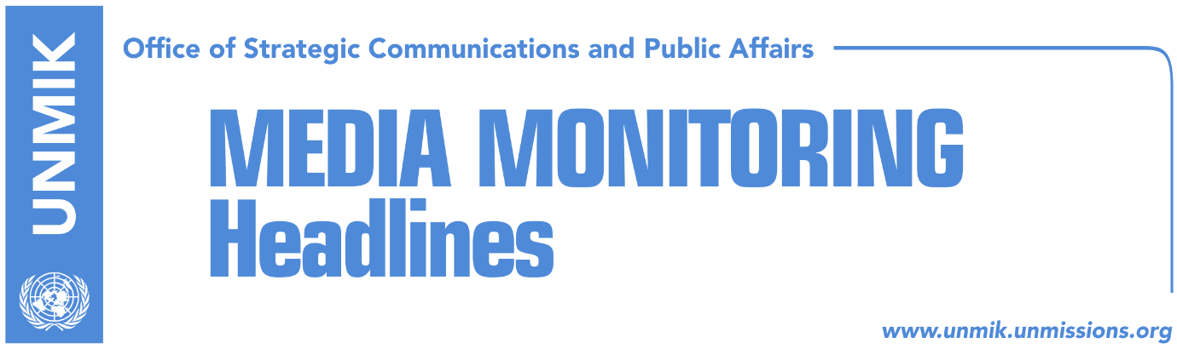

Main Stories 14 February 2019

- Thaci: There will be measures if tax is not lifted (RTK)
- Haradinaj: I will not step down, tax will bring Serbia’s recognition (Koha)
- Veseli: Friendship with the U.S. to be safeguarded (RTK)
- Relations with U.S. deteriorate, pressure to suspend tax increases (Koha)
- NATO reiterates: Kosovo forces cannot go to north without approval (Koha)
- Pacolli: Serbia can never come between Kosovo and U.S. (Zeri)
- Engel to Serbia: Take the speech of German Ambassador seriously (Bota)
- Kosovo and Albania planning to apply “Mini-Schengen” border control (Koha)
- Kosovo wants to open liaison office in Bratislava (media)

Kosovo Media Highlights

Thaci: There will be measures if tax is not lifted (RTK)
The President of Kosovo, Hashim Thaci, told Kosovo national broadcaster that by confronting the West, Kosovo will become isolated and warned that if the tax on Serbian goods is not lifted there will be measures against Kosovo. “There will be no liberalisation of visas by the EU and there can be concerning measures for Kosovo citizens and state. I work to overcome this situation,” he said. Thaci also had a message for Kosovo’s Prime Minister Ramush Haradinaj: “You can be a friend when you respect advise.” “There is no leader that can affect U.S. friendship with the population of Kosovo. Powers are divided. The government should make strategic decisions related to the Euro-Atlantic future,” Thaci said. “With this lack of respect for advises, we have passed the countries that were in conflict with the U.S. in different periods and with their own fault, countries from Western Balkans,” he said. “It is an unpleasant situation that I would never be able to imagine,” he added.

Haradinaj: I will not step down, tax will bring Serbia’s recognition (Koha)
In an interview with KTV last night, Prime Minister of Kosovo Ramush Haradinaj said his views on issues concerning Kosovo are well-known and that the cooperation between coalition partners will continue even if there is disagreement over the tax imposed on Serbia and Bosnia. He said the only compromise for lifting the tax would be a comprehensive agreement between Kosovo and Serbia. “No one gives you a market for free, Kosovo’s market for Serbia is valuable and we want this to precede a comprehensive agreement. If the tax is suspended, we provide Serbia with extra time to delay the dialogue,” Haradinaj said adding: “I strongly believe that the tax brings forth the recognition but patience is needed.” On the calls from the U.S. to suspend the tax, Haradinaj said it was true that the U.S. was not happy but “we are in dire position.” He said he was ready to endorse any solution that would be for the good of Kosovo, even if this means a broad-based government. He said however he would not step down from his post. “I don’t want to resign because I think I am right in the decisions I take… I don’t think me stepping down would fix the situation in the country,” he said. Haradinaj denied having knowledge that an agreement has been already reached by presidents of Kosovo and Serbia on territorial exchange. He warned however that anything in conflict to the Constitution of Kosovo cannot be accepted. “Two presidents have already gone home when they clashed with the Constitution,” he said. Commenting on his criticism of the EU High Representative Federica Mogherini on the way she facilitated the Belgrade-Pristina dialogue, Haradinaj said: “Her actions have harmed Kosovo if territory was discussed in the dialogue. Mogherini’s activity is not friendly, it is hostile.”

Veseli: Friendship with the U.S. to be safeguarded (RTK)
Kadri Veseli, President of the Assembly of Kosovo, told RTK that Serbia should not be allowed to benefit from Kosovo’s mistakes. “There was not a single need to reach this situation, to receive this letter. The U.S. should be understood and taken seriously. This is the reason I made a proposal some time ago to maintain dignity of the state decision-making. Serbia deserves not only a 100 percent tax, but reciprocity measures, and a range of measures due to its incorrect behavior during these two decades towards our goods, citizens and institutions of the Republic of Kosovo,” he said. “There was no need to have this letter, and we should not dare or allow to after two decades of freedom, to have something that is legitimate decision-making and state interest to become an obstacle or confrontation with partners,” he said. “Let us avoid populisms and some things that are affecting us more, trying to compete with each other. There is not competition, we should be wise and overcome this self-trapped situation from which Serbia benefits…we should safeguard our partnership with the U.S. and the West,” Veseli said. “Some pseudo-wise and pseudo patriots are inflaming the situation, trying to put the Prime Minister in a difficult position, through a very archaic mentality,” Veseli said.

Relations with U.S. deteriorate, pressure to suspend tax increases (Koha)
Kosovo institutional leaders are reported to have become alarmed with the letter the U.S. administration sent to Kosovo warning it of consequences if it continues to refuse suspending the import tariff on products from Serbia and Bosnia and Herzegovina. Nevertheless, three main leaders of Kosovo remain unmoved in their positions. Assembly Speaker Kadri Veseli called a meeting yesterday with Prime Minister Ramush Haradinaj and Kosovo Negotiating Team in dialogue with Serbia. Following the meeting, co-head of the team Shpend Ahmeti said they discussed the platform on dialogue and that there was no change of positions on the tax. “I don’t think there is any change of stances on the part of different representatives. I don’t think anything has changed in the prime minister’s opinion either,” Ahmeti said. Yesterday also saw a meeting between the U.S. Ambassador to Kosovo Philip Kosnett and President Hashim Thaci. The two agreed it is vital to remove all obstacles for resuming dialogue with Serbia and to make way for a peace agreement. “Partnership and friendly relations with the United States of America are crucial for Kosovo. Kosovo has achieved so much thanks to the overall support of the United States,” Thaci said.

NATO reiterates: Kosovo forces cannot go to north without approval (Koha)
NATO’s Secretary General Jens Stoltenberg reiterated that they expect Kosovo to respect what he said was an agreement not to deploy Kosovo Security Force troops to the north without prior approval of the KFOR Commander. “There is a Brussels agreement from the year 2013, which says clearly that KSF cannot go in the north of Kosovo, without the approval of the KFOR Commander. I made this clear to Mr. Haradinaj, and I expect for it to be respected,” Stoltenberg told KTV. He reiterated that Kosovo will be discussed during the first day of the Summit of Defense Ministers in Brussels. Stoltenberg said the level of the engagement of the KSF will be assessed, as the allies consider that it was not the right time to vote the army. The paper however reports that the 2013 Brussels Agreement makes no mention of KSF at all. Instead, it refers to integration of security forces in the north into Kosovo system.

Pacolli: Serbia can never come between Kosovo and U.S. (Zeri)
Kosovo’s Foreign Minister, Behgjet Pacolli, said Serbia can never come between Kosovo and the U.S. as “Kosovo has permanent and natural relations with the U.S. and the West.” In a Facebook post, Pacolli also said Kosovo would not become cause of disappointment for the U.S.

Engel to Serbia: Take the speech of German Ambassador seriously (Bota)
The U.S. Congressman Eliot Engel advised Serbia to treat with major seriousness the speech of the German Ambassador Cristoph Heusgen at the UN Security Council. “They will not be able to integrate in the European Union without recognizing Kosovo,” Engel said. Heusgen said in his speech that he does not understand Serbia’s campaign against Kosovo despite the opinion of the International Court of Justice. “An independent Kosovo exists. The only way for Serbia to join EU, will be through a successful dialogue for normalization of the relations and recognition of Kosovo,” he said.

Kosovo and Albania planning to apply “Mini-Schengen” border control (Koha)
The paper reports on the cover that it has secured a draft agreement that Kosovo and Albania are preparing to regulate border control. According to the draft, the two parties are planning to apply a type of a “Mini-Schengen” arrangement whereby there would be no control of persons crossing between Kosovo and Albania. The 50-page document is expected to be put up for approval with relevant institutions in Pristina and Tirana before being put into effect.

Kosovo wants to open liaison office in Bratislava (media)
Kosovo’s Foreign Minister, Behgjet Pacolli, met yesterday the new Head of Slovakia’s Liaison Office to Pristina, Rastislav Kostilnik, a press release issued by Kosovo’s Foreign Ministry announced. In the meeting, Pacolli spoke of issues of bilateral interest and Slovakia’s continued support for Kosovo’s Euro-Atlantic integration processes. Pacolli is also said to have requested Kosovo open a liaison office in Bratislava and according to the press release, “close consultations between the two countries will take place to this end.”

Disclaimer
This media summary consists of selected local media articles for the information of UN personnel. The public distribution of this media summary is a courtesy service extended by UNMIK on the understanding that the choice of articles translated is exclusive, and the contents do not represent anything other than a selection of articles likely to be of interest to a United Nations readership. The inclusion of articles in this summary does not imply endorsement by UNMIK.

