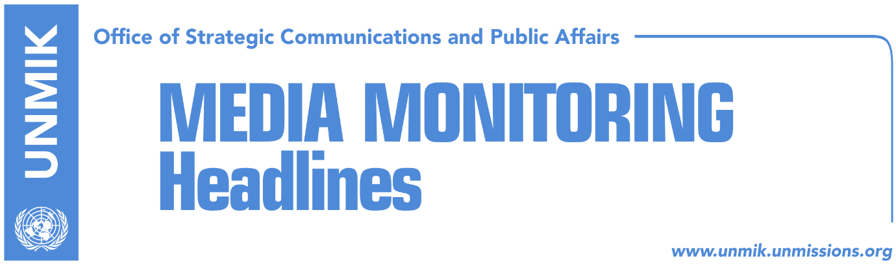

Main Stories 15 February 2019

- Kosovo State Delegation finalises platform for dialogue with Serbia (media)
- Dialogue platform’s “red lines” (Zeri/Koha Ditore)
- Thaci and Vucic both to attend Munich Security Conference (Zeri)
- AP: Kosovo president hopes for deal with Serbia (Bota Sot)
- Scott: Solution to come from Belgrade and Pristina (Klan Kosova)
- Limaj: We should open way to the dialogue with Serbia (RTK)
- LDK: Opening Kosovo borders “self-aggression” (Kosova Sot)
- Collaku: U.S. will not deal with us eternally, tax should be suspended (Klan)
- NATO to decide on cooperation with KSF in spring (dailies)
- Fajon: Visa liberalisation and dialogue have stalled (Zeri)
- “Serb parallel structures ransack offices of Ski Federation in Brezovica” (media)

Kosovo Media Highlights

Kosovo State Delegation finalises platform for dialogue with Serbia (media)
Kosovo State Delegation finalised the platform for dialogue with Serbia which is expected to be sent to the Assembly for further approval today. Prime Minister Ramush Haradinaj said the document is in line with the Constitution of Kosovo and provides a “good guarantee” for Kosovo. “We just concluded a meeting with the delegation and we finally have an agreement on the platform. The platform derives from the Constitution, it adheres to the country’s constitution and is a good guarantee for Kosovo,” Haradinaj said. He called on opposition parties – the Democratic League of Kosovo (LDK) and Vetevendosje – to give their contribution in support of the platform.

Dialogue platform’s “red lines” (Zeri/Koha Ditore)
The papers claim to have secured a copy of the platform for dialogue with Serbia which according to Zeri states that any agreement with Serbia should be fully in line with the Constitution of Kosovo which in turn stipulates that Kosovo’s sovereignty and territorial integrity is “intact, inalienable, indivisible and protected by all means provided in this Constitution and the law.” Koha Ditore meanwhile writes that the document contains 18 points and one condition for the Serbian delegation to pledge that it has authority to agree on recognition of Kosovo before the two parties sit down at the negotiating table in Brussels. The platform, expected to be submitted to the Assembly today, also states that Kosovo’s main goal in dialogue with Serbia is to secure its recognition through legally binding guarantees and that there can be no agreement on anything unless there’s an agreement on everything. Kosovo negotiating team stated further in the platform that the legally binding agreement can only enter into force after Serbia recognises Kosovo as an independent country, Kosovo holds referendum on agreement and the two respective parliaments ratify the deal. The document also specifies that the Constitution of Kosovo is not open for negotiation and speaks about the promotion of rights of Albanian community in Serbia in reciprocity to the rights the Serb community in Kosovo. As for natural resources, the team says assets located in the territory of Kosovo belong exclusively to Kosovo and, as a result, are non-negotiable. The platform says there can be no third-level government in Kosovo while the final agreement needs to result in the creation of a tribunal for investigation and prosecution of crimes committed by Serbian forces in Kosovo in 1998-1999. The document further notes that the UN Security Council resolution 1244 should be declared invalid while the final agreement would have to get the support of the UN Security Council and the UN General Assembly to pave way for Kosovo joining the UN. Finally, the agreement should be achieved through the mediation of the EU and the U.S. which will also serve as guarantors.

Thaci and Vucic both to attend Munich Security Conference (Zeri)
European Commissioner for Neighbourhood Policy and Enlargement Negotiations, Johannes Hahn, announced that he will be attending a panel on security in Southeast Europe as part of the Munich Security Conference alongside presidents of Kosovo and Serbia, Hashim Thaci and Aleksandar Vucic. “Commissioner Hahn will hold a series of bilateral meetings and will participate at discussions including a panel on Saturday about ‘Security in South East Europe’ with Presidents Hashim Thaci and Aleksandar Vucic,” a press release issued by the European Commission reads.

AP: Kosovo president hopes for deal with Serbia (Bota Sot)
Bota Sot carries an interview President of Kosovo Hashim Thaci gave to Associated Press where he said that he believed there was ‘good momentum’ for an agreement with Serbia to be reached this year. “Kosovo’s independence has brought more peace and stability in the Western Balkans,” he said. Thaci mentioned strong support from the United States and the European Union, and Russia’s pledge to accept a Pristina-Belgrade agreement. AP reports that Thaci has urged the government of Kosovo to temporarily suspend the tariff on Serbia and Bosnia as has been requested by the U.S. and the EU, but also said Serbia should not make it a condition of resuming dialogue. “But there is no coldness (from U.S.) toward Kosovo as a country or its population,” Thaci said.

https://bit.ly/2UZql25

Scott: Solution to come from Belgrade and Pristina (Klan Kosova)
The U.S. Ambassador to Belgrade, Kyle Scott, is quoted to have said in an interview with Belgrade-based paper Blic that the solution to the Kosovo problem should come from Belgrade and Pristina through direct talks. “Neither the United States nor anyone else should dictate how the solution should look like,” Scott said when asked whether he supported the border correction idea. He said the U.S. consider it is important for Belgrade and Pristina to resume dialogue and that this was the reason behind the message to the government of Kosovo to suspend the import tariff on Serbia and Bosnia.

Limaj: We should open way to the dialogue with Serbia (RTK)
Deputy Prime Minister of Kosovo and co-head of the state delegation for dialogue with Serbia Fatmir Limaj, told RTK that Kosovo should open way to the dialogue with Serbia. “Kosovo will have a unitary position on this matter, which opens way to the possibility of dialogue. We should open way to dialogue. Kosovo is sufficiently mature to act in accordance with its interests and respect friend’s suggestions,” he said. “A coalition which cannot build a unitary position loses sense,” he added.

LDK: Opening Kosovo borders “self-aggression” (Kosova Sot)
The Democratic League of Kosovo (LDK) expressed once again its position against change of Kosovo borders, stressing that opening of the dialogue for the borders is “a self-aggression against the country’s territory.” The leader of this political party, Isa Mustafa, took to Facebook to write that Kosovo’s borders are untouchable and that dialogue for the borders is forbidden. “If someone looks forward to bargain with correction of borders, then he can only trade the borders of his own property, not Kosovo’s borders,” Mustafa wrote.

Collaku: U.S. will not deal with us eternally, tax should be suspended (Klan)
Bekim Collaku, adviser to the President of Kosovo Hashim Thaci, told Klan Kosova that Kosovo still has responsible politicians and added that the Prime Minister Ramush Haradinaj should with complete responsibility suspend the tax. “There are great chance for us to end up in a scenario where Kosovo is responsible for lack of functioning of the dialogue,” he said. “Withdrawal of this decision can open a chance for negotiations. Our territorial integrity will not be negotiated at that table,” he added. “We should consider the good friendly advice, they are not requesting removal but suspension of the tax. Just as they helped us create the army, the U.S. will help us with NATO membership,” Collaku said.

NATO to decide on cooperation with KSF in spring (dailies)
NATO Secretary General, Jens Stoltenberg, said on Thursday that the Alliance remains committed to keeping stability in Western Balkans. He said that after transformation of Kosovo Security Force (KSF) into army, NATO is reviewing the level of cooperation with this force. He said discussions on the matter are ongoing and a decision will be made the latest, in spring. He added that the KFOR’s mission in Kosovo remains unchanged, based on UNSC Resolution 1244. “We are there to offer a safe and secure environment for all people of Kosovo and this is what we are doing right now,” Stoltenberg said.

Fajon: Visa liberalisation and dialogue have stalled (Zeri)
European Parliament rapporteur for visa liberalisation for Kosovo, Tanja Fajon, said that the Pristina-Belgrade dialogue and that on visa liberalisation have stalled. In a meeting a group of MEPs had with Kosovo MPs, Fajon said she hoped these two issues would soon get resolved. “I genuinely hoped that both – the dialogue between Belgrade and Pristina and visas for Kosovo citizens – are resolved still in this European Parliament mandate! Instead, both are still blocked! Call on all responsible to act,” Fajon wrote on Twitter.

“Serb parallel structures ransack offices of Ski Federation in Brezovica” (media)
Media report that parallel institutions in Brezovica ransacked the office of the Ski Federation of Kosovo. “Looting in Brezovica and attempt to expel us from the offices that the Federation established in “Molika” hotel. This was committed by parallel institutions. Kosovo Police is at these moments at the site, Kosovo flags and computers are removed, and two pairs of skis are stolen,” said head of the Ski Federation of Kosovo Milaim Kelmendi.

Disclaimer
This media summary consists of selected local media articles for the information of UN personnel. The public distribution of this media summary is a courtesy service extended by UNMIK on the understanding that the choice of articles translated is exclusive, and the contents do not represent anything other than a selection of articles likely to be of interest to a United Nations readership. The inclusion of articles in this summary does not imply endorsement by UNMIK.

